Creating a water table contour map of Happyville
Recent geologic surveys have revealed a large Marcellus Shale natural gas deposit in north central PA near the Susquehanna River. "Bob’s Gas Company" wants to drill several wells to start the process of hydraulic fractionation just north of Happyville, and you will debate the pros and cons of drilling the Marcellus Shale next week. However, in order to be an “informed citizen” you will first learn more about groundwater movement in Happyville. Below, you can see a map of Happyville. You can view the map below.
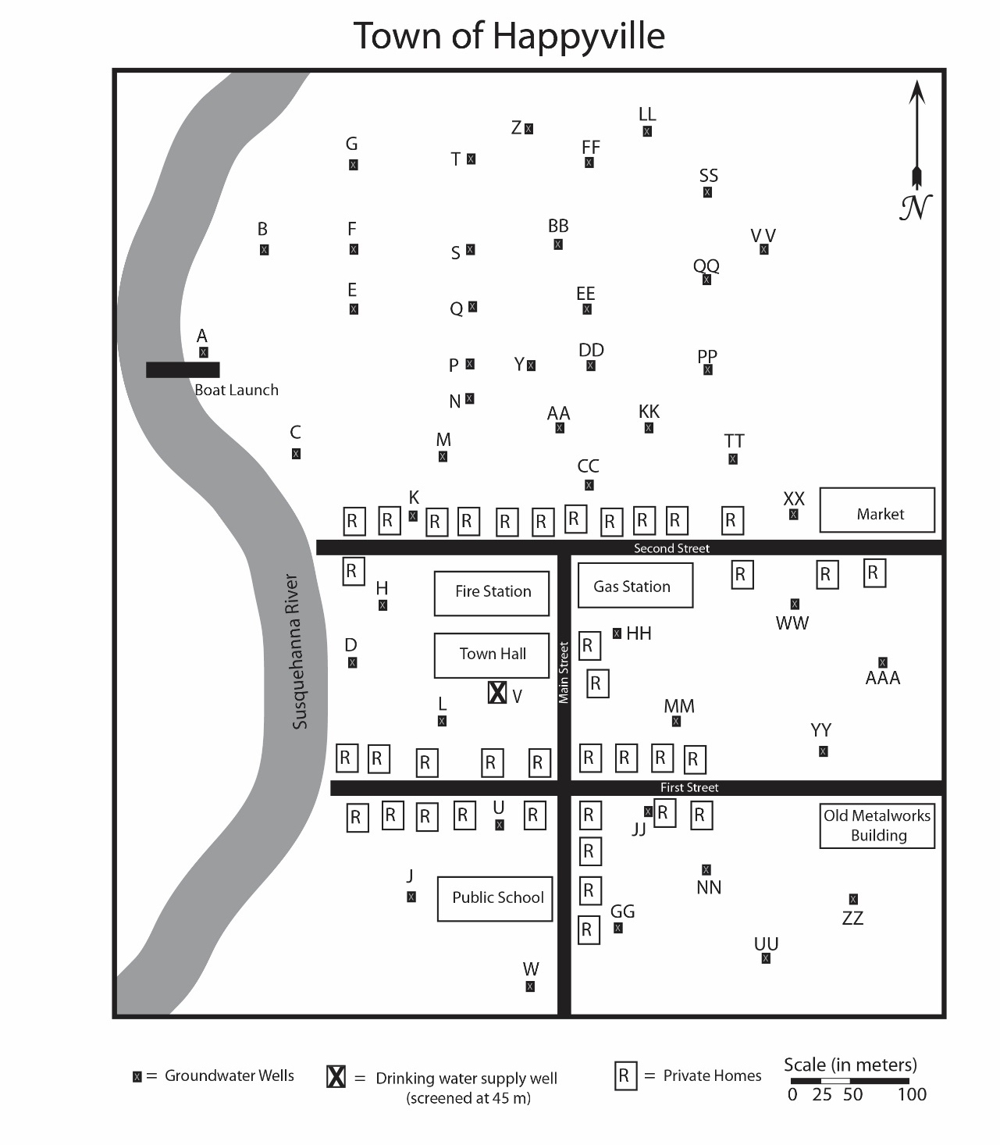

Happyville is underlain by ~150 m of Manhantango sandstone, which is on top of the Marcellus Shale. First, you need to determine where Happyville gets its groundwater. Then, you need to determine the direction of groundwater flow in the region. To help you determine this information, the PA Department of Environmental Protection (PaDEP) has drilled several wells in Happyville to determine the direction of groundwater flow. These wells are marked on the map as a black box with an “x”.

In this exercise, you will create a contour map of the water table in Happyville. You should download the excel spreadsheet - Happyville Calculations. Your first task is to determine the groundwater table elevation at each of the wells. To determine water table elevation, you subtract the “depth from top of well to water” from “Top of well elevation” (I have completed the first two for you). (Hint: You can use the equation function in Excel complete the calculations for you.)

Once you determine the water table elevation at each of the wells, you should write the elevation levels on the map of Happyville. You will need to identify each of the wells on the map and then write the water table elevation at each well. As you have 46 wells, this step may take some time!

In this process, you should identify the drinking water supply well. (Hint: look at line 50 in the excel sheet). You should also think about the statement "screened at 45 m.” What does this mean?

Now, you need to contour the groundwater table in Happyville and determine the direction of groundwater flow. The highest contour line should be 636 m above sea level, the lowest contour interval should be 616 m above sea level, and the contour interval is 2 m. I suggest you start with the 636 m contour line and work your way down the map. After you create the contours of the water table, you should draw an arrow indicating the direction of groundwater flow. Remember: each contour line represents the changing groundwater elevation, and water always flows downhill!!

Once you finish creating your contour map, consider the following questions:
- What is the direction of groundwater flow in Happyville?
- Where is the drinking water supply well?
- What geologic rock unit supplies the drinking water to the town of Happyville?
- Which has a higher natural permeability - sandstone or shale?

