Soil, Systems, and the Environment Module

Unit 2 Mapping, Links to maps for Massachusetts

LAND USE
http://maps.massgis.state.ma.us/map_ol/oliver.php?lyrs=Land%20Use%202005~massgis:GISDATA.LANDUSE2005_POLY~GISDATA.LANDUSE2005_POLY::Default|Structures~Basemaps_Structures~|Detailed%20Features~Basemaps_MassGISBasemapWithLabels2~&bbox=-71.04739090938687,42.04852600093989,-70.99696537990593,42.075130194101654&coordUnit=m&measureUnit=m&base=MassGIS%20Statewide%20Basemap&center=-7906152.7060912,5170245.7062449&zoom=15&opacity=1,1,1&baseO=1&filt=undefined|undefined|undefined

(from https://docs.digital.mass.gov/dataset/massgis-data-land-use-2005)
(And https://www.mass.gov/service-details/massgis-data-layers?_ga=2.164243446.876181561.1534258903-1282005464.1534258903)

SOIL:
General
https://www.arcgis.com/home/webmap/viewer.html?webmap=0edea1c7bbb84ba5842d20483af11679
Detailed
https://websoilsurvey.sc.egov.usda.gov/App/WebSoilSurvey.aspx

TOPOGRAPHY
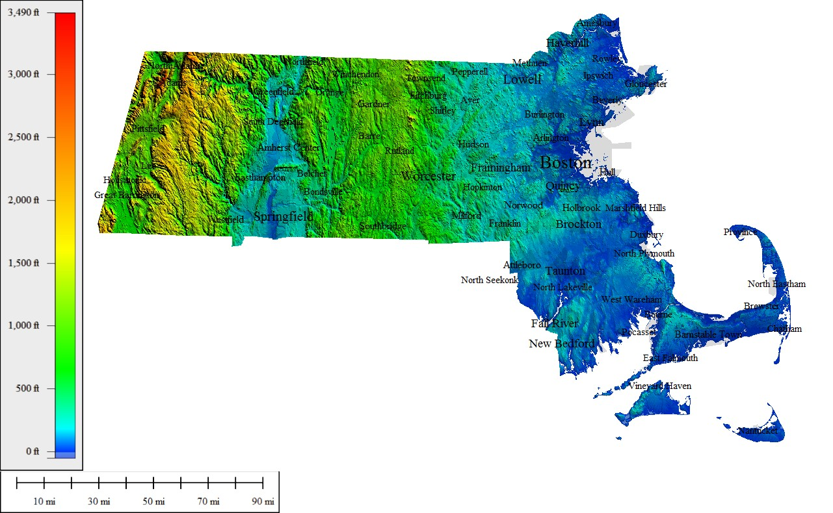

PRECIPITATION
