MINERAL SEPARATION LAB
Joel S. Aquino, PhD
University of North Georgia

Rationale: The raw materials and energy that we use for our civilization to continually exist and advance comes from the ground. These natural resources have to be mined and processed profitably in order to extract the required minerals. Mining and energy companies take great efforts to conduct research on how best to cost-efficiently extract these minerals without compromising safety and the environment.
In this lab you are required to DESIGN a process and DRAW a flowchart on how to separate the individual components of a certain mixture made up of a beaker of 500 to 1000 ml of water with dissolved salt, oil, quartz sand, pebbles and iron filings.
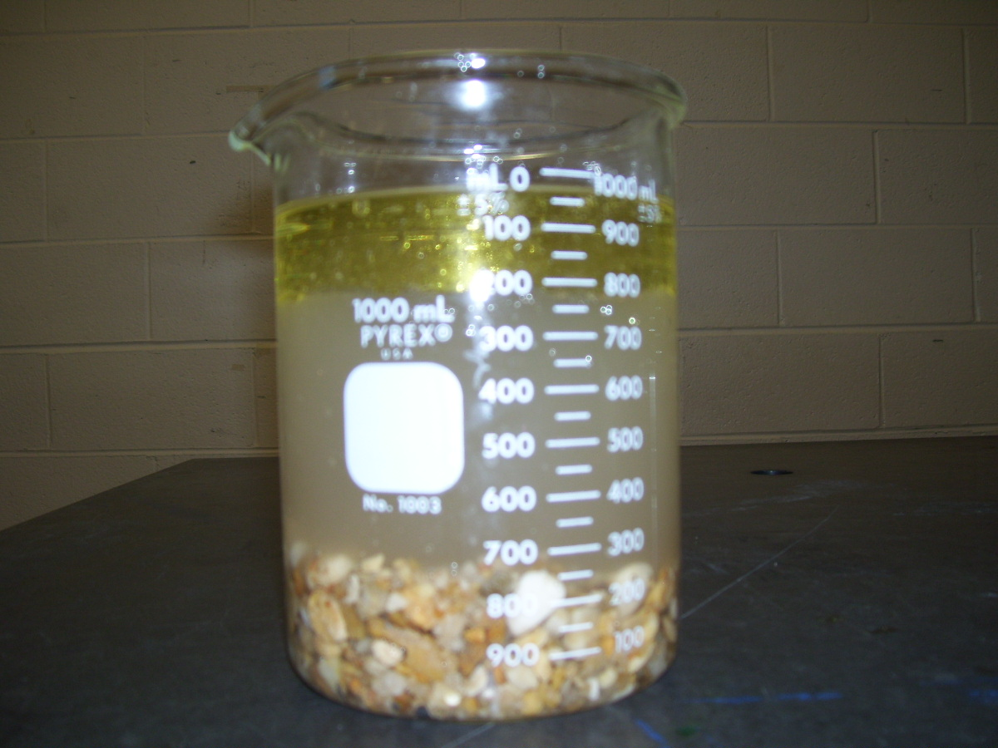
Among these components, the most valuable item is the iron filings and requires the least contamination, if possible, during separation. Below are the required guidelines:
- Create a table with the following headings:
Substance | Wt (g) before mixing | Recovered Wt (g) | % Recovery | Time spent in separating individual components
Iron Filings
Salt
Sand
Pebble
Oil
Water

- Write a detailed procedure on the separation process and LIST the required equipment to be used.
HETEROGENEOUS MIXTURE
- vegetable oil, saline solution, iron filings, sand, gravel

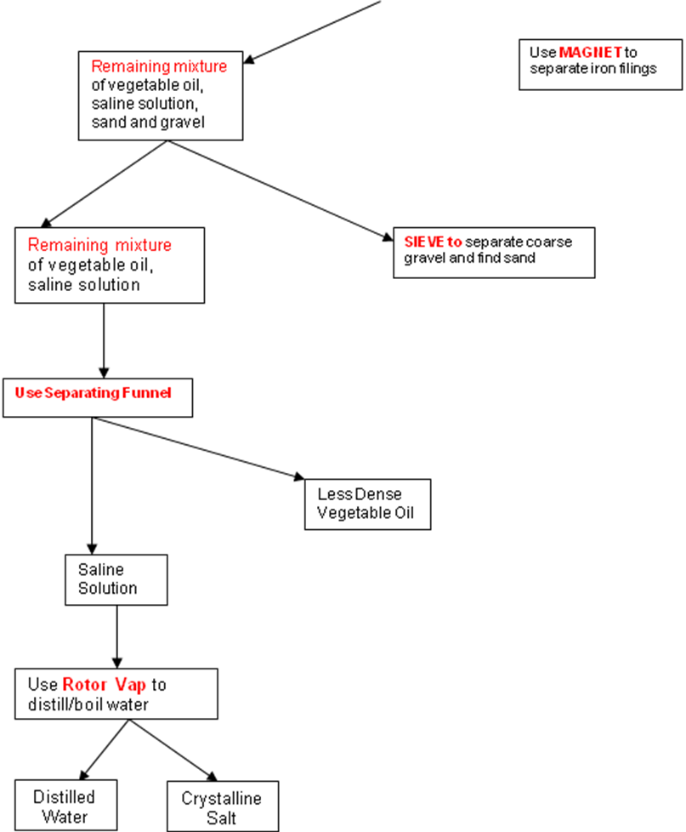
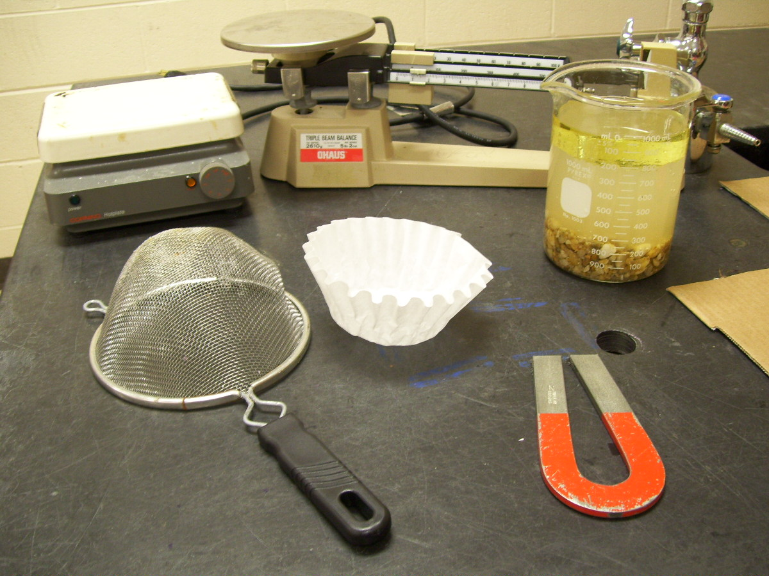

- Cost Analysis
Students are then required to construct a simple cost analysis spreadsheet to determine operational cost and profitability using the following parameters:
- Calculate Global Ground Value of Iron Filings before mixing assuming $3,000/gram
- Operational Costs
- Except for the iron filings, for every % lost recovery or added contamination of each component x $50
- For every minute spent in separation process x $75
- Profit
- Recovered Value of Iron Filings – Total Cost due to % lost recovery – Total Cost due to separation

