Geol 2
Think Like a Geologist Fieldtrip: Downtown San Jose
300912

Introduction:
This fieldtrip will give you the opportunity to learn about the different rock types and their use as building stones, facades, and ornaments. We will identify minerals, identify rocks and classify rocks as igneous, sedimentary, or metamorphic. You will learn how to differentiate between the major rock families by observing telltale characteristics of each rock type. We will connect how the properties of each rock type determine its usage as building, walkway, or ornamental material. You will also learn about flood control measures on the Guadalupe River, which has had a history of flooding downtown San Jose (as recently as in 1995). We will discuss what it means to “channel” a river and the pros and cons of doing so. We will also discuss the effects of the 1906 San Francisco Earthquake on San Jose and talk about earthquake-resistant structures.

Starting Point: Duncan Hall, campus side

Stop 1: Police Memorial, rock with plaque next to the Spartan Memorial Chapel

- What type of rock is this? igneous sedimentary metamorphic

- What are the darker blobs in the rock called? _________________________

- How did they get there?

- Would they affect the durability of this type of rock if it were used as building stone?

  - What is your evidence?

Stop 2: Black Sculpted Rocks outside the Colonnade Building near the DASH Bus stop on 4th Street near Paseo de San Antonio
- Examine the black sculpted rocks.
  - Does the rock have visible minerals? yes no
  - Is the rock intrusive or extrusive? intrusive extrusive
  - How do you know?
  - What is the name of this rock? __________________________________

Stop 3: Walkway between the original and new sections of the Fairmont Hotel

- Look at the rocks on both buildings.
  - Which building contains rock made up of clasts and which contains interlocking minerals?
Original Fairmont Hotel clasts interlocking minerals
New section of the Fairmont Hotel clasts interlocking minerals

Questions about the rocks on the original building:
(The original Fairmont Hotel building contains the Tova Day Spa.)

- There are two types of rock on the original building, but they both have the same name. What is the name of the rock on the original building? ______________________

- What type of rock is on the original Fairmont? Igneous sedimentary metamorphic
- Give a brief visual description of the following minerals:
  - Potassium feldspar:
  - Plagioclase feldspar:
  - Biotite:
  - Hornblende:
  - Quartz:

Questions about the new section of the Fairmont Hotel:
- What type of rock is on the new building? Igneous sedimentary metamorphic
- What are the clasts in the rock made of and what environment did they come from?

- What is the name of this rock? ______________________________

Stop 4: San Jose Museum of Art

- What type of rock is the museum made of? ______________________________
- Which rock from the Fairmont Hotel buildings does this rock resemble most? ___________________________
- List 3 differences between this rock and the rock on the newer Fairmont building:

- In what environment did this rock form? ________________________________________

- The steps of this building are made from diorite, an intrusive igneous rock which is much more durable than the rock that the rest of the building is constructed of. Why was diorite used for the steps, but not the rest of the building?

- This building, as well as many others in downtown San Jose, suffered major damage in the Great San Francisco Earthquake in 1906. The photo below shows the art museum (the post office, back then) after the earthquake. Draw the damaged tower as it looks today.
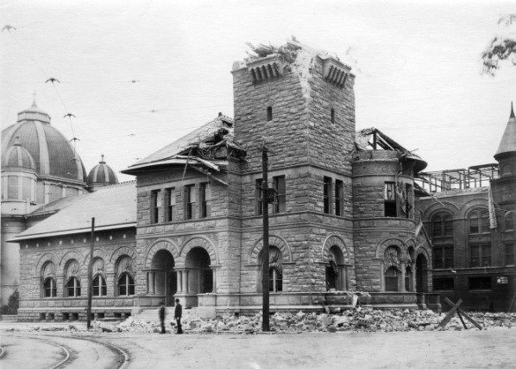

- Why was this building damaged in the earthquake, but the Cathedral Basilica of St. Joseph—right next door—not damaged?

Stop 5: McEnery Park

- Observe the size of the minerals in the rock wall. Is the rock in the wall intrusive or extrusive?
Intrusive extrusive
- Which rock at the Fairmont Hotel is similar to the rock making up the low wall along the sidewalk? (Give the name of the rock, not the building.)

- Identify the following minerals in the wall rock: feldspar and quartz (see instructor).

- Why are the minerals in the wall rock so much larger than the ones seen at the Fairmont Hotel? (What conditions cause a rock to have large minerals vs. small minerals?)

- Observe the brownish rocks created by columnar jointing.
  - Are the tall rock columns made of intrusive or extrusive igneous rock?
Intrusive extrusive

  - The true color of the rock is black, as we can observe on one of the fresh surfaces of the rock. The process that makes the outside of the column lighter in color than the inside is ______________________________.
  - What is the name of the rock that the tall columns are made of? ____________________________
  - At which previous stop did we see a rock that is the compositional equivalent of the rock of the black columns? 1 2 3 4

  - Why are parts of the columns white? (Hint: It’s not bird poop.)

Stop 6: Guadalupe River

- What type or rock are the steps down to the river made of? slate schist sandstone
- Is this rock igneous, sedimentary, or metamorphic?
igneous sedimentary metamorphic

- In this section of downtown San Jose, the Guadalupe River is channeled.

- What is the purpose of channeling a river?

- What natural elements have the engineers tried to mimic in this artificial channel?

- Draw a cross-section of the artificial stream channel:

- Why has the artificial channel been terraced?

- What is the advantage of using caged rocks instead of completely cementing in the river channel?

- Why do the cement pavers at the bottom of the channel have holes in them?

Stop 7: Adobe Systems building
The Adobe Systems building contains slabs of whitish speckled igneous rock, and dark green and black metamorphic rock.

- Place a checkmark in the appropriate box to indicate the characteristics of each type of rock see at the Adobe Systems building:

Characteristic: | Igneous: | Metamorphic:
Random mineral orientation
Minerals somewhat aligned
Shear zones
Large potassium feldspars

- Find the large potassium feldspars in the metamorphic rock. These feldspars are the centers of augens. Draw a sketch of an augen and label the feldspar.
- What is the name of this metamorphosed rock? ____________________________
- What is the protolith for this rock? granite sandstone gabbro

Stop 8 (Rolling Stop): San Jose Tech Museum
(This is called a “rolling” stop because we’re just going to talk as we walk by instead of stopping or going in.)

The Tech Museum has several informative earthquake exhibits as well as a fun earthquake simulator ride. It is well worth a visit before or during our study of earthquakes in class.

Stop 9: Duncan Hall

We have seen a variety of rock types along our fieldtrip route. To determine patterns of usage amongst the different rock families, answer the questions below.

- Which rock type was used primarily for walkways? Igneous Sedimentary Metamorphic
- Which rock type was used primarily for ornamental & decorative purposes (this includes facades)?
Igneous Sedimentary Metamorphic
- Which rock type was used for building stones? Igneous Sedimentary Metamorphic

- What characteristics make each rock type suitable or unsuitable for each of the uses above?

- What are the tiles on Duncan Hall made of? ___________________________________________

Turn in your completed fieldtrip guide!

