**Handout/Worksheet – Pair Analysis of Virtual Water Statistics**

About Virtual Water

Global virtual water trade – 67% crops, 33% livestock products, 10% industrial products

The regions with a significant net virtual water *import* are Central and South Asia, Western Europe, North Africa, and the Middle East.

**Top 3 virtual water exporting countries Top 3 virtual water importing countries**

|  |  |  |  |  |
| --- | --- | --- | --- | --- |
| COUNTRY | NET EXPORT VOLUME (109 m3) |  | COUNTRY | NET IMPORT VOLUME (109 m3) |
| USA | 758.3 |  | Sri Lanka | 428.5 |
| Canada | 272.5 |  | Japan | 297.4 |
| Thailand | 233.3 |  | Netherlands | 147.7 |

Figure 2. Annual *net* volumes of virtual water either imported or exported by the top 3 countries. Note that these values are cubic meters times 1 ***billion***. From Chapagain and Hoekstra, 2003.

*What is meant by “net” volume?*

*What are the ramifications of being an exporter of virtual water?*

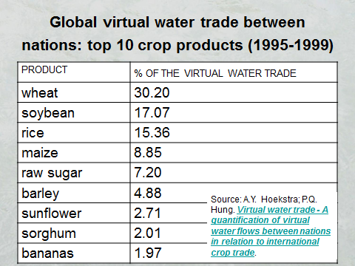

*Through which crops is most of the water flowing via trade?*

Figure 3. The top products in virtual water trade.

The next two figures provide data on the amount of water required to produce different commodities. It is quite variable!

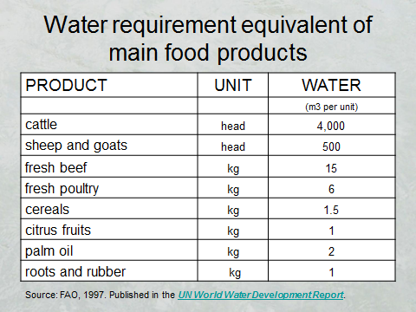

Figure 4. Comparison of the amount of water required, on average, to produce a unit of a particular commodity.



Figure 5. Global average virtual water content to produce on unit of selected commodities. From Hoekstra and Chapagain, 2007

Let’s put these values in context. It takes ~2,500 liters to fill an Olympic-sized swimming pool.

How can it take so much water to produce these items? *Where do you think it goes?*

Estimate how many cotton t-shirts you own. Multiply it by the virtual water content. *How much virtual water is residing in your dresser just for your t-shirts?*

Do the same for your leather shoes. *How many Olympic swimming pools would that virtual water fill?*

What is the **minimum** quantity of water needed for a person per day? The World Health Organization says “about 20 litres per capita per day should be assured to take care of **basic** hygiene needs and basic food hygiene,” as well as for drinking. *How many people could the virtual water of your shirts and shoes support for one day?*

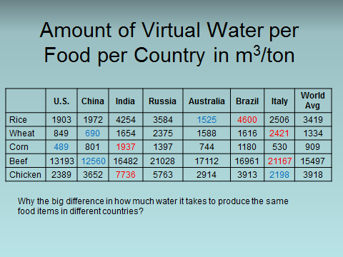

Figure 6. Geographic variability in the amount of water required to produce different food items. Data from Lenntech ([http://www.lenntech.com/water-food-agriculture.htm#ixzz3Y9dqOXkz](http://www.lenntech.com/water-food-agriculture.htm))

From [http://www.lenntech.com/water-food-agriculture.htm#ixzz3Y9dqOXkz](http://www.lenntech.com/water-food-agriculture.htm)

Review the data in Figure 6 above. *Why do you think there is so much variability in how much water it takes to produce the same food item in different regions?*

Review the following statistics.

* ~70 m3 of water for one kilogram of grain-fed beef, 4 m3 of water for one kilogram of pork
* ~40% of world’s grain production went to livestock at the turn of the century.
* Over the past few decades, consumption of meat in developing countries has grown at a rate of about 5 to 6% per year; consumption of milk and dairy products at 3 to 4%.
* The American diet requires twice as much water as diets common in Asian and European nations.

*What are the ramifications of these statistics?*

**Preparing for the Virtual Water Debate**

In small groups, prepare to make a case both in support *and* against the following statement:

***More of the world should rely on virtual water trade***

* Come up with arguments for *and* against (10 min)
* Discuss the *ramifications* of your positions (5 min)
* Find out where your group members stand on this issue (5 min)

At the beginning of the next class, groups on one side of the classroom will argue for the affirmative side of the statement while the groups on the other side of the room will argue the negative side. Only then will you learn which side of the debate you are on.