Group Analysis of Case Studies in Unsustainable Water Use in Agriculture

Part 1 - Reading Group Analysis
(Get in groups with students who have read the same article as you.)

- Take turns sharing your insights on your reading. (10 min)
- What are the primary water-resource problems discussed?
Break it down…
  - What are the competing needs?
  - How is agriculture an important part of the story?
  - What negative impacts were outlined?
  - What were the drivers of the problems?

- As a group, use the Gleick article to evaluate the sustainability of water use in the region(s) discussed in your article. (10 min)
- In what ways are the actions discussed in your reading failing to meet the criteria in the table below?
- In which of these ways are the actions discussed in your reading most failing to meet the criteria below? Prioritize them.
- In the situations you read about, do you think it is possible to meet all of the following criteria?
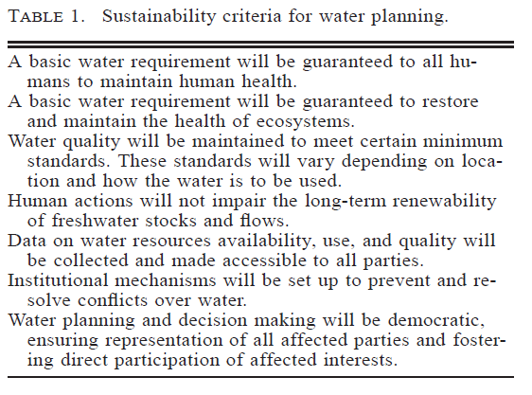
According to Gleick, sustainable water use is “the use of water that supports the ability of human society to endure and flourish into the indefinite future without undermining the integrity of the hydrological cycle or the ecological systems that depend on it.”

From Gleick, P (1998). Water in Crisis: Paths to Sustainability. Ecological Applications, 8(3): 571-579.

Part 2 – Cross-Case Study Meta-Analysis
(Get in a group that has a student to represent each of the 5 articles.)

- Have each person in the group take < 2 minutes to quickly identify the location of your region and the primary problems outlined in the article. You will get more time to share in parts B and C below. (5 min)

- Go through the following list of questions, one by one, sharing how the answers vary from article to article. Take note of the similarities and differences. (10 min)
  - What are the competing needs?
  - How is agriculture an important part of the story?
  - What negative impacts were outlined?
  - What were the drivers of the problems?
  - In what ways are the actions discussed in your reading failing to meet the Gleick’s sustainability criteria?
  - In which of these ways are the actions discussed in your reading most failing to meet the following criteria?
- What do these various case studies have in common? (10 min)
- What problems, what unsustainable actions/decisions, are cropping up again and again?
- What are the opportunities for more sustainable water use in agriculture?
- Get prepared to report out on your group’s cross-case study meta-analysis. (5 min)
  - Identify the main points you want to make as a group.
  - Nominate a spokesperson.
- REFLECT
  - Consider the activity you just completed. In what ways was it interdisciplinary?
  - What are the advantages of discussing multiple articles written by authors with varying disciplinary perspectives on water problems in different regions?
  - What are the challenges of discussing multiple articles written by authors with varying disciplinary perspectives on water problems in different regions?

