*Water, Agriculture and Sustainability Module*

Unit 2.1 > Activity 2.1b

**Pair Analysis of Virtual Water Statistics**

Activities by Robert Turner – 2016

Summary

This document provides context and guidance for Activity 2.1b – Pair Analysis of Virtual Water Statistics. Following a short list of learning objectives, there is a reading list with active URLs and prompts for an online discussion of the readings.

Context

This activity engages student learning on the concept and statistics of virtual water via a Power Point slide presentation and a worksheet with questions for students to answer. The student handout is included in this document. Using the handout, students working in pairs will analyze the virtual water quantities in several commodities and consider how that varies from region to region. This activity prepares students for a deeper understanding of the pros and cons of virtual water trade, the water impacts of our cultural demands, and geographic variability in agricultural productivity and water efficiency.

Learning Goals

Participation in Activity 2.1b is designed to help students advance in achievement of the following module learning goals:

1. Students will be able to explain how variability in water availability and current water use and management practices threaten ecological integrity, human health, security, and agricultural production.
2. Students will be able to explain what goes into the calculation of virtual water amounts and water footprints and the application of these concepts.

Participation in Activity 2.1b will also help students advance in achievement of the following unit specific learning objectives:

Upon completion of the unit, students should be able to:

* 1. Explain the concept of virtual water and how the amounts of water embedded in commodities varies by commodity and region of production.
  2. Evaluate the pros and cons of virtual water trade.
  3. Demonstrate improved ability to analyze and evaluate complex quantitative information.
  4. Demonstrate facility in working with student partners in equitable and inclusive collaboration.

Activity 2.1b Instructions for Instructors – (Activity takes place in the class)

Activity 2.1b consists of two parts that together should take about 60 minutes of class time. The first part (~40 minutes) consists of progressing through PowerPoint presentation while students also answer questions on a worksheet. The second part consists of breaking up students into small groups and having them prepare for the Virtual Water debate to take place on the following class period (Activity 2.1c).

On the class day of Activity 2.1b you should:

1. Open up the PowerPoint presentation for Activity 2.1b.
2. Distribute the Activity 2.1b handout/worksheet – Pair Analysis of Virtual Water Statistics – to the students.
3. When you get to slide 4, point out to your students the questions in italics in the handout/worksheet. Have the students identify a partner to work with in answering the questions throughout the handout/worksheet, then ask them to answer the first two questions.
4. Walk through the rest of the presentation and handout/worksheet with your students, pausing when you get to questions so student pairs have the time to answer them. Ask for student answers as you go along.
5. After you have gotten through the Virtual Water worksheet and slides (ending with the case study on virtual water transfers within China), ask students to get into groups of 4, then orient them to the Virtual Water Debate that will take place during the next class.
6. Have the students in groups work on the Preparing for the Virtual Water Debate prompts at the end of the handout/worksheet until the end of the class period (or hour).

**Handout/Worksheet – Pair Analysis of Virtual Water Statistics**

About Virtual Water

Global virtual water trade – 67% crops, 33% livestock products, 10% industrial products

The regions with a significant net virtual water *import* are Central and South Asia, Western Europe, North Africa, and the Middle East

**Top 3 virtual water exporting countries Top 3 virtual water importing countries**

|  |  |  |  |  |
| --- | --- | --- | --- | --- |
| COUNTRY | NET EXPORT VOLUME (109 m3) |  | COUNTRY | NET IMPORT VOLUME (109 m3) |
| USA | 758.3 |  | Sri Lanka | 428.5 |
| Canada | 272.5 |  | Japan | 297.4 |
| Thailand | 233.3 |  | Netherlands | 147.7 |

Figure 2. Annual *net* volumes of virtual water either imported or exported by the top 3 countries. Note that these values are cubic meters times 1 ***billion***. From Chapagain and Hoekstra, 2003.

*What is meant by “net” volume?*

*What are the ramifications of being an exporter of virtual water?*

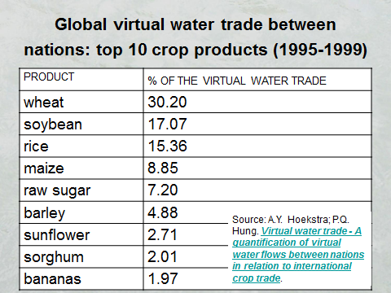

*Through which crops is most of the water flowing via trade?*

Figure 3. The top products in virtual water trade.

The next two figures provide data on the amount of water required to produce different commodities. It is quite variable!

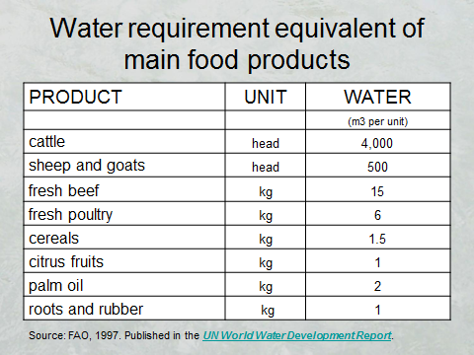

Figure 4. Comparison of the amount of water required, on average, to produce a unit of a particular commodity.



Figure 5. Global average virtual water content to produce on unit of selected commodities. From Hoekstra and Chapagain, 2007

Let’s put these values in context. It takes ~2,500 liters to fill an Olympic-sized swimming pool.

How can it take so much water to produce these items? *Where do you think it goes?*

Estimate how many cotton t-shirts you own. Multiply it by the virtual water content. *How much virtual water is residing in your dresser just for your t-shirts?*

Do the same for your leather shoes. *How many Olympic swimming pools would that virtual water fill?*

What is the **minimum** quantity of water needed for a person per day? The World Health Organization says “about 20 litres per capita per day should be assured to take care of **basic** hygiene needs and basic food hygiene,” as well as for drinking. *How many people could the virtual water of your shirts and shoes support for one day?*

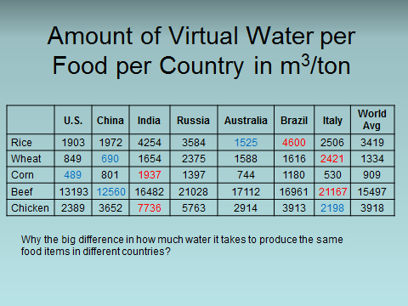

Figure 6. Geographic variability in the amount of water required to produce different food items. Data from Lenntech ([http://www.lenntech.com/water-food-agriculture.htm#ixzz3Y9dqOXkz](http://www.lenntech.com/water-food-agriculture.htm))

From [http://www.lenntech.com/water-food-agriculture.htm#ixzz3Y9dqOXkz](http://www.lenntech.com/water-food-agriculture.htm)

Review the data in Figure 6 above. *Why do you think there is so much variability in how much water it takes to produce the same food item in different regions?*

Review the following statistics.

* ~70 m3 of water for one kilogram of grain-fed beef, 4 m3 of water for one kilogram of pork
* ~40% of world’s grain production went to livestock at the turn of the century.
* Over the past few decades, consumption of meat in developing countries has grown at a rate of about 5 to 6% per year; consumption of milk and dairy products at 3 to 4%.
* The American diet requires twice as much water as diets common in Asian and European nations.

*What are the ramifications of these statistics?*

**Preparing for the Virtual Water Debate**

In small groups, prepare to make a case both in support *and* against the following statement:

***More of the world should rely on virtual water trade***

* Come up with arguments for *and* against (10 min)
* Discuss the *ramifications* of your positions (5 min)
* Find out where your group members stand on this issue (5 min)

At the beginning of the next class, groups on one side of the classroom will argue for the affirmative side of the statement while the groups on the other side of the room will argue the negative side. Only then will you learn which side of the debate you are on.