Water, Sustainability and Agriculture Module
Unit 1 > Activity 1.2b
Evaluate Definitions of Sustainability and Sustainable Development
Activity by Robert Turner – 2016

Summary

This document provides context, guidance, and worksheets for the Activity 1.2b – Group Work: Evaluate Definitions of Sustainability and Sustainable Development.

Context
This activity is designed to enhance the critical thinking and negotiation skills of the students and deepen their understanding of the concepts of sustainability and sustainable development. In addition, it underscores how these concepts are value-laden and thus contestable. Inviting students to evaluate definitions and challenging them to come up with their own is empowering and may help some students progress beyond dualistic thinking.

Learning Goals
Participation in Activity 1.2b should help students advance in achievement of the following learning objectives:
- Discuss how pursuing different sustainable development ideals can affect our future with regard to water resources.
- Demonstrate improved ability to compare, synthesize, and assess multiple perspectives.
- Demonstrate facility in working with student partners in equitable and inclusive collaboration.

Activity 1.2b Instructions for Instructors – (60 minutes in class)

A. In advance of the class, print out the following handout (Definitions of Sustainability and Sustainable Development on pages 3-7) for every student in class.

B. At the beginning of class, break the students into small groups (4-5 students).

C. Ask each student to take a minute to write down their own definition of sustainability.

D. While they are writing their definition, distribute the handout.

E. Then ask the students to do the following:
- Review the various definitions of sustainability and sustainable development; (8 min)
- Circle the definitions that you favor most; (1 min)
- Consider what they have in common; (2 min)
- Discuss your favorites with the other students in your group; (10 min)
- Identify the elements of the definitions that you collectively support the most; (5 min)
- Try to come to consensus on a favored definition, either one on the handout or one of your own making; (10 min)
- Take note of your disagreements, particularly if you are having difficulty in coming to consensus;
- Be prepared to share your group definition and what you like about it. Be prepared to share why you think you have disagreements. Identify a spokesperson; (2 min)
- Reflect on how your understanding of sustainability has evolved as a consequence of the course readings and this activity.

Circulate throughout the room during this activity to encourage participation and answer questions. Provide 40 minutes for the activity.

C. When all groups are ready, have a representative of each group write their definition on the whiteboard. (5 minutes)

D. Query groups as to how they came to their definitions and where they had any difficulty or disagreements. (5 minutes)

E. Have an open class discussion, challenging students to identify the important shared elements among the various definitions. Highlight these fundamental aspects of sustainability and/or sustainable development on the whiteboard. (10 minutes)

F. If you have additional time, you can provide a lecture on Sustainability and Sustainable Development using the PowerPoint presentation available for download. The last page of the student handout goes with the presentation.

Evaluate Definitions of Sustainability and Sustainable Development

Activity Guidance
- Review the various definitions of sustainability and sustainable development; (8 min)
- Circle the definitions that you favor most; (1 min)
- Consider what they have in common; (2 min)
- Discuss your favorites with the other students in your group; (10 min)
- Identify the elements of the definitions that you collectively support the most; (5 min)
- Try to come to consensus on a favored definition, either one on the handout or one of your own making; (10 min)
- Take note of your disagreements, particularly if you are having difficulty in coming to consensus;
- Be prepared to share your group definition and what you like about it. Be prepared to share why you think you have disagreements. Identify a spokesperson; (2 min)
- Reflect on how your understanding of sustainability has evolved as a consequence of the course readings and this activity.

Definitions of Sustainability and Sustainable Development

Brundtland Report (World Commission on Environment & Development)  Sustainable development is development that meets the needs of the present without compromising the ability of future generations to meet their own needs. |  | Jerry Sturmer  Sustainability is meeting the needs of all humans, being able to do so on a finite planet for generations to come while ensuring some degree of openness and flexibility to adapt to changing circumstances.
 | James Coomer  A sustainable society is one that lives within the self-perpetuating limits of its environment. That society is not a "no growth" society - it is, rather a society that recognizes the limits of growth and looks for alternative ways of growing. |  | Thomas Jefferson Sustainability Council  Sustainability may be described as our responsibility to proceed in a way that will sustain life that will allow our children, grandchildren, and great grandchildren to live comfortably in a friendly, clean, and healthy world.
Sustainable Seattle  Sustainability is a new way of thinking about an age-old concern: ensuring that our children and grandchildren inherit a tomorrow that is at least as good as today, preferably better. We want to make sure that the way we live our lives is sustainable - that it can continue and keep improving for a long, long time. |  | Robert Gilman  Sustainability is equity over time. As a value, it refers to giving equal weight in your decisions to the future as well as the present. You might think of it as extending the Golden Rule through time, so that you do unto future generations (as well as to your present fellow beings) as you would have them do unto you.
 | James McNeil  Growth based on forms and processes of development that do not undermine the integrity of the environment on which they depend. |  | David Schaller  Achieving the ecological balance which allows economic prosperity and social equity to be achieved across generations.
Robert Gilman  Sustainability refers to the ability of a society, ecosystem, or any such ongoing system to continue functioning into the indefinite future without being forced into decline through exhaustion. . . of key resources. |  | Paul Hawken  Sustainability is an economic state where the demands placed upon the environment by people and commerce can be met without reducing the capacity of the environment to provide for future generations.
Caring for the Earth  Development that provides real improvements in the quality of human life and at the same time conserves the vitality and diversity of the Earth. |  | Donella Meadows  A sustainable society is one that is far-seeing enough, flexible enough, and wise enough not to undermine either its physical or its social systems of support.
 | Sustainable Sonoma County  Sustainability secures people's quality of life within the means of nature in a way that is fair and equitable to all humanity, other species and to future generations. Sustainability recognizes the inter-relatedness of the economy, society, and environment. It requires that we not consume resources faster than they can be renewed nor produce wastes faster than they can be absorbed. |  | Thomas Jefferson  Then I say the Earth belongs to each...generation during its course, fully and in its own right. The second generation receives it clear of the debts and encumbrances, the third of the second, and so on. For if the first could charge it with a debt, then the earth would belong to the dead and not to the living generation. Then, no generation can contract debts greater than may be paid during the course of its own existence.
Mike Nickerson  Activities are sustainable when they:  1. use materials in continuing cycles;  2. use continuously reliable sources of energy; and  3. come mainly from the potentials of being human, i.e., communication, creativity, coordination, appreciation, and spiritual and intellectual development. |  | Theodore Roosevelt  The "greatest good for the greatest number" applies to the [number of] people within the womb of time, compared to which those now alive form but an insignificant fraction. Our duty to the whole, including the unborn generations, bids us to restrain an unprincipled present-day minority from wasting the heritage of these unborn generations."
 | Jamie Cloud  Sustainability is a dynamic condition which requires a basic understanding of the interconnections and interdependency among ecological, economic and social systems. Sustainability means providing a rich quality of life for all and accomplishing this within the means of nature. |  | David Orr  The overall challenge of sustainability is to avoid crossing irreversible thresholds that damage the life systems of Earth while creating long-term economic, political, and moral arrangements that secure the wellbeing of present and future generations.
Juan Carlos Wandemberg  Sustainable development is a socio-ecological process characterized by the fulfillment of human needs while maintaining the quality of the natural environment indefinitely. |  | Elliot Rosenberg  Sustainable development refers to a positive rate of change in the quality of life (i.e. well being) of people based on a system which permits this positive rate of change to be maintained for an indefinite period of time.
 | President's Council on Sustainable Development  Sustainable development is economic growth that will benefit present and future generations without detrimentally affecting the resources or biological systems of the planet.  A sustainable United States will have a growing economy that provides equitable opportunities for satisfying livelihoods and a safe, healthy, high quality of life for current and future generations. Our nation will protect its environment, its natural resource base, and the functions and viability of natural systems on which all life depends. |  | Debra Dadd-Redalia  Sustainable means being able to keep going or able to endure; sustainability, then, is acting in such a way that life on Earth endures on into the future, providing for the needs of all citizens and creatures while maintaining the natural functions, resources, and beauty of the planet...Sustainability is rooted in looking to the inherent workings of nature as a model, with the idea that the natural systems of the world do work in balance to perpetuate life, and by working in harmony with those natural systems, we can sustain our own lives.
Hamilton Wentworth Regional Council  Sustainable development is positive change which does not undermine the environmental or social systems on which we depend. It requires a coordinated approach to planning and policy-making that involves public participation. Its success depends on widespread understanding of the critical relationship between people and their environment and the will to make necessary changes. |  | Center for Sustainable Communities  Sustainability is part of a trend to...consider the whole instead of the specific. Sustainability emphasizes relationships rather than pieces in isolation.... Sustainability is not all about regressing to primitive living conditions. It is about understanding our situation, and developing as communities in ways that are equitable, and make sense ecologically and economically.
 | Interfaith Center on Corporate Responsibility Sustainable development...[is] the process of building equitable, productive, and participatory structures to increase the economic empowerment of communities and their surrounding regions.

Adapted from a similar document formerly found on the Sustainability website of the Washington State Department of Ecology.

Life Quality

Equity

Biodiversity

Human Survival

Four Dimensions of Sustainability. Prough and Assadourian, 2003. World Watch Magazine, 16(5).

Sustainable water use:
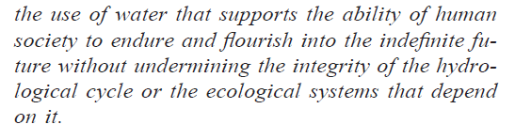

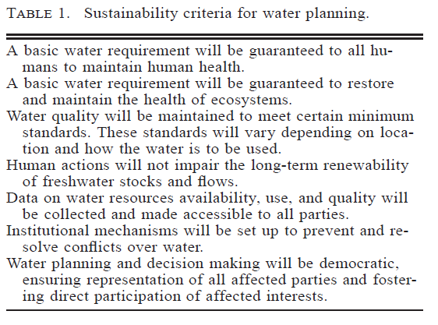
- Do you agree with all of these criteria?
- How do they reflect your understanding of sustainability?
- Anything missing?
From Gleick, P (1998). Water in Crisis: Paths to Sustainability. Ecological Applications, 8(3).

