Earth 111: Module 4 Formative Assessment 2

Instructions

Use the map below to answer questions 1.1 – 1.5.

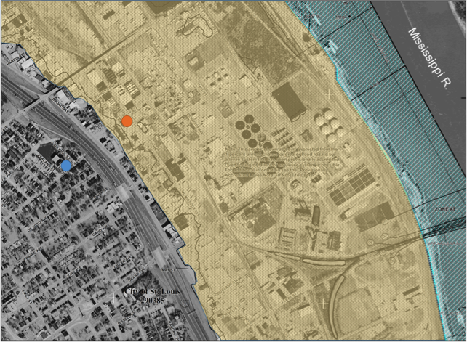
Flood risk map for a section of the city of St. Louis, Missouri
Google Earth

Questions
- The map above is a flood risk map for a section of the city of St. Louis, Missouri. The Mississippi river is in the top right corner, the area in blue shading is the designated floodway, and the area in yellow is the estimated flood area for the 100-year flood (although it is protected from the 100-year flood by a levee system). You are a flood insurance salesman selling insurance to the houses marked by the blue and orange dots.
  - Which house (blue or orange) would you charge higher rates to for flood insurance? Why?

  - The owners of the blue house do not want to buy flood insurance, because they are not within the 100-year flood risk zone. Do you agree with the homeowners or would you suggest they purchase flood insurance? Explain your reasoning.

  - The 1993 flood discussed above exceeded the 100-year flood at many locations on the Mississippi River. Knowing this, the owners of the orange house argue that they do not need insurance, because the 100-year flood occurred recently. Do you agree with the homeowners or would you suggest they purchase flood insurance? Explain your reasoning.

  - The owners of the orange house also argue that they do not need flood insurance, because the levee system eliminates the risk of flooding. What would you say to the homeowners to convince them that flood insurance is a good investment?

  - The owners of the blue house are real-estate developers and do not understand why valuable riverfront property is set aside as a floodway. Explain whether you as an insurance salesman would agree on housing development in the floodway (think in terms of economic benefit and risk). Also explain why the homeowners should value the floodway, especially given the location of their house.

- Flood risk maps are available throughout the U.S. Visit the FEMA Flood Map Service Center website (https://msc.fema.gov/portal/) and lookup the flood risk map for your community. To do this, type in your address into the search bar and click "Search". Click "View Map" icon to see a paper copy of the flood map, then click on the "Interactive Map" icon to be directed to a web-based Geographic Information System (GIS) map that contains digitized flood maps for the US. You can then explore the interactive map for your community and around the country. Use the flood map of your community to answer the following questions.
  - Is there a potential flood risk for your community?

  - Is there a floodway established for any rivers that run through your community?

  - Are there any houses or structures within a flood risk zone in your community?

