Earth 111 Module 4 Formative Assessment

Instructions

Grading and Rubric
Each answer will earn a maximum of 25 points, as described in the rubric below.
Work Shown | Possible Points
Provides a well-reasoned response to the question posed | 10
Uses correct grammar, spelling, and sentence structure | 5
ncludes one or more references to specific materials in Module or assigned reading | 5
Appropriate length (100-150 words) | 5

Questions
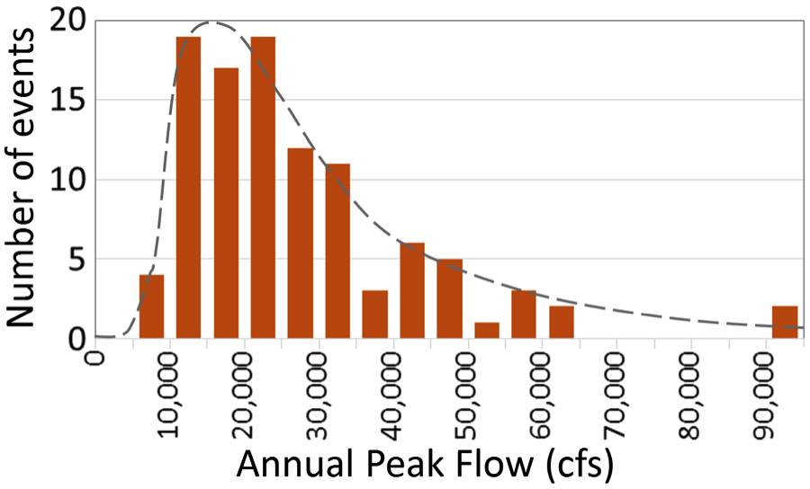
Figure 4. Orange bars show the histogram of the annual peak flows shown in Figure 3 for the Lehigh River. Grey dashed line is a theoretical distribution (a probability density function, or PDF) approximating the complete distribution represented by the histogram of historical data. The PDF can be used to make predictions of flood frequency.
Data from US Geological Survey
- Determine which of the following should be considered forecasts versus predictions:
  - The peak flow of the Mississippi River in St. Louis, MO next year
  - Weather in Charleston, SC tomorrow
  - Mean global temperature in 2100
- Why do you think flood magnitude histograms (and associated probability density functions) like Figure 4 above are typically right skewed (i.e., have a long tail to the right side of the plot, as opposed to a bell curve which has the mean, median and mode in the middle and symmetrical tails on each side)? What does this say about how these systems function?

Submitting your Answers
Bring your written answers to class.

