Earth 111 Module 3 Formative Assessment 1

Instructions

Read the questions below fully and follow the instructions

Grading and Rubric
Scoring and Rubric
Each answer will earn a maximum of 5 points, as described in the rubrics below.
Rubric for Questions 1, 3, and 4
Work Shown | Possible Points
Diagram is accurate / correct | 2
Symbols, labels, and/or legend are effective | 2
Conveys information requested in question | 1

Rubric for Questions 2 and 5
Work Shown | Possible Points
Answer reflects careful consideration of the question | 2
Answer is appropriate in length | 1
Answer is legible | 1
Answer given in complete sentences, correct spelling and grammar | 1

Questions
- You live in a watershed…or more likely multiple watersheds that are nested within one another. Find your location on Google Earth or a similar mapping program and determine which watersheds you live in. If a drop of rain hits your front yard, which stream would it flow into? Where does it go from there? For the purpose of this exercise, ignore the (likely) possibility that it goes into a storm sewer and waste water treatment plant before being discharged into a local stream or river. Use the ‘terrain’ view of Google Earth to delineate the watershed upstream from the location where your raindrop would enter the nearest stream, following the highest topography that drains to your stream, similar to the dashed lines in Figure 1. Submit a screen-shot of your watershed map.
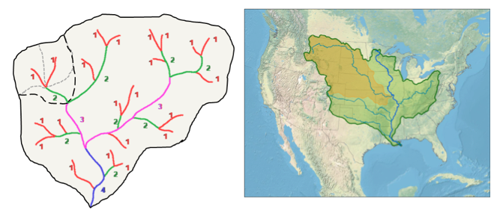
Figure 1

- Take a look at the cartoon watershed drawn below. What is the stream order at the mouth/outlet of the watershed? Draw arrows on the watershed cartoon to illustrate each of the fluxes shown in Figure 1, above.
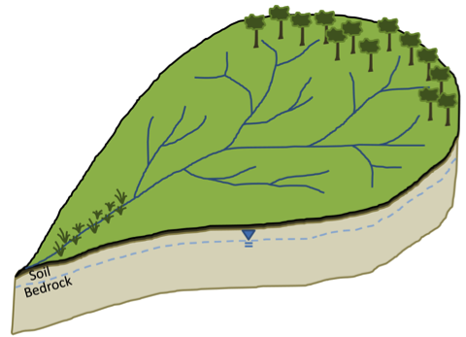
Figure 2

- If the width of the arrows in Figure 2 above were scaled to the percentage of flow following each pathway (i.e., pathways conveying more water get thicker arrows), which arrows would be thickest (i.e., which pathways are dominant) for a densely forested watershed in Pennsylvania or western Washington state? How might you redraw the thickness of the arrows in that figure following a clear-cut for timber harvest or urban development?

- The confluence of the Missouri and Mississippi rivers is just north of St. Louis, Missouri. From Figure 1 above you can see that the Missouri River is much longer and has a much larger drainage area than the Mississippi River upstream from that point. So why do you think the official ‘headwaters’ of the Mississippi River is in northern Minnesota, rather than western Montana (i.e., the headwaters of the Missouri River)? Hint: Think back to concepts of the distribution of water discussed in module 2.

Submitting Your Assessment
Bring your written answers with you to class.

