Learning Goal: stimulate critical thinking to define “water sustainability in cities”

Directions:
- Review the attached sustainability-related definitions and graphics.
- In less than 2 minutes, write a definition of “water sustainability in cities”.
- Consensus process:
  - Pair with another student, review two definitions and choose one to modify and represent your team.
  - Pair again (now in teams of four) and review two definitions and choose one to modify and represent your team.
  - Repeat until one definition is selected to represent the class

Your Definition:

Final Class Definition:

Notes/Scratch:

What is “sustainability”?

Directions: Review definitions and graphics. (a) Individually craft a definition of “Water Sustainability in Cities” in a written form (graphics may also be included). Be concise, yet sufficiently detailed to give direction toward actionable planning, design, and operation guidance. Think broadly at the systems level. (b) Share definition with one neighbor and create a unified definition. (c) Provide one example of how your team definition could be used to guide a water infrastructure plan or design to be more sustainable. Be prepared to report back to the class in 10 minutes.

Sample Definitions:

Sustainability: capacity to endure.

Sustainability is an ideal end-state. Like democracy, it is a lofty goal whose perfect realization eludes us. For this reason, there will always be competing definitions of sustainability. We know these definitions will always include the well-being of people, nature, our economy, and our social institutions, working together effectively over the long term. Alan AtKisson, The Compass of Sustainability, 1998

Sustainable development is development that meets the needs of the present without compromising the ability of future generations to meet their own needs. World Commission on Environment and Development. Our Common Future. (Frequently referred to as the Brundtland report after Gro Harlem Brundtland, Chair of the Commission)

Sustainable communities foster commitment to place, promote vitality, build resilience to stress, act as stewards, and forge connections beyond the community. Northwest Policy Institute (University of Washington Graduate School of Public Affairs, Seattle, Washington USA)

Sustainable development is a process which enables all people to realize their potential and improve their quality of life in ways which protect and enhance Earth’s life-support systems. Jonanthan Porritt, Forum for the Future.

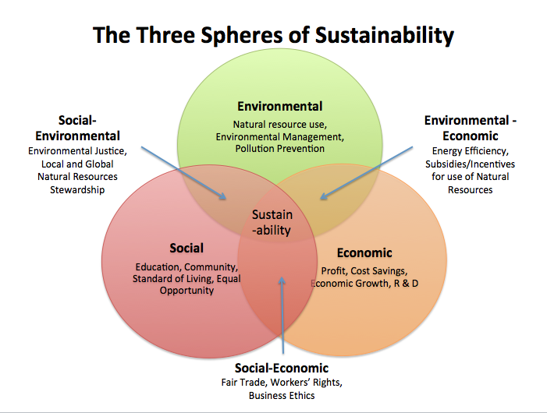
Sample Graphics:
