Watch the video Evapotranspiration and Landscape Plant Water Needs (http://youtu.be/bYIQz7XkMTA) (17:27) about evapotranspiration and answer the following questions using the attached maps. Be prepared to discuss your answers in class.

Part 1 – Evaporation and Evapotranspiration
- Find the urban areas of Phoenix, AZ, Atlanta, GA and Chicago, IL, on the maps below. Discuss the relationship between solar radiation (Figure 1) and lake evaporation (Figure 2) at these locations. Then, consider actual evapotranspiration (Figure 3) and precipitation (Figure 4). In which areas would you expect to need to provide irrigation water for landscape plants? Are there any other climatic variables that may play a role in rates of evaporation and ET at these urban locations?

  - Phoenix, AZ

  - Atlanta, GA

  - Chicago, IL

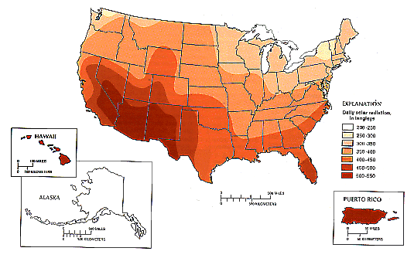
200-250
250-300
300-350
350-400
400-450
450-500
500-550
Mean Daily Solar Radiation (langleys)
Figure 1. Mean daily solar radiation in the United States and Puerto Rico.
(Source: Data from the U.S. Department of Commerce, 1968). From Hanson 1991.

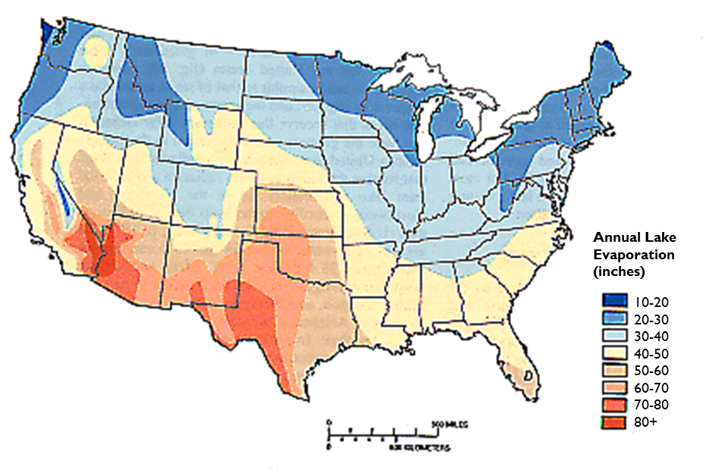
Figure 2. Mean annual lake evaporation in the conterminous United States, 1946-55.
(Source: Data from U.S. Department of Commerce, 1968). From Hanson 1991.

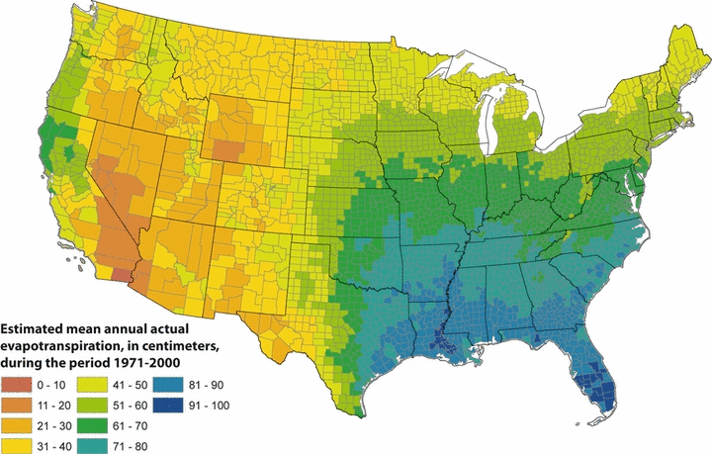
Figure 3 - Map of Estimated Mean Annual Actual Evapotranspiration (ET) for the Conterminous U.S. for the Period 1971-2000.
Estimates are based on the regression equation of ET⁄P in Table 1 that includes land cover multiplied by the mean annual precipitation from the PRISM climate data for the same period. Calculations of ET were made ﬁrst at the 800-m resolution of the PRISM climate data. The mean values for the counties (shown) were then calculated by averaging the 800-m values within each county. From Sanford and Selnick, 2012. Used with permission.
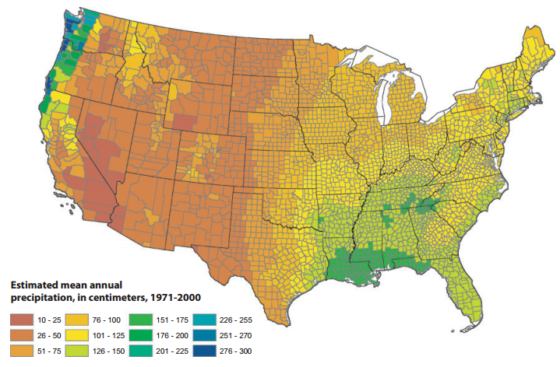
Figure 4. Estimated Mean Annual Precipitation, for the Period 1971 to 2000.
Data compiled from PRISM Climate Group, Oregon State University (Daly et al., 2008), http://www.prism.oregonstate.edu, accessed July 2009. From Sanford and Selnick 2012. Used with permission.

Part 2 – Reference ET and Irrigation needs
Reference or potential evapotranspiration, ET_{O}, is measured with an instrument called an atmometer or ET gauge. Watch this video about how an ET gauge works: http://youtu.be/bXH1cFb0bbU. The data you will work with below were collected with an ET gauge just like the one shown in this video.
Evapotranspiration, ET, is a measure of the amount of water that a plant uses. If precipitation, P, is insufficient to meet the ET needs of the plant, then supplemental irrigation is necessary. So, the amount of irrigation needed is = ET-P. We usually measure ET and P in inches or centimeters of water. We can also measure irrigation in inches.
If ET exceeds precipitation, we express that as being in “water deficit.” If precipitation exceeds ET, then we have a “water surplus.”
Consider the graphs below (Figures 5-7), which show reference ET and precipitation over a growing season at three different locations in the United States with very different climates: Phoenix, Arizona; Atlanta, Georgia; and Chicago, Illinois. Remember reference ET is the amount of ET that a standard plot of grass would evaporate if it were provided with as much water as it needed. Daily ET is indicted by the red columns, and daily precipitation is indicated by blue columns. Accumulated water deficit is indicated as red shading and indicates times during the growing season when accumulated ET is greater than the accumulated precipitation. Time periods of water surplus are indicated with blue shading and occur when the accumulated precipitation exceeds the accumulated ET.
- Which location would require additional irrigation water? _____________________________________
On September 1, how much additional water should have been applied to keep up with the evapotranspiration?

Roughly how many inches per day were evaporating during the month of June?

- Which location received adequate water to grow turf grass for the entire season shown? ______________________
Would any irrigation be necessary at this location? Why or why not?

Roughly what was the average daily ET rate (in/day) during the month of June?

- Which location would require irrigation at certain times, but not at others? ____________________________
During which time periods would irrigation be necessary?

About how much irrigation (in) should be applied during the months of July and August at this location?
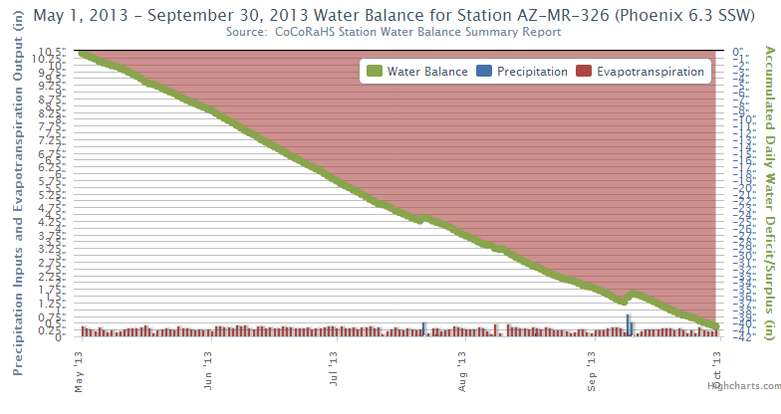
Figure 5 – Water balance graph for Phoenix, AZ, May 1 – September 30, 2013. (from CoCoRahs.org)

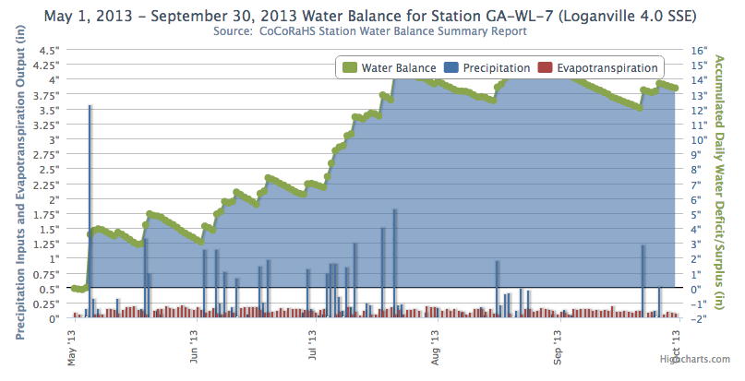
Figure 6 - Water balance graph for Loganville, GA, which is just outside of Atlanta, GA, May 1 – September 30, 2013. (from CoCoRahs.org)
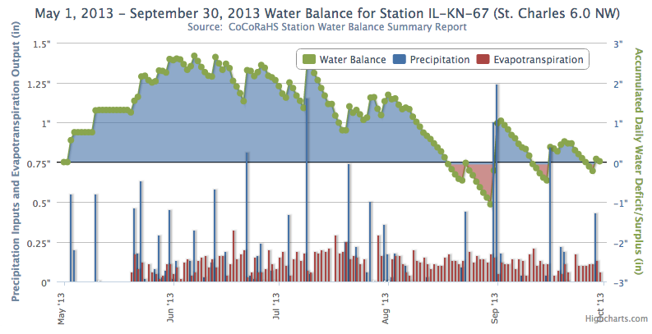
Figure 7 - Water balance graph for St. Charles, IL, which is outside of Chicago, IL, May 1 – September 30, 2013. (from CoCoRahs.org)

References
Hanson, R.L., 1991, Evapotranspiration and Droughts, in Paulson, R.W., Chase, E.B., Roberts, R.S., and Moody, D.W., Compilers, National Water Summary 1988-89—Hydrologic Events and Floods and Droughts: U.S. Geological Survey Water-Supply Paper 2375, p. 99-104. http://geochange.er.usgs.gov/sw/changes/natural/et/
Sanford, Ward E. and David L. Selnick, 2012. Estimation of Evapotranspiration Across the Conterminous United States Using a Regression with Climate and Land-Cover Data. Journal of the American Water Resources Association (JAWRA) 1-14. DOI: 10.1111/jawr.12010

