Table 1. Summary of figures and scientific data related to Marine Reserves.

Figure or Graph | Summarize Scientific Finding | Describe why Marine Reserves are beneficial to a species or ecosystem
Group 1 - Biomass
Figure 1 | Relative Change in Kelp; 13x increase inside reserve, 4x increase outside reserve | Kelp provides habitat for thousands of species, marine reserves provide for more kelp.
Figure 2

Group 2 - Fish Length and Number of Young
Figure 3

Figure 4

Group 3 - Density and Abundance

Figure 5

Figure 6

Figure 7

Group 4 - Home Range and Distance Traveled
Figure 8

Figure 9

Group 1 - Biomass – Figures 1,2

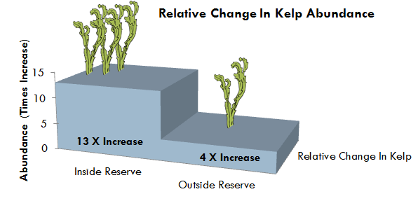
Figure 1. Chart showing the relative amounts of kelp (biomass) inside and outside marine protected areas. Infographic Created by Michelle Kinzel, 2015.

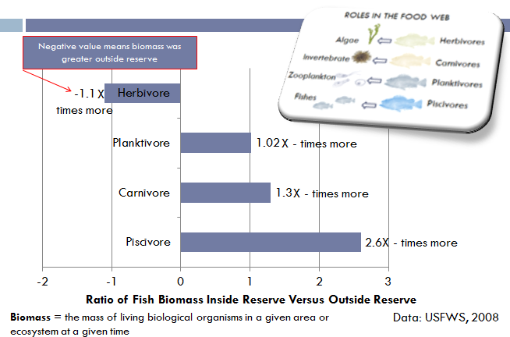
Figure 2. Relative measures of biomass of fish inside and outside marine reserves. All types of fish, piscivores, carnivores, planktivores and herbivores had higher biomass measurements inside reserves than outside. Thus, the number of fish species in marine reserves is greater than other areas. Reserves protect a more natural food web structure, including greater numbers of predatory fish and lobster, than fished areas. Infographic Created by Michelle Kinzel, 2015.
Group 2 - Length and Number Young – Figures 3,4

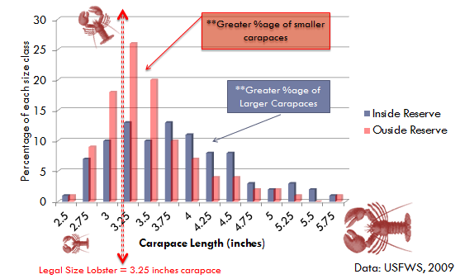
Figure 3. Chart displaying length of lobsters inside and outside a marine reserve. The data show that the age structure inside a marine reserve displays older, larger individuals, which are capable of producing more offspring per spawning event. These older, larger animals contribute to a larger population that grows faster than one with a larger proportion of smaller individuals (shown in red bars). Infographic Created by Michelle Kinzel, 2015.

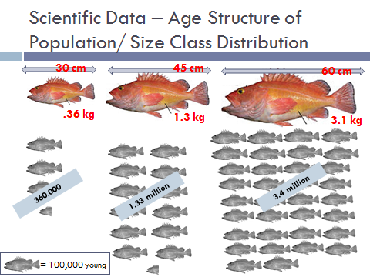
Figure 4. Data collected on gray snappers show that older, larger individuals produce more numbers of young. Bortone & Williams. 1986. US Fish and Wildlife Service Biological Report. Graphic Image Produced by Michelle Kinzel, 2015.

Group 3 - Density and Abundance – Figures 5, 6 and 7

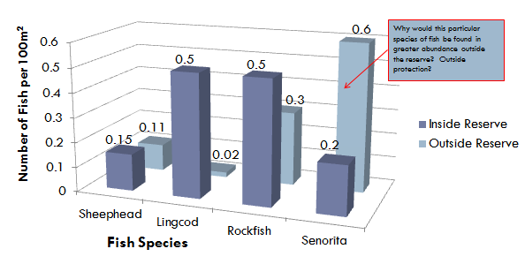
Figure 5. Comparisons of fish densities inside and outside marine reserves for 4 different fish species.
Scientists are using the data to help understand how marine reserves affect fish abundance. Preliminary results suggest that most fish species in the surveys have increased since the reserves were established. Infographic Created by Michelle Kinzel, 2015.

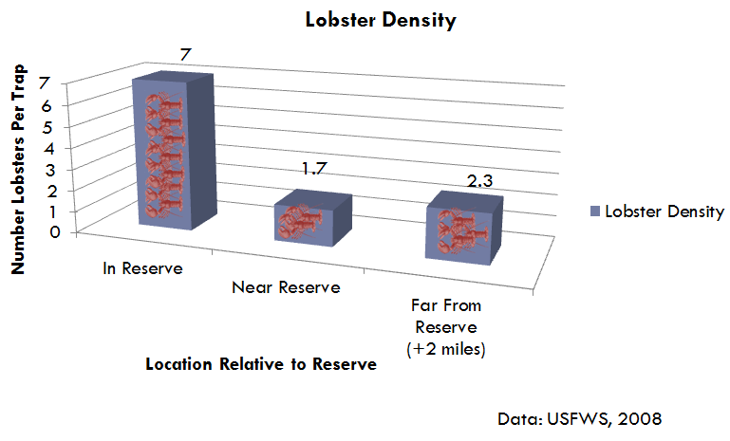
Figure 6. Relative numbers of lobsters in traps located in, near and far away from marine reserves. Traps inside reserves consistently had equal or higher yields than traps outside reserves, indicating a higher population density inside marine reserves. Infographic Created by Michelle Kinzel, 2015.
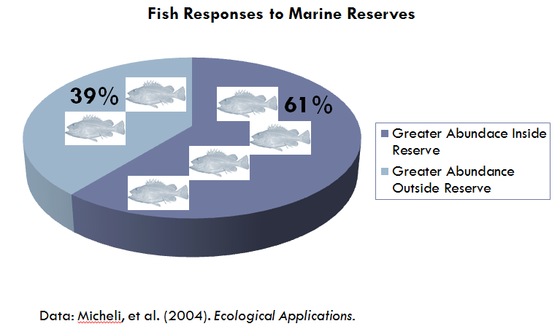
Figure 7. Marine reserves support increasing abundance, or total numbers of individuals of fish species worldwide. Infographic Created by Michelle Kinzel, 2015.

Group 4 - Home Range and Distance Traveled – Figures 8, 9

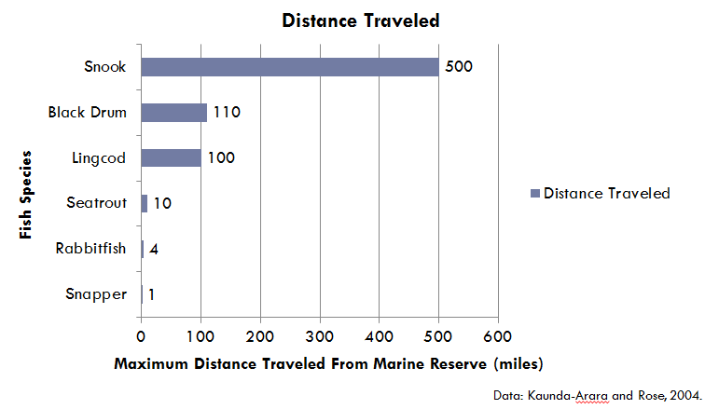
Figure 8. Marine reserves have impacts that reach beyond their borders, as fish grow and mature and travel away from the reserve (a phenomenon known as dispersal). Infographic Created by Michelle Kinzel, 2015.

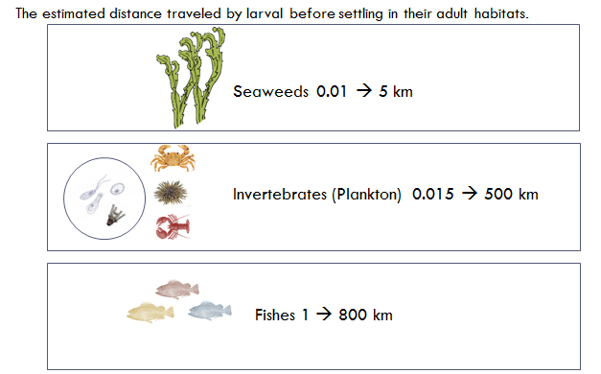
Figure 9. Home ranges of animals should include habitat for all aspects of the life cycle, including breeding requirements and larval dispersal. Infographic Created by Michelle Kinzel, 2015.
End Group Figures for Homework - Jigsaw Activity

