Oceans In Protection: Marine Protected Areas

Part 1) Interpret and summarize scientific charts and graphs. This step should be completed before class as homework.
Step 1) Read the following background information.

Marine Reserves are critical tools for marine conservation, allowing for the protection of important oceanic resources. The oceans make Earth habitable, providing support in terms of oxygen, regulation of carbon dioxide, and driving weather and climate patterns. Ocean fisheries provide the majority of the world’s protein needs, and humans and the oceans are inextricably linked. All of the world’s spheres, atmosphere, hydrosphere, geosphere, cryosphere, biosphere and anthroposhpere are inextricably linked to one another. Changes or impacts in one sphere have the potential to affect the other spheres. A healthy ocean is necessary for a healthy Earth. Marine Reserves foster the conservation and protection of vital resources that we all depend upon.

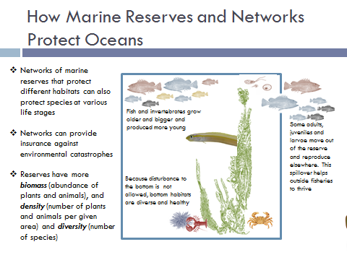Figure 1. Summary of how Marine Reserves work and function in ocean sustainability. Partnership for Interdisciplinary Studies of Oceans. 2000. University of Maryland Center for Environmental Science. Infographic Created by Michelle Kinzel, 2015.
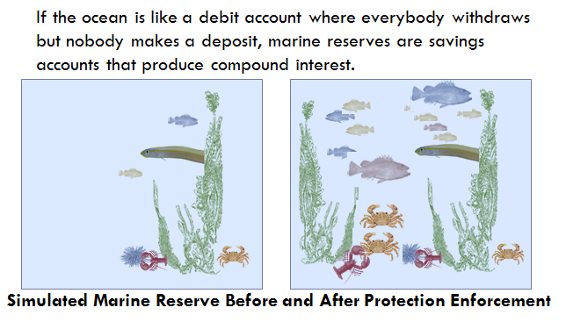
Figure 2. Analogy between marine reserves and savings accounts, describes how reserves affect ocean habitats. Infographic, Michelle Kinzel 2015. 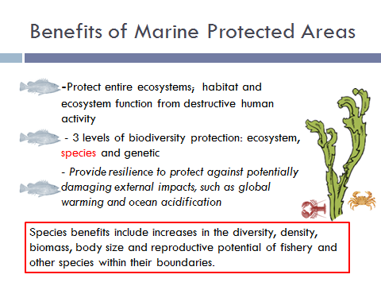 Figure 3. Summary of Marine Reserve benefits in sustaining oceans. Infographic, Michelle Kinzel 2015.

Question: (Quick Write) Provide an answer in 3-4 sentences to the following:
Given what you have just read about Marine Reserves and learned in previous units in this module, why do you think anyone would seek to create Marine Reserves?

Step 2) Divide into groups of 4, with each student assigned a number 1 through 4. In the NEXT step, these groups will break up to join with the jigsaw groups; students with the same number assigned and compare their interpretations of figures from the homework according to the following assignments:
Group 1 – Biomass = Figures 1,2
Group 2 – Fish Length and Number of Young = Figures 3,4
Group 3 – Density and Abundance = Figures 5,6 and 7
Group 4 - Home Range and Distance Traveled = Figures 8,9
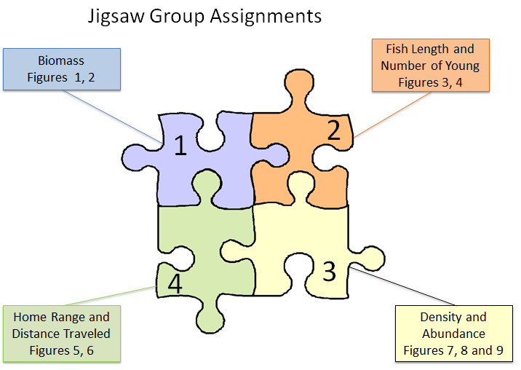
Schematic 1. Diagram representing Jigsaw group breakout assignments according to Figure numbers.

Step 3) Students regroup to form groups of all the same number (all Number 1’s at one table, all Number 2’s at another table, etc.). Form small subgroups within this group of 4 people and compare results from the homework table which summarizes the scientific findings of the charts and graphs provided for your assignment. The task in this step is to discuss with other member the figures assigned to you and compare your findings and summaries from completing Table 1 as homework. After this stage, the student will become the expert on that section of figures, and will return to the original group to report and summarize findings in the next step.

Step 4) Return to the original group with each student having a number 1-4 assigned. Students report one at a time until all 4 students have shared their expertise. Each student summarizes the main points of what they learned in their subgroups about the Figures, concentrating on these talking points -
  - What type of scientific data did you examine and what was the finding? For example, Figure 1 (homework) displayed abundance of kelp inside and outside a reserve.
  - What is the main advantage of having a marine reserve?

Part 2) Synthesize the analysis you have performed and work as a team to select a geographic location for a marine reserve.

This step is a complex one requiring a lot of information and discussion. Please read through all of Part 2 before beginning the tasks for Part 2.

Step 1. Read through all of the steps here (#1-#6) before marking your map!

Step 2. Select a target species.
All species have specific habitat requirements; use the ‘Habitat Requirements for Marine Organisms’ (Table 2) when considering the minimum size of the reserve. Circle where your species falls in ‘Species Type’ in the Table below.
Table 2. Requirements for Habitat of Marine Organisms.

Species Type | Habitat Requirements | Prey Requirements | Minimum Home Range** | Other considerations
Piscivore (Fish) | Open ocean or kelp beds | Small, schooling fish | 10 km² | High demand commercially
Carnivore (Fish) | Rocky habitats | Invertebrates (shallow water) | 1 km²
Planktivore (Fish) | Open Ocean | Plankton, upper 10m of ocean waters | 10 - 100 km² | High demand commercially
Herbivore (Fish) | Kelp Beds | Kelp Beds, 10m or shallower water near coastlines | 1 km² | High demand commercially
Invertebrate  (Urchins, Lobsters, Crabs) | Rocks, sandy bottom or kelp for habitat | Zooplankton | 10s of meters² | High demand commercially
Zooplankton | Sunlight, upper 10 m ocean water | Phytoplankton, sunlit ocean waters | Global
Kelp Beds (Algae) | Sunlight, rocky bottom, 30 m depth or shallower along coastline | No prey | 1- 10 Km ² | Habitat supports hundreds of other species
Minimum Home Range** This estimate is given in factors of 10m to help in the size choice for Marine Protected Reserves. Ideally, an animal or plant must have a protected area equal to or greater than its home range for affective protection. In the real world, constraints from political and social pressures will limit the size of reserves, and students should be conservative in proposing realistic areas to set aside for protection.
Effective reserves included habitats that support the life history of focal species (e.g. home ranges, nursery grounds, migration corridors and spawning aggregations), and were located to accommodate movement patterns among them.

List the main factors necessary for your target species
1.
2.
3.

Step 3. Select a total area for your reserve.

Limit the total area of your marine reserve to a maximum of100 km² for initial proposals. Use the 10km scale bar and the polygons approximating 100 km² drawn on the map to estimate the size and shape of your marine reserve.

Tips on Shapes –
- Oval or square maximize amount of shoreline.
- If organism needs deep water, larval near shore next stage offshore, pick rectangle

Area for your reserve ________________________
Best Shape for this Total Area ____________________

Step 4. Decide on the best geographic location. Consider near shore vs. offshore, populated areas and other factors.

Helpful Information #1) The map data displays the existing Marine Sanctuary Boundary, and fishing and recreational activities are allowed within the Sanctuary. You do not have to propose your marine reserve within the sanctuary, but will have a better chance of gaining voter and political approval inside these areas that are already recognized for their conservation importance. When proposing a Marine Reserve, consideration of areas with human activities, such as boating, diving, swimming and fishing should be considered. The most popular fishing spots are noted with the fish icon as seen in the map legend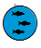. Voters may not approve of a marine reserve that eliminate recreational opportunities in most popular fishing spots, and your chances of acceptance may be higher in areas near or adjacent to these recreational hot spots.

Helpful Information #2) The existing kelp beds are shown with a polygon according to the legend in the map. Kelp can grow in waters up to 100m deep, and thrive best in shallow waters less than 30m deep. For your reference, a 30 m bathymetry line has been drawn around the islands and along the coastline. You can consider the area between this line and all shorelines as 30m or less.

Notes on factors you want to include ________________________________________________

Step 5. Consider all the factors in Steps 1-4 above and sketch out your Marine Reserve on the map image provided at the end of this lesson. Draw your reserve with a thick boundary line in the location you select.

Step 6. Justify and support your decision using scientific facts and information.

For your reserve, provide a minimum of 3 supporting facts or justifications for selecting that location. These facts must come from the Figures 1-11 and/or Table 2 provided in this lesson, and you must cite which source you are referencing with that justification. These justifications are facts that you can find in the charts, diagrams or habitat summaries provided to you.

Examples for a proposed location, with references cited could include;
- The site is in a location with existing kelp beds (Map Template)
- The site is placed in shallow water, less than 30 m, which is ideal for kelp bed growth (Table 2).
- Studies have shown that numbers of lobsters (population density) increase inside marine reserves (Figure 9).

Example for a Proposed Location

Site Chosen represented on map on next page with this symbol
Step 2) Species = Lobster, Invertebrate
1. Larval Travel = 0.15 to 500 km (Figure 12)
2. Lobsters need zooplankton
3. Lobsters need kelp for habitat

Step 3) Area selected for reserve = 100km²

Step 4) Near coastline, near kelp beds, not including existing fishing spot
      - The site is in a location with existing kelp beds (Map Template)
      - The site is placed in shallow water, less than 30 m, which is ideal for kelp bed growth (Table 2), and includes up to 10 km offshore for larval travel (Figure 12).
      - Studies have shown that numbers of lobsters (population density)
increase inside marine reserves (Figure 9).

Sample Proposed Location for Marine Reserve
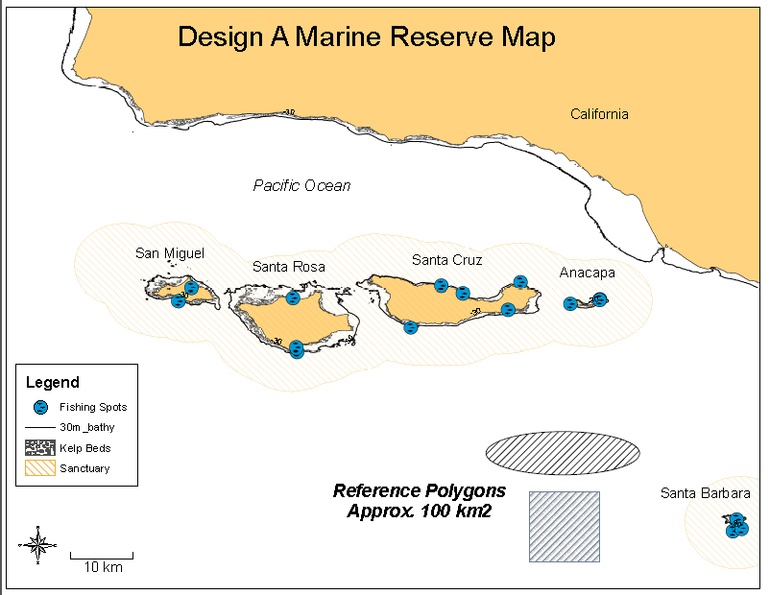

Marine Reserve Map Directions: Use the above information and the provided map template to design your own Marine Reserve. The map contains detailed information on the Channel Islands National Marine Sanctuary, off the coast of California. Refer to the map legend and consider the information on fishing spots, bathymetry, kelp beds and sanctuary boundaries in the design of your marine reserve.

Step 7. Read this 3 paragraph summary on the political and social aspects (policy) of establishing a Marine Reserve from a report on the Channel Islands by the California Department of Fish and Game. Answer the questions at the end of the summary.

In 1998, a group of concerned recreational anglers urged the State of California to provide greater protection for marine resources at the Channel Islands. Recognizing an increase in human impacts, government agencies and a public working group came to consensus that one important strategy was to establish marine protected areas (MPAs) that prohibit or restrict taking of marine life. At the same time, the California State Legislature passed the Marine Life Protection Act, requiring the Department of Fish and Game to improve the state’s MPAs to protect habitats and preserve ecosystem integrity. In 2003, based on public input, scientific guidance, and socioeconomic considerations, the State of California designated 10 marine reserves (red dashed lines) and 2 marine conservation areas (blue dashed lines) in state waters within the sanctuary. In 2006 and 2007, the originally proposed network of protected areas was completed in federal waters by the National Oceanic and Atmospheric Administration (NOAA) to create a total of 11 marine reserves (red) and 2 marine conservation areas (blue) in Figure 4.
A marine protected area (MPA) is an area of the ocean where human activities such as fishing are limited or restricted in order to protect or conserve marine life or habitats. A marine reserve is a type of MPA that prohibits all extractive uses. Marine reserves do not allow any human activity that alters habitats or removes animals, plants, or seaweeds, except as needed for scientific monitoring and research. A marine conservation area is a less restrictive type of MPA. Commercial and/or recreational fishing may be allowed in these areas with restrictions that provide some protection for animals, plants, and habitats.
Conducting long-term monitoring, outreach, and enforcement is important for effective management of MPAs. Monitoring reveals changes that occur inside and outside MPAs. The Channel Islands Marine Protected Area Monitoring Plan was released in 2004 and incorporates recommendations from scientists, recreational and commercial fishermen, conservationists, government agencies, and the public. The monitoring plan is designed to detect changes in biology, economic factors, and people’s activities in areas that are within, nearby, and distant from the MPAs. During the last several years, scientists from many different institutions, organizations, and agencies have conducted surveys of the marine habitats, animals, and plants of the Channel Islands using scuba, traps, remotely operated vehicles, submersibles, and other tools. To keep track of human activities, scientists interviewed fishermen, analyzed fishery logbooks and landings, and conducted aerial surveys of vessels.
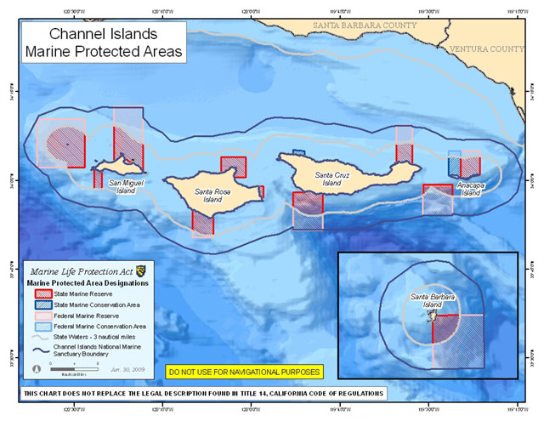
Figure 4. Map showing Marine Reserves and Conservation Areas in the Channel Islands, California. California Department of Fish and Game, Partnership for Interdisciplinary Studies of Coastal Oceans, Channel Islands National Marine Sanctuary, and Channel Islands National Park. 2008. Channel Islands Marine Protected Areas: First 5 Years of Monitoring: 2003–2008. Airamé, S. and J. Ugoretz (Eds.). 20 pp. www.dfg.ca.gov/marine

Question: Imagine that you are a politician running for office in Southern California. You are speaking to your constituents about conserving local ocean areas and want to support the proposal of a Marine Reserve in coastal waters. List 5 talking points you would use to convince voters that the Marine Reserve to support your idea. Be sure to include at least one idea that would appeal to fishermen, one idea that would appeal to consumers of seafood and one idea that would appeal to recreational users.
1.
2.
3.
4.
5.

