Marine Mammals as Ecosystem Sentinels
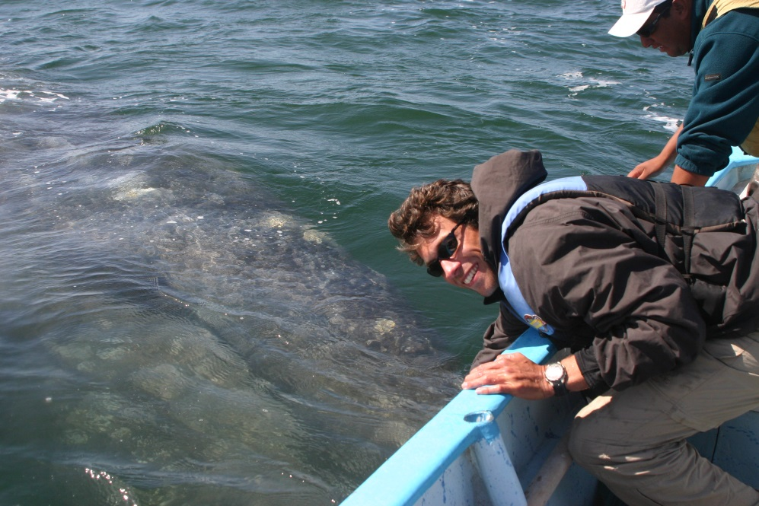
Scientists who study climate change consider various factors and environmental variables in order to assess the nature and degree of changes correlated with a changing climate. Physical geographers and chemical oceanographers study changes in ocean temperatures, increasing amounts of carbon dioxide in seawater, rising sea levels and other physical parameters when assessing climate change.
Figure 1. Gray whale approaches fishing panga to interact with humans. Image: San Ignacio Lagoon, Baja California, 2006, Michelle Kinzel.

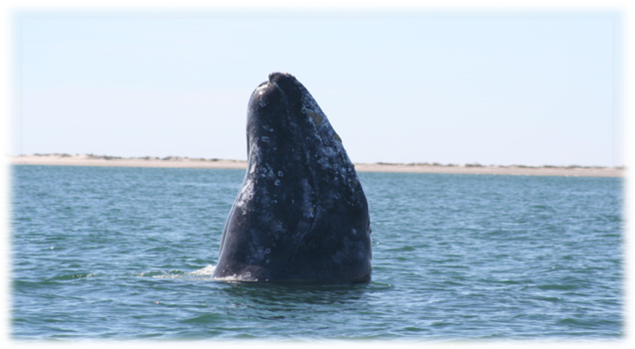
Biologists and ecologists examine the behavior patterns and responses of organisms and search for possible linkages or correlations to climate change parameters. For each of the six examples below, you are to identify the evidence provided for each study, as well as determine the interpretation offered that explains how the evidence is related to potential climate change. The evidence is presented as examples of changes in the distribution or behavior of gray whales, and the interpretation is a hypothesis or possible explanation of how these observed changes relate to climate change. The gray whale is thus considered to be a major indicator of environmental changes in the ecosystem and can be labeled as an ecosystem sentinel. Scientists search for linkages between gray whale behaviors and climate change variables in ocean systems.
Figure 2. Gray whale spyhopping to view surrounding area. Image: Michelle Kinzel, 2006.
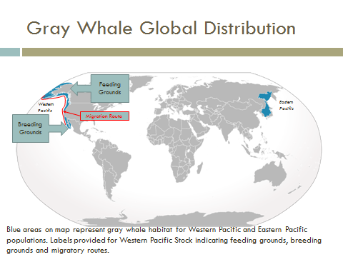
Figure 3. Gray whale global distribution, showing higher latitude feeding grounds and lower latitude breeding grounds along the Pacific Coast of North America. Image Credit: "Cypron-Range Eschrichtius robustus" by Own work. Licensed under CC BY-SA 3.0 via Wikimedia Commons.
For each of the four studies you are provided, you need to identify the example of change in distribution or behavior of the gray whales. These changes represent the facts or observations. Then use the information provided with that example to determine the scientific interpretation related to the whales’ change, noting how the observations or facts could be attributed changes in the atmosphere, biosphere, and hydrosphere.
Scientific Study 1) Between 1967 and 1999, scientists monitoring the migratory movements of whales at two locations along the Pacific Coast of North America, Granite Canyon and Point Vicente, observed a 6–8 day delay in the southbound migration of the gray whale population. The overall median sighting date shifted from Jan. 8 before 1980 to Jan. 15 after 1980. This shift in migration coincides with the North Pacific “regime shift” that occurred in the 1970s. A regime shift is described as a “major reorganization of biota in the Pacific Northwest” and is directly related to the Pacific Decadal Oscillation. The water temperature itself does not influence the whales, but due to feedback loops in the system, the changes in the hydrosphere are affecting the prey availability and delaying the journey south for many whales in the population.
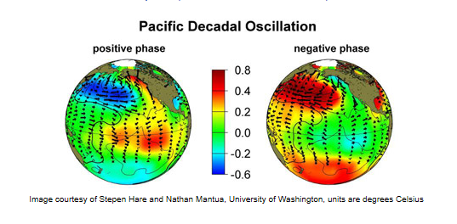
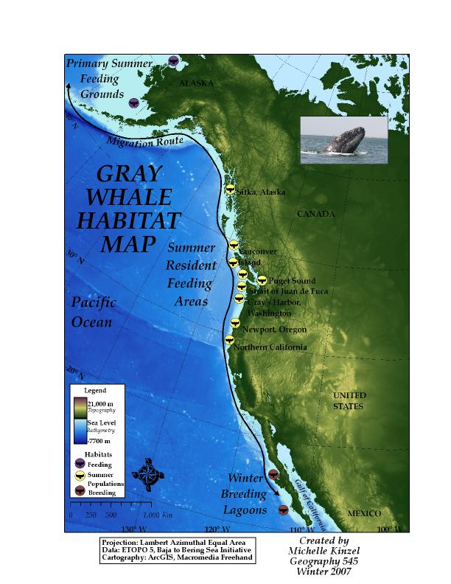
Figure 4. The Pacific Decadal Oscillation (PDO) is a long-term ocean fluctuation of the Pacific Ocean with cool and warm phases oscillated every 20–30 years. Image: Creative Commons Permission, https://sealevel.jpl.nasa.gov/science/elninopdo/pdo/

Scientific Study 2) Gray whales exhibited responses in behavior to the extremes of warm El Nino and cooler La Nina oceanic conditions in their southern range. In the breeding grounds, there was a decline in the presence of mother-calf pairs by half and a delay in peak occupancy following the warm El Nino of 1997–1998 in San Ignacio Lagoon, Baja California. This alteration of behavior was related to the change in prey availability for pregnant gray whales during the El Nino year. With reduced amounts of prey available caused by the warmer El Nino waters, the female gray whales produced fewer calves and took longer to reach the birthing lagoons (delay in peak occupancy). This increase in temperature and increase in prey creates a response in the gray whales, an example of a positive feedback loop.
Figure 5. Gray whale migratory route along the Pacific Coast of North America. Map Created by Michelle Kinzel, 2007.
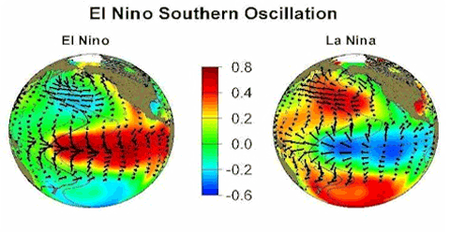
Figure 6. El Nino is a disruption of the ocean-atmosphere system which causes ocean temperatures to increase by a few degrees. Image Credit: JPL, http://www.jpl.nasa.gov/imagepolicy/, Creative Commons Licensed.
Scientific Study 3) In 1999 and 2000, gray whales were recorded feeding year-round in waters offshore of Kodiak Island, Alaska. During this time, increasing numbers of whales were found feeding in areas traditionally considered migrating grounds, a response to lack of prey in the higher latitudes that resulted from the El Nino. This lack of traditional prey items, benthic invertebrates, caused the gray whales to shift their primary prey and their main feeding locations. Because of changes in the biosphere, the gray whales were found in non-traditional feeding areas.
Scientific Study 4) The most surprising and last example of evidence of a shift in the gray whales’ behavior came from recordings of whale calls in the Beaufort Sea, located north of Alaska, in the winter of 2003–2004. Sea ice conditions as noted from analysis of satellite imagery found ice cracks large enough to provide breathing holes for gray whales during winter conditions. This provided evidence that the gray whales could potentially overwinter in Arctic conditions, as they were responding to the reduction in sea ice. The change in the hydrosphere, or reduction in sea ice, elicited a direct behavioral response in the gray whales’ behavior.
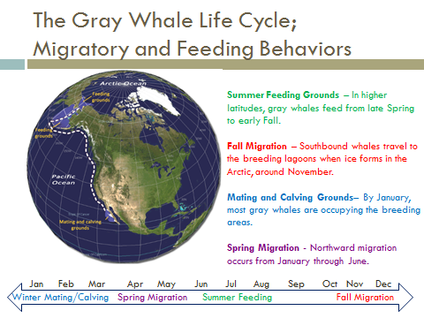
Figure 7. Life cycle of gray whale and migratory movements represented in map format and in a timeline. Image by Michelle Kinzel, 2015.
All scientific studies cited from the following journal article:
Moore, S. E. 2008. “Marine Mammals As Ecosystem Sentinels.” Journal of Marine Mammalogy. 89(3) 534-540.
Marine Mammals as Ecosystem Sentinels — Pre-Activity Worksheets
1) Read the summary article “Gray Whales As Ecosystem Sentinels” by Michelle Kinzel, 2015.
2) Complete the following chart based on the information provided in the article you read for Step 1. For homework, you only need to complete all sections of this chart.
Tips for completing the chart:
- Scientific Study: Summarize the information for each station number by providing a short title-like name for the scientific study.

- Examples might include “Feeding in July,” “Calf Production,” etc.

- Observation/Facts: Read the article and list anything that can be categorized as an observation or fact. Look for examples with data references, summaries of things seen or recorded and examples of scientific evidence.
- See Example below related to Climate Change
- Interpretation of Observation: These are often referred to as a hypothesis and offer an explanation for the observations and facts. These are also factual, but cover a bigger picture summary or overarching description of the information presented. Key words that indicate a statement is an interpretation could include “coincided with,” “attributed to,” “related to,” etc.
- See Example below related to Climate Change
- Life Cycle Most Affected: Determine from the summary provided which life cycle is affected, migration, feeding or breeding/calving.
Example of Scientific Study, Observations and Interpretation. Use this example to understand how to identify observations, facts and interpret them.
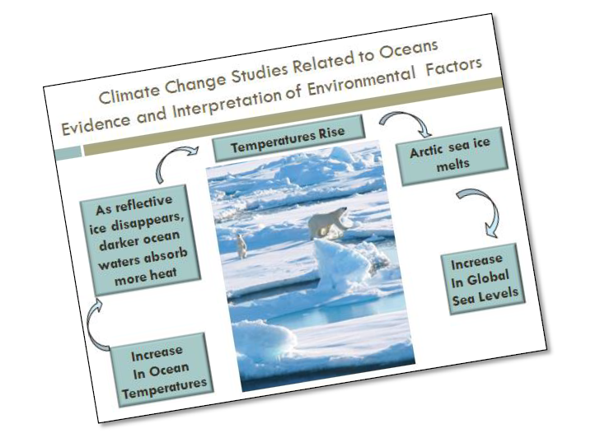
Figure 7. Climate change study examples showing effects on ecosystems and species.

Scientific Study: Climate Change in Oceans Affecting Polar Bears
Facts: 1) Ocean temperatures have increased.
2) Reflective ice disappears, and darker waters absorb more heat.
3) Arctic sea ice melts as temperatures rise in hydrosphere and atmosphere.
4) ewer polar bear cubs are surviving.
Interpretation of Observation: The reduced polar bear cub survival is attributed to food shortages caused by reduction in habitat from melting sea ice. This is an example of a negative feedback loop.
Question: How do changes in the physical environment affect the biology (reproductive success) of polar bears in the Arctic?

Table 1. Complete this table based on information from the article.
Scientific Study/Station  Number | Observation/Facts | Interpretation of Observation/Causal Factors  (Scientific reason related to climate change) | Life Cycle Most Affected; Feeding, Migration or Breeding
1

2

Scientific Study/Station  Number | Observation/Facts | Interpretation of Observation/Causal Factors  (Scientific reason related to climate change) | Life Cycle of Gray Whale Most Affected; Feeding, Migration or Breeding
3

4

Question: What physical (hydrospheric or atmospheric)/environmental and biological factors affect gray whales?

Question: How do these factors affect the behavior of the gray whale? Are these direct or indirect influences?

3) Label the following map with scientific study numbers. Use the article “Marine Mammals As Ecosystems Sentinels” to determine which geographic location correlates with which scientific study, 1–4. Place the number of the scientific study on the map in the text box of the correct geographic location.

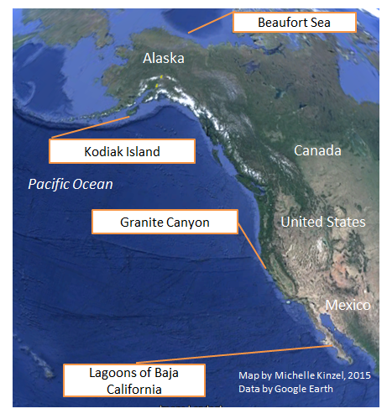
Figure 8. Range of eastern North Pacific gray whales, depicting coastal study sites from wintering/breeding areas offshore of Mexico, summering/feeding areas extending from the Pacific Northwest to Alaska. Map Image Created by Michelle Kinzel, Google Earth, 2015.

