Iron Fertilization Experiment NAME_________________________

Background: The iron fertilization hypothesis relies on the principles of the biological carbon pump where increased nutrients (i.e. iron) lead to higher algal productivity and export of carbon to deeper, colder water below the thermocline. The exported carbon is remineralized at depths and eventually transported back to the surface (over ~100s of years) as dissolved carbon (DC) and nutrients which then become again available to primary producers. This diagram illustrates changes in the magnitude of carbon flux (white arrows) at a control site (A) compared to an iron fertilization experimental site (B).

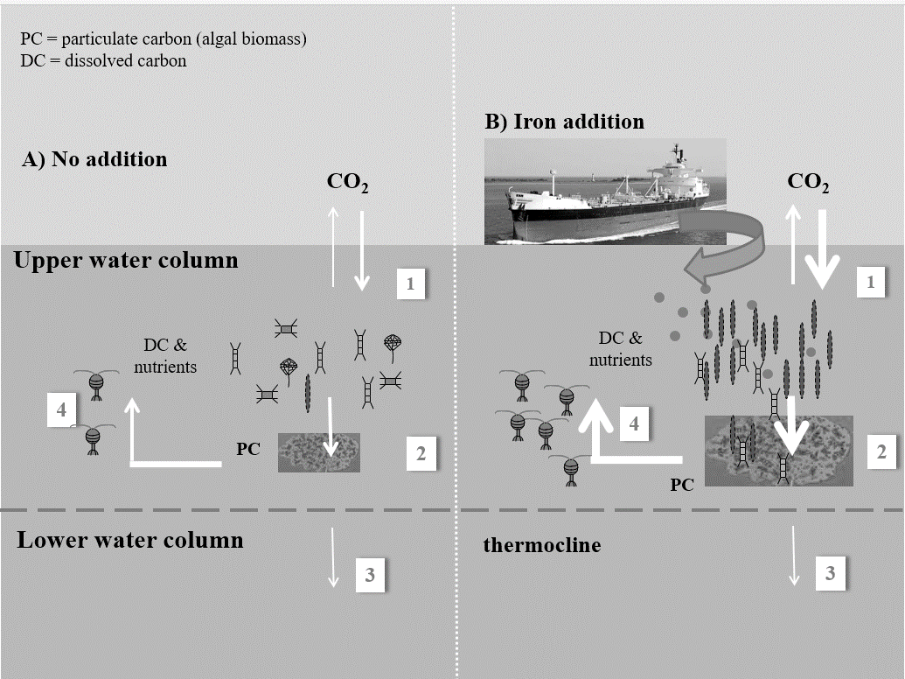

- Assign the processes to the correct number
Remineralization of algal biomass via zooplankton grazing and bacterial decomposition ____________
Carbon being fixed as algal biomass (Particulate Carbon = PC) ___________
Sinking of PC to depth ____________
Carbon exchange with atmosphere ____________

2. Examine relative changes in the magnitude of carbon flux, indicated by the thickness of the white arrows, within parts of the water column between the control (A) and experimental (B) site. Briefly describe where in the water column most of the carbon is recycled and what the major changes (if any) are in carbon flux in response to the iron addition. Compare all processes (i.e., all 4 major fluxes indicated by the white arrows).

3. Was this iron fertilization experiment successful? Was iron fertilization efficient in leading to carbon drawdown from surface to deep water? Describe the evidence that supports your conclusion.

4. How do the algal communities compare at sites A and B in regard to overall abundance and algal diversity? How did algal diversity change due to iron addition and how does that affect marine food webs?

