**Review of examples on how temperature and carbon concentration may interact and affect organisms**

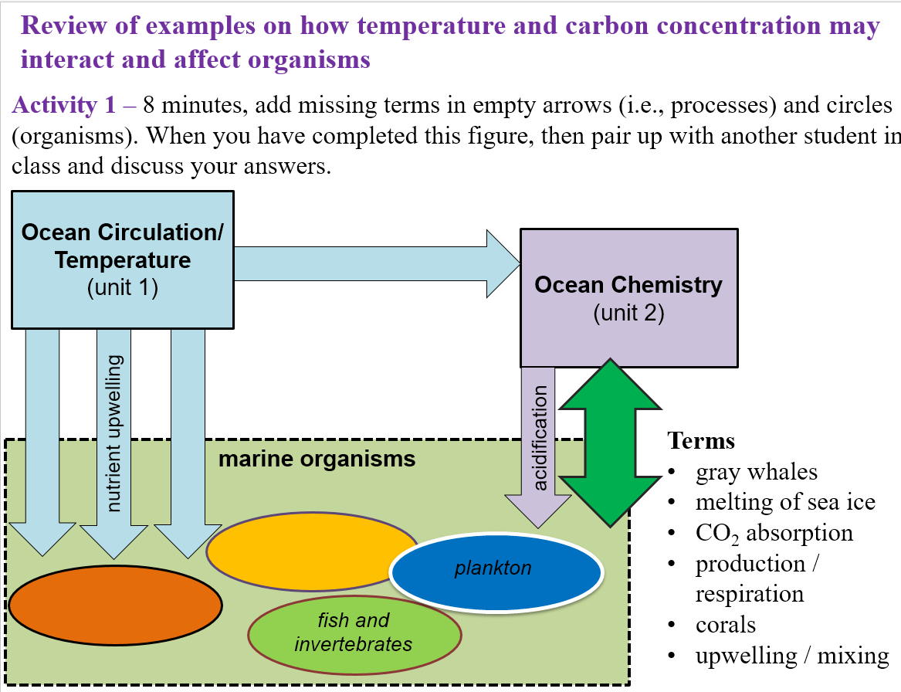**Activity 1** – 8 minutes, add missing terms in empty arrows (i.e., processes) and circles (organisms). When you have completed this figure, then pair up with another student in class and discuss your answers

*Definitions:*

Plankton – marine organisms that “drift in the ocean”; for example: algae or shrimp

Invertebrate – animal lacking a backbone; for example: mussels or crabs