Activity 2.1 Solubility Chart NAME Use the chart below to outline the solubility cycle for carbon in the ocean.

Questions:
- Using the word bank provided, fill in the blank boxes on the solubility chart.
- Name the process that is represented by the white arrow (labeled 2) that goes between the atmosphere and ocean. (label arrow on chart below)
- Notice that all arrows are double-ended. This is meant to indicate that these chemical reactions are not unidirectional. The large arrow near the base of the diagram represents the reactions you have outlined proceeding to the right (in other words, release of H+). Does this direction represent increasing or decreasing seawater pH? (label arrow on chart below)

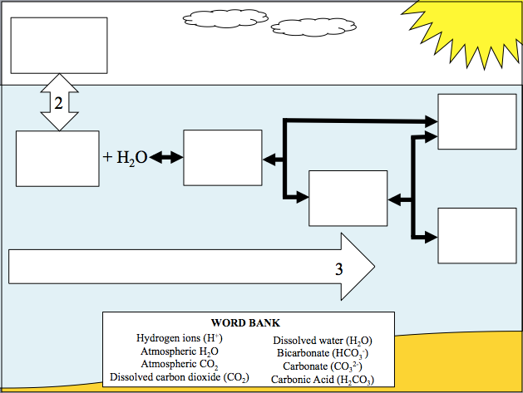

Activity 2.2 Ocean Carbon Cycle Guided Questions NAME Use the data set provided to answer the following questions. Your answers should be in complete sentences. Write in the name of the data set provided to your group:

Data Set:

- Describe the trends in pCO2, pH, and atmospheric CO2 (if present) you see in the plots provided.

- Do pCO2 and pH appear to be positively or negatively correlated? Positive correlation means when one parameter changes, the other changes in the same way (e.g., more heat trapped in the atmosphere causes temperature to rise). Negative correlation means when one parameter changes, the other changes in the opposite direction (e.g., more heat trapped in the atmosphere reduces the amount of ice coverage at the poles).

- In the space below explain why pCO2 and pH are correlated. It will help to apply the knowledge you learned in exercise 1 (ocean CO2 flow chart) to your answer for question 2 (above).

- Does the buffering system appear to be neutralizing all acidity associated with increased atmospheric carbon dioxide?

- Predict what implications pH change will have for organisms that precipitate shells/skeletons made up of carbonate (CO32-).

- Compare your data to data analyzed by nearby groups. Do the trends you identified in question 1 appear to be local, regional, or global?

- In this last question, draw connections between human use of fossil fuels, atmospheric carbon dioxide concentration, atmospheric temperature, seawater pCO2, seawater pH, and seawater temperature in the form of a flow chart. Boxes should consist of underlined terms above (human use of fossil fuels and seawater pH have been filled in for you). Arrows should be labeled “I” for increases and “D” for decreases.

