Activity 1.1. Vertical Ocean Circulation NAME____________________________
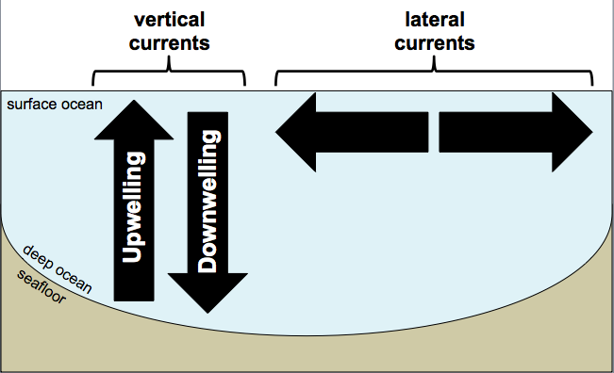
Reading: Ocean circulation is an important aspect of ocean health because it controls redistribution of both heat and nutrients. Humans indirectly affect ocean circulation via climate change. To understand this let’s first examine what drives ocean circulation.
In the NASA Perpetual Ocean video, you learned that wind drives ocean currents laterally across the surface of the oceans. In addition to moving laterally, ocean water moves vertically (see Fig. 1). This is called upwelling (rising) and downwelling (sinking). Whether seawater upwells or downwells depends on a few things...

Figure 1 (right). Types of ocean currents.

Instructions: Answer the questions 1-8 to set up basic rules for how lateral current direction controls vertical motion of seawater.

Water density as a control on upwelling and downwelling:

- What has higher density, warm water or cold water? (circle one)

- What has higher density, salty water or fresh water? (circle one)

- Given your answers for questions 1 & 2, surface ocean water that becomes _______ (warm or cold) and _______ (salty or fresh) will tend to downwell.

- What part/s of the Earth’s ocean might experience a lot of downwelling as a result the formation of very cold water? (circle on Figure 2 below)

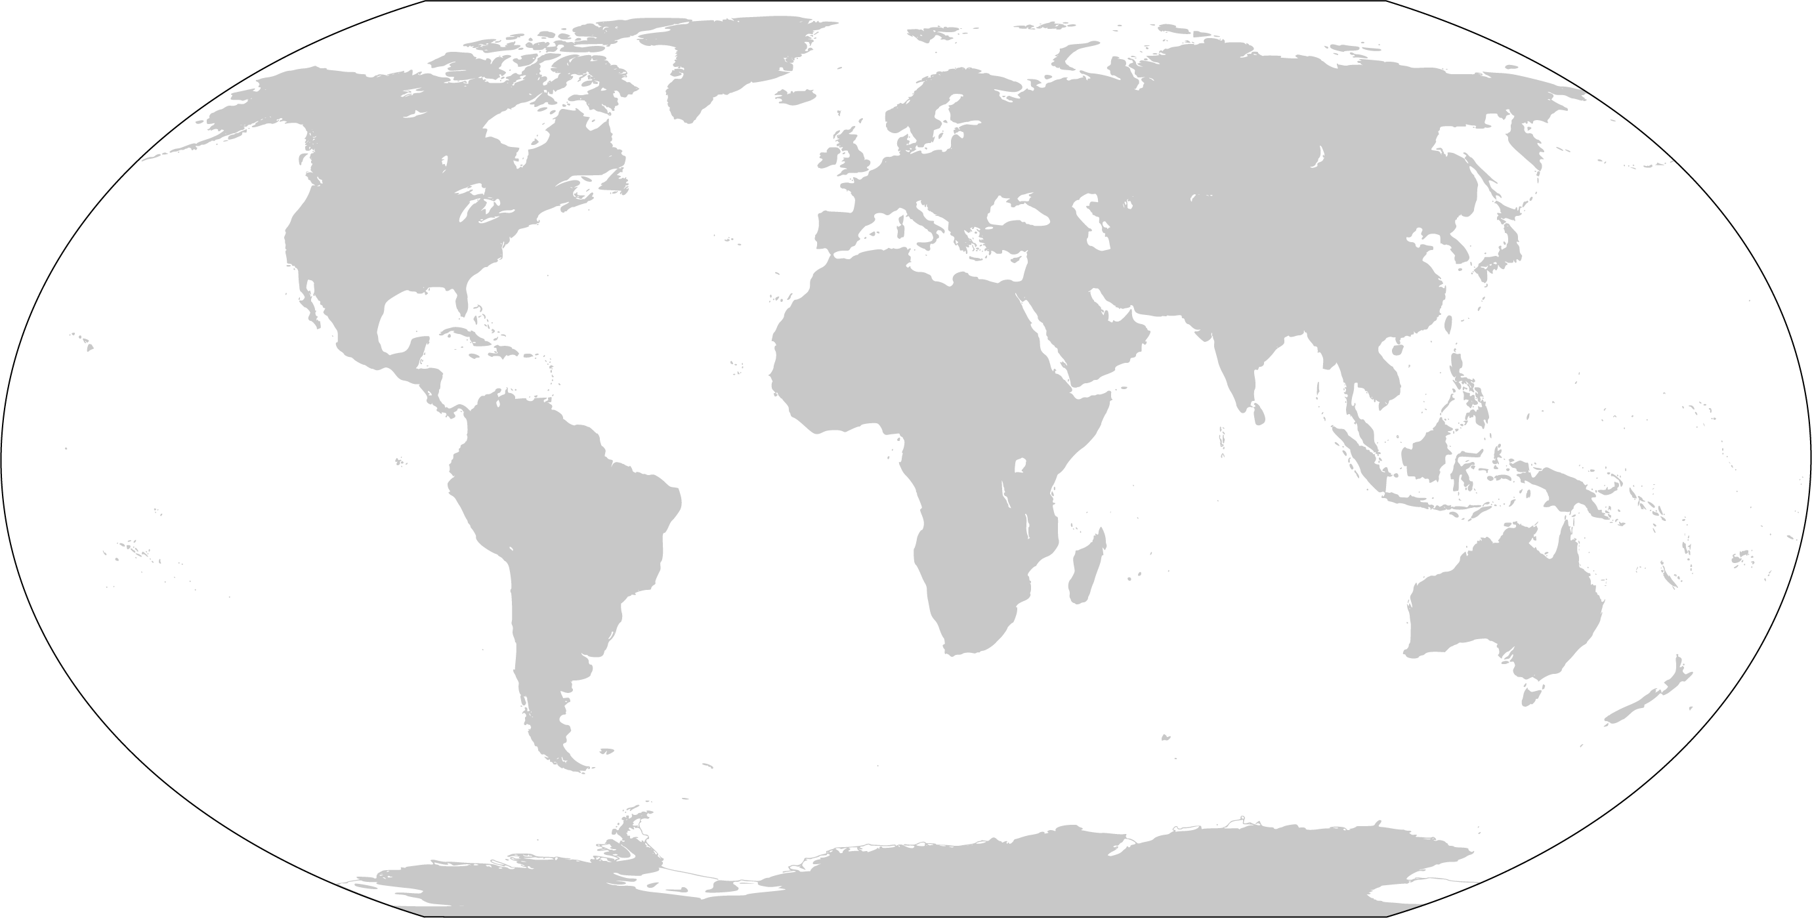
Figure 2. World map. Circle areas of ocean where high production of cold water would result in downwelling.

Current direction as a control on upwelling and downwelling:
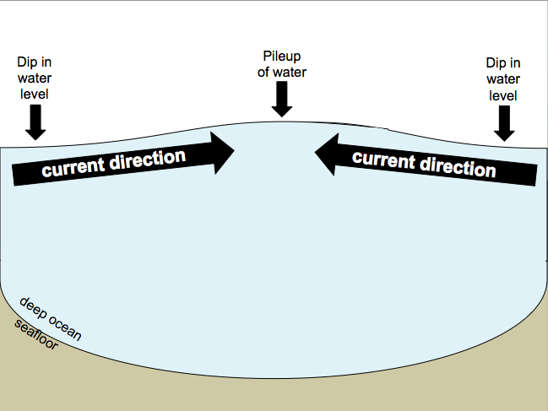
Currents that converge (come together) tends to cause water to pile up (like pushing water to one end of the bathtub raises the water level there). Currents that diverge (move away from each other) tends to cause a “dip” in water level (like pushing water to one end of the bathtub decreases the water level at the other end).

Figure 3 (right). Example of current convergence.

- Will convergence of currents cause deep water to upwell or surface water to downwell? (circle one).

- Draw the vertical direction of motion of water in the area labeled Question 6 in Figure 4 below.

- Will divergence of currents cause deep water to upwell or surface water to downwell? (circle one).

- Draw the direction of motion of water in the area labeled Question 8 in Figure 4 below.

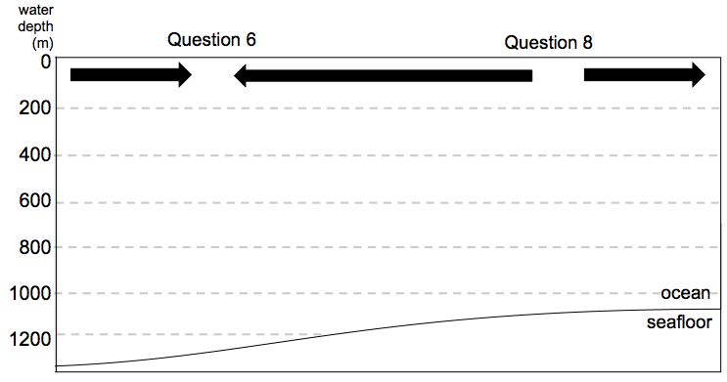
Figure 4. Draw arrows to indicate the direction of motion of water (either rises or sinks) for the regions labeled question 6 and question 8.

STOP HERE. Check with your instructor to make sure your answers are correct. Your instructor will organize you into groups before you continue to Activity 1.2.

Activity 1.2. Surface Currents and Productivity
Instructions: In this activity your instructor will assign a number to your group. Use the chart below to determine which region your group will work on. Circle your group number and region.

Group # | Region
1 or 2 | West coast of North America
3 or 4 | East coast of North America
5 or 6 | West coast of South America
7 or 8 | East coast of South America
9 or 10 | West coast of Africa
11 or 12 | East coast of Africa
13 or 14 | East coast of Asia
15 or 16 | Australia

If your group number is odd: work with the ocean current map to identify areas of possible upwelling in your region – base your answers on whether currents are converging with or diverging from the coast.
If your group number is even: work with the net primary productivity map to identify areas of high net primary productivity.

Reading: Deep ocean water tends to be cold and nutrient-rich (in part because decomposition in the deep oceans releases nutrients). Surface water tend to be warm and nutrient-poor (in part because nutrients are used up by organisms). For this reason, upwelling in coastal areas support high rates of primary productivity (rate at which photosynthetic organisms make organic matter), which is the base of the ecosystem in these regions.

- Identify regions of upwelling (for even numbered groups) or regions of high primary productivity (for odd numbered groups). Circle those regions on your map.

- Find the other group that is assigned to your region and compare the regions that you have identified as upwelling and high net primary productivity. Do these areas agree? Explain any discrepancies between the groups.

- Discrepancies imply that there are other conditions that affect primary productivity than upwelling. In the space below, describe what, other than upwelling, might affect primary productivity.

- Use the space below to describe the relationship between ocean current direction and the potential for a strong local fishing industry. Keep in mind that high rates of productivity can mean lots of food for fish!

Activity 1.3. Ocean Currents and Climate Change NAME__________________________
Reading: Activities 1.1 & 1.2 provide an understanding of how ocean currents redistribute nutrients and fuel primary production. Now you will think about global-scale effects of the climate change on ocean currents and net primary productivity. Read the passage below to answer the attached questions.

OCEAN PLANT LIFE SLOWS DOWN AND ABSORBS LESS CARBON
NASA Goddard Spaceflight Center, Sept 16, 2013

Plant life in the world’s oceans has become less productive since the early 1980s, absorbing less carbon, which may in turn impact the Earth’s carbon cycle, according to a study that combines NASA satellite data with NOAA surface observations of marine plants.

Microscopic ocean plants called phytoplankton account for about half the transfer of carbon dioxide (CO₂) from the environment into plant cells by photosynthesis. Land plants pull in the other half. In the atmosphere, CO₂ is a heat-trapping greenhouse gas.

Watson Gregg, a NASA GSFC researcher and lead author of the study, finds that the oceans’ net primary productivity (NPP) has declined more than 6% globally over the last two decades, possible as a result of climatic changes. NPP is the rate at which plant cells take in CO₂ during photosynthesis from sunlight, using the carbon for growth. The NASA funded study appears in a recent issue of Geophysical Research Letters.

“This research shows ocean primary productivity is declining, and it may be a result of climate changes such as increased temperatures and decreased iron deposition into parts of the oceans. This has major implications for the global carbon cycle,” Gregg said. Iron from trans-continental dust clouds is an important nutrient for phytoplankton, and when lacking can keep populations from growing.

Gregg and colleagues used two datasets from NASA satellites: one from the Coastal Zone Color Scanner aboard NASA’s Nimbus-7 satellite (1979-1986); and another from Sea-viewing Wide Field-of-view Sensor data on the OrbView-2 satellite (1997-2002).

The authors found nearly 70% of the NPP global decline per decade occurred in the high latitudes (above 30°). In the North Pacific and North Atlantic basins, phytoplankton bloom rapidly in high concentrations in spring, leading to shorter, more intense lifecycles. In these areas, plankton quickly dies and can sink to the ocean floor, creating a potential pathway of carbon from the atmosphere into the deep ocean.

In the high latitudes, rates of plankton growth declined by 7% in the North Atlantic basin, 9% in the North Pacific basin, and 10% in the Antarctic basin when comparing the 1980s dataset with the late 1990s observations.

The decline in global ocean NPP corresponds with an increase in global sea surface temperatures of 0.26° Fahrenheit (F) (0.2° Celsius (C)) over the last 20 years. Warmer water creates more distinct ocean layers and limits mixing of deeper nutrient-rich cooler water with warmer surface water. The lack of rising nutrients keeps phytoplankton growth in check at the surface.

The North Atlantic and North Pacific experienced major increases in sea surface temperatures: 0.7° C (1.26° F) and 0.4° C (0.72° F) respectively. In the Antarctic, there was less warming, but lower NPP was associated with increased surface winds. These winds caused plankton to mix downward, cutting exposure to sunlight.

Also, the amount of iron deposited from desert dust clouds into the global oceans decreased by 25% over two decades. These dust clouds blow across the oceans. Reductions in NPP in the South Pacific were associated with a 35% decline in atmospheric iron deposition.

“These results illustrate the complexities of climate change, since there may be one or more processes, such as changes in temperature and the intensity of winds, influencing how much carbon dioxide is take up by photosynthesis in the oceans,” said co-author Margarita Conkright, a scientist at NOAA’s National Oceanographic Data Center, Silver Spring, Md.

End article. Source: http://www.nasa.gov/centers/goddard/news/topstory/2003/0815oceancarbon.html

Activity 1.3 Questions:
- As you can see in the article, a reduction in net primary productivity in the ocean impacts more than just fishing industries. What other effects does it have on the Earth system?

- Use the space below to outline the positive feedback loop between climate change, sea surface temperature, atmospheric CO₂, and net primary productivity.
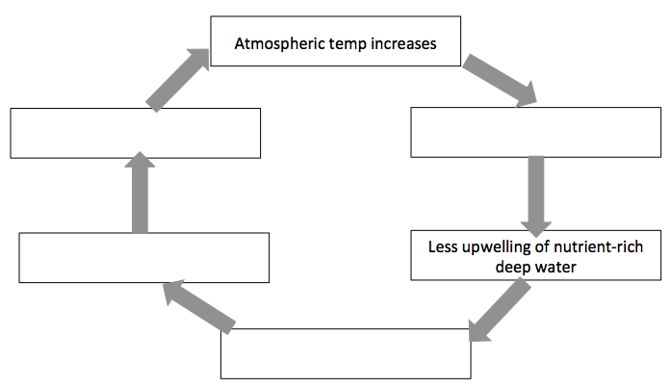

- As you read in the article, net primary productivity is controlled by a number of factors other than upwelling. Describe one listed in the article.

- What is humanity’s role in the recent climate change that is affecting the ocean’s net primary productivity?

