How Full is Full? Porosity and Permeability Activity
Modified from Environmental Engineering: Lesson 3, “How Full is Full? by TeachEngineering.org
Purpose
To study the characteristics of pore space (porosity) and permeability in soil.
Background
"To be a successful farmer one must first know the nature of the soil." –Xenophon (Greek historian)

The world’s population is more than 7 billion and feeding all of those people is a challenge. It is essential that farmers around the world learn to raise food sustainably if we hope to continue to feed these people—and the 70 million+ that are added each year. Sustainable agricultural practices will ensure that we are providing food not only for the world today but also for the world of the future. Conventional agricultural methods deeply reduce the porosity and permeability of the soil that can reduce yields and increase erosion. Similarly, subsistence agriculture reliant on deep hand plowing also degrades soil quality.

The porosity of a material is a measurement of how much of its volume is open space (also called pore space). Porosity is usually expressed as a percentage of the material’s total volume. In soil science, permeability is defined qualitatively as the ease with which gases, liquids, or plant roots penetrate or pass through a soil mass or layer. The permeability of a small soil sample will be interpreted in this activity by measuring the amount of water traveling through the soil during a given time period. The permeability of water is just one of the fluxes important to plants, which rely on soil to grow. Other things like nutrients also travel through the soil system in fluxes in response to changes in climate and other conditions.

As you complete steps A through E in this exercise, record your data on this table:

DATA TABLE

 | Sample #1 | Sample#2 | Sample #3 | Sample #4
Porosity
Estimated |  |  | — | —
Actual |  |  | — | —
Permeability (Flux)
Actual | — | —

Materials
- Soil samples #1-4, provided by your instructor
- A graduated cylinder or measuring cup
- A container of water, preferably one with a spout for pouring

Procedure
A. Soil Porosity
Start with soil sample #1. The soil you are looking at has been disturbed during collection or comes from a bag, where it has also been disturbed. “Disturbed” could mean either the soil was loosened or compacted some during collection or transport.
- How might the disturbance impact the soil structure or the number of pore spaces in the soil?
______________________________________________________________________________________________
______________________________________________________________________________________________
2) Now, starting with this sample, a graduated cylinder or measuring cup, and a container of water: How could we figure out the amount of open space (percentage of pore space) in this soil sample? For the purposes of this activity, we’ll consider the percentage of pore space as the volume of pore space divided by the total volume of the soil. This will allow you to visually estimate the pore space first.
______________________________________________________________________________________________
______________________________________________________________________________________________
Try your method, but first write here what percentage of the sample you estimate is open space (pore space).____________ Record both the estimated and actual percentages on the table.
How close was your estimate of pore space to your actual porosity? Can you see this porosity?
______________________________________________________________________________
Now estimate the percentage of pore space in sample #2 and then use your method of measuring pore space on the sample. Record both the estimated and actual percentages on the table.

B. Soil Permeability (Flux)
Examine the picture below (http://upload.wikimedia.org/wikipedia/commons/a/a5/Worm.bin.jpg):
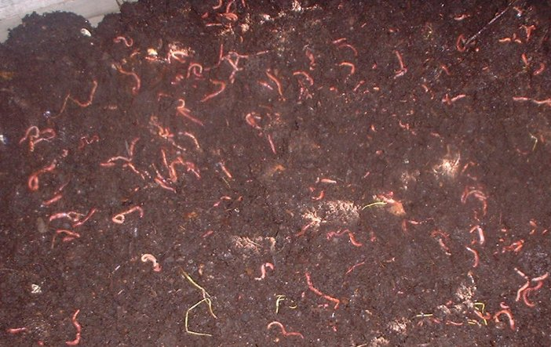

1) Soil structure is the arrangement of the solid parts of the soil and the pore space between them. As you look at the picture above, how does the structure of soil with the organisms and organic material within it appear to promote permeability? In other words, how do you think a permeable soil would be structured in comparison to a less permeable soil?
______________________________________________________________________________________________
______________________________________________________________________________________________

2) How does human disturbance impact the permeability of soil? Compare the structure in the photograph to the structure of soil sample #2, which is a compacted version of sample #1.
______________________________________________________________________________________________
______________________________________________________________________________________________
______________________________________________________________________________________________

3) How could we measure the flux, or movement, of water through this soil? How does measuring the flux give us an idea of how permeable this sample is?
______________________________________________________________________________________________
______________________________________________________________________________________________
______________________________________________________________________________________________

4) Now try your method for measuring flux on samples #3 and 4, which are uncompacted (#3) and compacted (#4) and record your measurements here and on the table. The measurements should be stated in units of weight or volume over units of time, for example: milligrams/minute (mg/min.) or milliliters/minute (ml/min.).
______________________________________________________________________________________________
Note: We are looking at flux as a reflection of the permeability of our soil samples. Look at the page or slide labeled “Water Flux” to see how flux is actually calculated.

C. Compaction
Repeated tillage, heavy machinery, animal, pedestrian, or vehicle traffic can compact soil.
- How might compaction impact soil porosity?
______________________________________________________________________________________________
______________________________________________________________________________________________
______________________________________________________________________________________________

Your job now is to evaluate the impacts of compaction on porosity and permeability.

E. Exploration Activity

You’ve already considered how tillage and compaction impact porosity and permeability. Now consider how annual and perennial vegetation influence permeability. Annual plants such as the annual wheat shown below have roots and stems that die annually, whereas roots in perennial vegetation such as that of the wheatgrass shown below remain even after the stems have died.

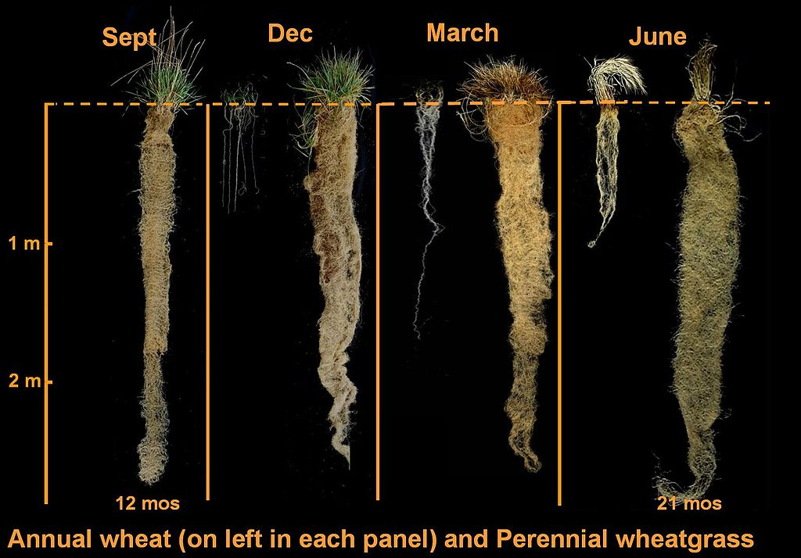

- Based on the above example, would annual or perennial vegetation promote greater infiltration (permeation of water) into the soil? Why?
______________________________________________________________________________________________
______________________________________________________________________________________________
______________________________________________________________________________________________

F. Conclusions

1) Think about how porosity and permeability might be related. How do you think a change in one of these properties might affect the other property?
______________________________________________________________________________________________
______________________________________________________________________________________________
______________________________________________________________________________________________

2) If soil is not permeable, where does rainfall go and what happens to any soil that is at the surface?
______________________________________________________________________________________________
______________________________________________________________________________________________

3) Finally, if you were a farmer or a gardener planting vegetation and needed to improve your soil drainage and reduce erosion, would you plant more perennial or more annual vegetation?

______________________________________________________________________________________________
______________________________________________________________________________________________
______________________________________________________________________________________________

Water Flux

The flux (J), or flow of water, through this soil is the quantity of water (Q) moving through a cross-sectional area (A) per unit of time (t)

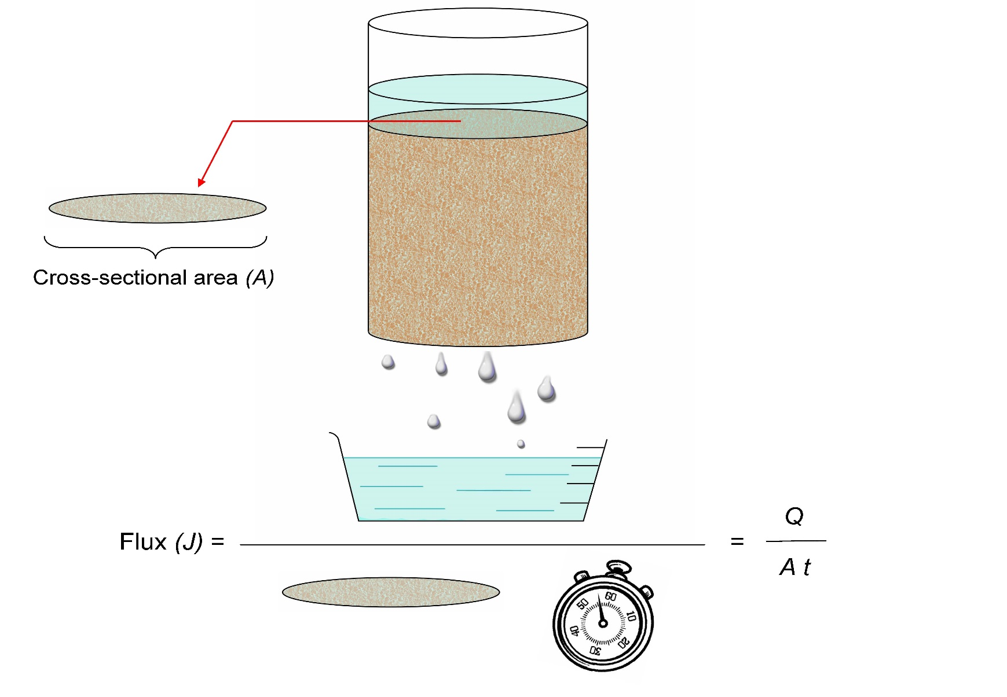
Source: USDA NRCS
In the “How Full is Full” activity, we are looking at flux as a reflection of the permeability of our soil samples. The formula above can be used to calculate the actual flux.

