Background
Geologic and Mining History of Homestake Deposit
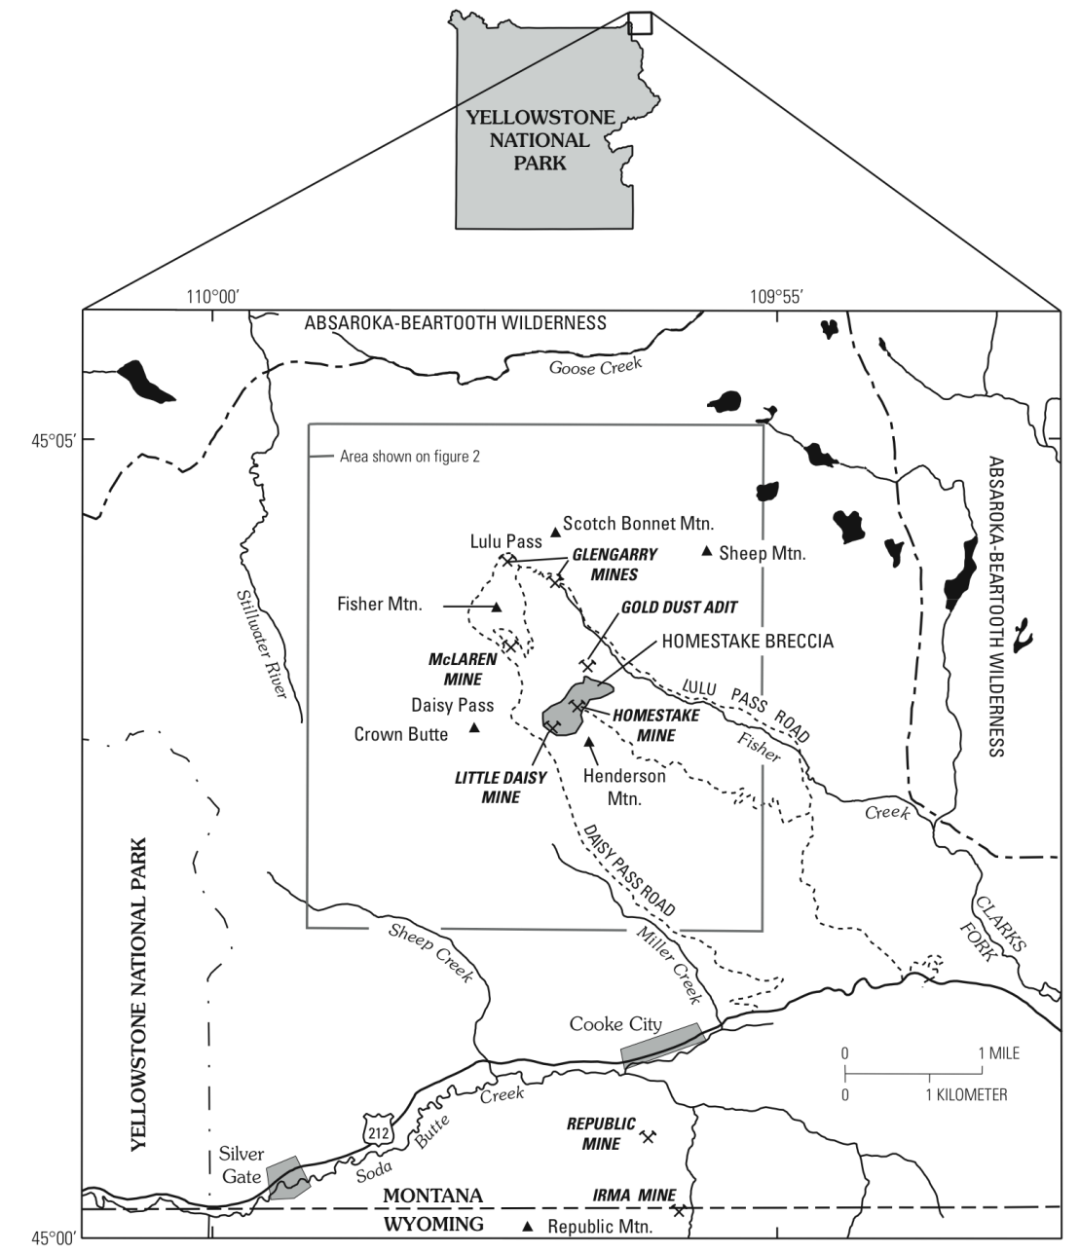
Map modified from USGS Special paper 1717, Chapter M: “The Life Cycle of Gold Deposits Near the Northeast Corner of Yellowstone National Park—Geology, Mining History, and Fate,” by Bradley S. Van Gosen (http://pubs.usgs.gov/pp/1717/downloads/pdf/p1717M.pdf).
The Homestake Mine, Montana, belongs to an area called New World Mine District (see above map). This mine contains proven and estimated economic ore deposits of gold, silver, and copper. These deposits were formed about 40–50 million years ago during multiple episodes of igneous activity in this region. The extrusive (igneous rocks formed above ground) and intrusive (igneous rocks formed below ground) rocks found in this region were formed during this time period. Magma that formed these extrusive and intrusive igneous rocks flowed from underground magma chambers. After the eruption was over, these magma chambers also solidified underground forming the Scotch Bonnet Mountain, Fisher Mountain, and Henderson Mountain.
No gold/copper mineralization has been linked to the Scotch Bonnet Mountain or Henderson Mountain magmatic event. Instead, the main episode of economic mineral deposit formation took place as magma rose in the region under Fisher Mountain and nearby areas. Hydrothermal fluids carrying gold and sulfide ore minerals started to move away from the magma chamber toward cooler sedimentary rock layers, deposited there, ultimately forming the ore deposits we see in this area today (see Figure 1 below). Several times the pressure of the hydrothermal fluids shattered surrounding rocks, including nearby sedimentary rock layers, and deposited the ore minerals between the shattered rock fragments as well as along unbroken sedimentary rock layers. Hydrothermal ore deposits ceased forming when magma intruded under Henderson Mountain, perhaps because of a change in magma composition.
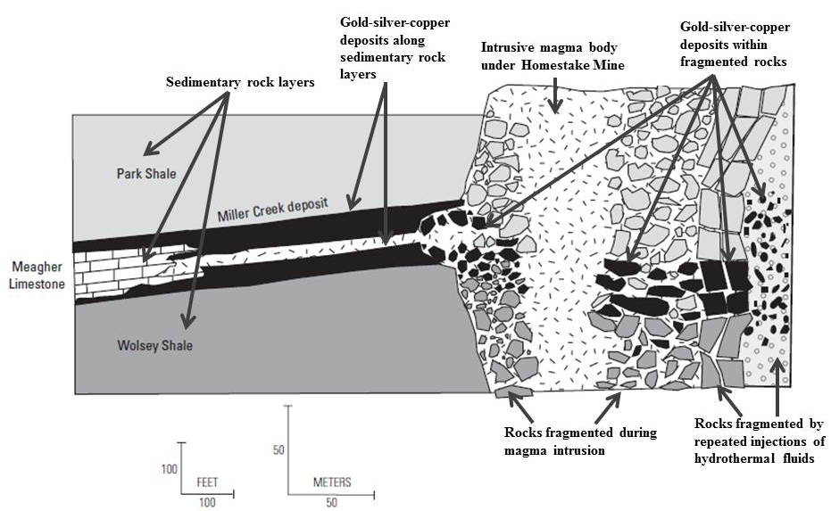
Figure 1: This schematic diagram shows how economic deposits of gold, silver, and sulfide minerals formed in the region near the Homestake Mine, Montana. Diagram modified from chapter M of USGS special Publication 1717 (full reference below).

Mining activities in this region started as early as 1869 and continued until the early 1920s. However, the high-grade gold deposits were not discovered at that time, and mining operations closed when financial support ended. Interest in mining these deposits was renewed after 1985. In 1990, Crown Butte Mine, a subsidiary of Noranda Inc., submitted a plan to develop an underground mine in this area. In addition to the underground mine, the mining proposal included a tailings pond, waste rock storage site, access roads, a work camp, transmission lines, and ore processing facilities for recovering gold without using cyanide. The tailings pond, waste rock storage site, work camp and the access roads were proposed to be built within nearby Shoshone and Gallatin National Forests. In the face of intense opposition to the mining proposal from environmental groups such as the Sierra Club and Greater Yellowstone Coalition, as well as from employees of the Yellowstone National Park, the Federal Government bought out the mineral rights of this region from Noranda Inc. in 1997, and the area was made part of the Gallatin National Forest. Beginning August 1997, a 20-year “No-Mining” period went into effect in that area.
Geologic History of Yellowstone National Park
The proposed Homestake Mine site is less than five miles from the northeastern entrance of the Yellowstone National Park. The Yellowstone National Park region (Figure 2) is the site of active vulcanism today.
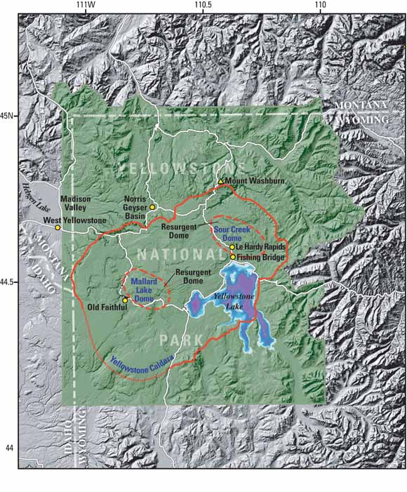
Figure 2: The region of Yellowstone National Park in Wyoming, Montana, and Idaho is famous for its spectacular geysers and extensive hot springs, indications that an underlying volcanic system remains active. The central part of the park is occupied by the great, partly filled depression of the Yellowstone Caldera, formed in a giant volcanic eruption 640,000 years ago that blasted 240 cubic miles (1,000 km³) of molten rock (magma) into the atmosphere—more than 1,000 times the volume erupted at Mount St. Helens in 1980. Later eruptions largely filled the caldera and pushed up two resurgent domes within it—the Sour Creek and Mallard Lake Domes. No actual volcanic eruption has occurred in the Yellowstone region for about 70,000 years. However, since the 1970s, scientists have detected significant changes in this remarkable volcanic and hydrothermal (hot water) system, including rapid ground uplift and subsidence and bursts of earthquake activity.
Figure and figure caption from: “Tracking Changes in Yellowstone's Restless Volcanic System” U.S. Geological Survey Fact Sheet 100-03, 2004 (http://pubs.usgs.gov/fs/fs100-03/).
The Yellowstone Caldera shown by the orange line in Figure 2 (a caldera is a large, relatively circular depression in the ground formed as a result of volcanic activity) marks the location of the most recent (640,000 years ago) cataclysmic eruption (see Figure 3 below) at Yellowstone. Vulcanism at Yellowstone occurred as the North American Plate traveled over a hot spot (the top portion of a relatively stationary column of hot mantle material). The locations and ages of the calderas that formed over the last 2 million years is shown in the diagram below and help us determine the direction of movement of the North American plate with respect to the hot spot (in a general southwesterly direction). The vulcanism that culminated in forming the Yellowstone Caldera began approximately 16 million years ago, almost 25 million years after the volcanism that created the mineral deposits present around the Homestake Mine ended.
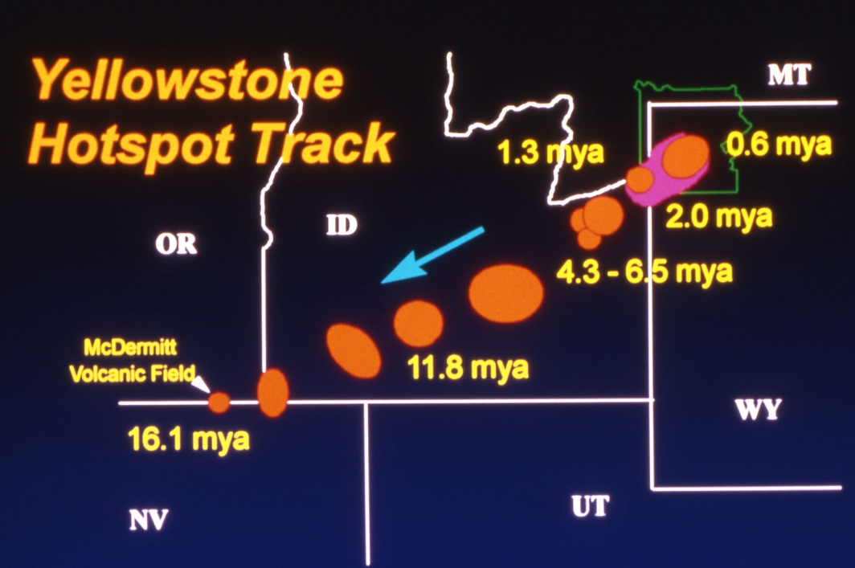
Figure 3: This figure shows the ages and locations of explosive calderas that formed over the last 16 million years (mya = million years ago) as the North American plate moved southwest over the hot spot currently located under Yellowstone National Park. Image from Yellowstone’s Photo Collection, National Park Service (http://www.nps.gov/features/yell/slidefile/graphics/diagrams/Page.htm).

Currently, the hot spot sits below the Yellowstone Caldera (see Figure 4 below). Although there has not been any actual volcanic eruption in this area since a lava flow covered the floor of the caldera about 70,000 years ago, the hot spot is still a site of igneous activity.
The magma (molten rock) rising from deep within the mantle under Yellowstone starts out with a mafic (also known as basaltic, after the main type of extrusive igneous rock formed from this type of magma) composition, meaning the molten rock contains about 50% silica (or SiO₂). However, as this mafic magma moves upward through the North American plate, it partially melts the silica-rich continental crust and eventually forms felsic magma (also known as rhyolitic magma, after the main type of extrusive igneous rock formed from this type of magma) with a higher percentage (65–70%) of silica. Mafic magma is denser, forms at a higher temperature, and is relatively more fluid than felsic magma. The magma reservoir below Yellowstone Caldera contains both mafic and felsic magma. The more viscous (sticky) felsic magma prevents Yellowstone from erupting as frequently as the volcano in Big Island, Hawai’i, which contains mostly mafic magma in the magma chamber. As a result, pressure builds up within the magma reservoir in Yellowstone from the molten rocks and hydrothermal fluids (Figure 4). This pressure within the magma reservoir is currently lifting up parts of the Yellowstone Caldera (see Figure 2 for location of the resurgent domes) while letting other parts subside. These pressurized fluids also make the area around Yellowstone National Park highly earthquake prone.

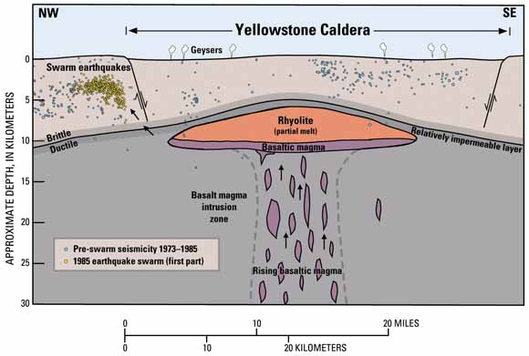
Figure 4: Volcanic and hydrothermal activity in the Yellowstone area is fueled by a large reservoir of magma (partially molten rock) beneath a caldera (volcanic depression) that formed in a cataclysmic eruption 640,000 years ago. The magma reservoir includes both rhyolitic (or felsic) magma, rich in silica (SiO₂) and basaltic (or mafic) magma, which contains less SiO₂ and is denser. Capping the magma reservoir is a zone of hot, ductile rock that can slowly flow to close any fractures and is therefore relatively impermeable (meaning that fluids cannot easily pass through). The cooler rock above behaves in a more brittle manner and can be readily fractured. Sometimes the impermeable rock can be ruptured, allowing hot, salty fluids to escape upward and laterally, moving through cracks in brittle rock. As shown in this diagram, such a fluid release in 1985 is thought to have triggered a large swarm of earthquakes just northwest of the caldera.
Figure and figure caption from: “Tracking Changes in Yellowstone's Restless Volcanic System” U.S. Geological Survey Fact Sheet 100-03, 2004 (http://pubs.usgs.gov/fs/fs100-03/).

Groundwater and/or rainwater percolating through fractures in the rocks above the magma reservoir gets heated and ultimately forms the famous geysers in Yellowstone National Park. Also, the hydrothermal fluids from within the magma reservoir are actively depositing minerals within Yellowstone National Park today, though no evidence of gold and silver deposits has been found.
Yellowstone was the first National Park in the United States. It was established in 1872 to protect the unique natural features such as the geysers, rugged plateaus, scenic lakes, waterfalls, other beautiful landscapes and diverse wildlife population for public recreation and enjoyment. As such, more than 2 million acres of land within the boundaries of Yellowstone National Park is protected land. The World Heritage Committee of the United Nations designated Yellowstone National Park a World Heritage Site in 1978.

Geologic History of Lake Superior and the Origin of the Sulfide Mineral Deposits
Unlike the hot spot vulcanism at Yellowstone, the sulfide mineral deposits on the shore of Lake Superior crystallized along a mid-ocean ridge-rift system that formed when the supercontinent Rodinia broke apart. About 1.1 billion years ago, part of the mantle under the region where Lake Superior is today began to melt and form a dome, lifting up the crust above it. The crust was stretched thin above the dome, and it eventually fractured and formed a rift zone almost 2500 kilometers (approximately 1000 miles) long (Figure 5), splitting the continental crust. The rocks along the center of the rift slid downward (normal faulting), as well as sagged in the middle, creating a broad basin or rift valley. A tremendous amount of basaltic (or mafic) magma that formed from partial melting of the mantle poured into the rift valley. Most of these basalts rose rapidly through the crust and poured out in vast quantities forming thick lava flows (almost 30 km, or 12 miles, thick under Lake Superior). However, a portion of the melt was contained within underground magma chambers at several locations along the rift valley.
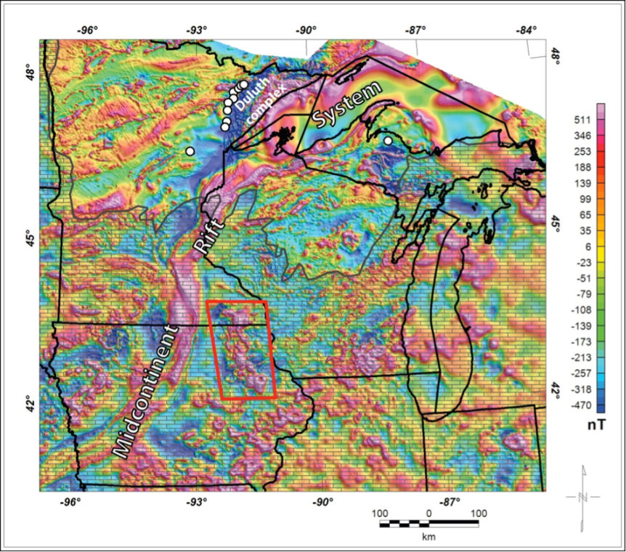
Figure 5: Regional aeromagnetic anomalies over the Midcontinent Rift System region. White dots show locations of known Keweenawan Ni-Cu-PGE mineral deposits. Gray block pattern shows area of sedimentary cover. Red polygon shows location of Northeast Iowa Intrusive Complex.
Figure and figure caption from USGS Crustal Geophysics and Geochemistry Science Center, “Multidisciplinary Studies to Image and Characterize the Mineral Resource Potential of the Midcontinent Rift, USA” (http://crustal.usgs.gov/projects/midcontinent-rift-minerals/index.html).
The basaltic (or mafic) magma contained high concentrations of copper (Cu), nickel (Ni), cobalt (Co), and metals belonging to the platinum group, collectively called Platinum Group Metals, or PGM. As the magma rose through the continental crust, it mixed with sulfur present in crustal rocks. This sulfur combined with the Cu, Ni, Co, and PGM, forming sulfide minerals. These sulfides were not soluble in the rest of the magma and started to settle out of the melt as droplets, ultimately forming economic sulfide deposits, either on the floor of the ancient magma chambers or along magma conduits.
The continental rift system did not manage to tear Rodinia apart because of a continental collision to the east of the rift zone, which pushed the two sides of the rift back together about 1040 million years ago. The faults that initially allowed downward movement of rocks (normal faults) during the rifting event now reacted to the compressional forces by allowing the rocks to tilt and move upward (thrusting and reverse faulting) along the fault planes. This upward movement brought some (but probably not all) of the metal sulfide deposits closer to the surface. The Cu-Ni sulfide deposits near Duluth, Minnesota, and near Mellen, Wisconsin, are considered to have been formed in this manner (Figure 6). 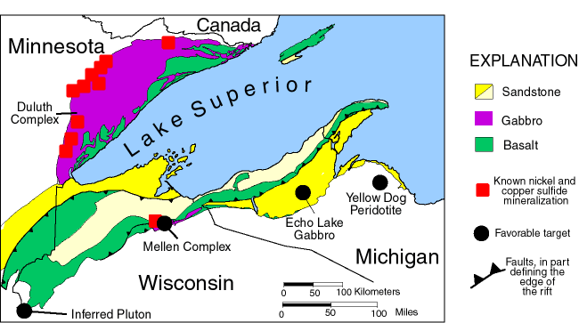
Figure 6: Generalized map of the western Lake Superior region showing the distribution of major rock types of the Midcontinent rift and locations of known Ni-Cu sulfide mineralization in Minnesota and Wisconsin. Also shown are the locations of favorable new targets for Ni-Cu-PGM exploration - Mellen Complex, Echo Lake Gabbro, Yellow Dog Peridotite, and an inferred intrusion recognized from geophysical data in western Wisconsin.
Figure and figure caption from: USGS publication titled “Potential for New Nickel-Copper Sulfide Deposits in the Lake Superior Region” (http://pubs.usgs.gov/info/mwni_cu/)

Figure 6. Generalized map of the western Lake Superior region showing the distribution of major rock types of the Midcontinent rift and locations of known Ni-Cu sulfide mineralization in Minnesota and Wisconsin. Also shown are the locations of favorable new targets for Ni-Cu-PGM exploration: Mellen Complex, Echo Lake Gabbro, Yellow Dog Peridotite, and an inferred intrusion recognized from geophysical data in western Wisconsin.
Figure and figure caption from: USGS Publication “Potential for New Nickel-Copper Sulfide Deposits in the Lake Superior Region” (http://pubs.usgs.gov/info/mwni_cu/).

Copper, nickel, cobalt, and PGM are extensively used in various industries such as making stainless steel (Ni); rechargeable and electric-car batteries (Ni); light, strong and durable “superalloys “ (Co) for aircrafts; catalytic converters for car exhausts (PGM); and electric wires (Cu). Because of this, demand for these commodities is on the rise. Geophysical and geochemical characteristics of some of the intrusive igneous bodies along Lake Superior (Figure 6) indicate the presence of similarly formed Cu-Ni-sulfide deposits along the shore of Lake Superior. Several locations within the Michigan Upper Peninsula, northern Wisconsin, and northern Minnesota are currently being assessed for mining potential.
Lake Superior became the freshwater lake we see today about 7,500 years ago, after the last Ice Age. Prior to glaciation (about 3 million years ago), the loose sediments within the gently downwarped rift valley hosted an eastward flowing river channel at the current location of Lake Superior. The orientation of this basin directed the ice sheets coming from near Hudson Bay area westward towards Minnesota. Several episodes of ice advance widened and deepened the basin, and carried out the eroded material to the surrounding land. Eventually the ice melted and the land covered under the ice sheet rebounded (crustal rebound) to the present outline of all five Great Lakes (Superior, Michigan, Huron, Erie, and Ontario).
Lake Superior currently contains about 10% of world’s entire supply of freshwater (Minnesota Sea Grant, http://www.seagrant.umn.edu/superior/characteristics). Besides the United States and Canada, the land around Lake Superior belongs to several Tribal/First Nation/Métis (one of the aboriginal people in Canada). Besides concerns of water pollution, any potential mining activity around Lake Superior must consider the priorities (for example, location of sacred sites) of these diverse groups of stakeholders.
More information about Homestake Mine, Montana, and Yellowstone National Park:
USGS Professional Paper 1717: “Integrated Geoscience Studies in the Greater Yellowstone Area—Volcanic, Tectonic, and Hydrothermal Processes in the Yellowstone Geoecosystem” (http://pubs.usgs.gov/pp/1717/).
Bradley S. Van Gosen. 2007. “The Life Cycle of Gold Deposits Near the Northeast Corner of Yellowstone National Park—Geology, Mining History, and Fate.” Chapter M of USGS Professional Paper 1717 (http://pubs.usgs.gov/pp/1717/downloads/pdf/p1717M.pdf).
CRS Report for Congress. “New World Gold Mine and Yellowstone National Park” by Marc Humphries, August 27, 1996 (http://www.nps.gov/whsa/parknews/upload/CRS%20Report%20on%20Yellowstone%20Gold%20Mine%20Issue-2.pdf.).

More information about the Geology of the Lake Superior Region and Mining Activities:
“Potential for New Nickel-Copper Sulfide Deposits in the Lake Superior Region” (http://pubs.usgs.gov/info/mwni_cu/)
LaBerge, Gene L. 1994. Geology of the Lake Superior Region. Penokean Press.
“Mining and Exploration Activity in the Region of the 1836, 1837, 1842, and 1854 Ceded Territories.” http://www.lic.wisc.edu/glifwc/web/mining/.
Lake Superior Binational Forum (http://www.superiorforum.org/.)
“Responsible Mining Recommendations from the Lake Superior Binational Forum,” December 2013. (http://www.superiorforum.org/wp-content/uploads/2013/12/Responsible-Mining-Binational-Forum-2013.pdf.)

