Using the Rubric for Concept Map Assessment

A note to instructors: As written, in order to earn a high score, the concept map will need to be very large (see the sample halite map). Students should be advised to use a large sheet of paper (larger than 8.5 x 11”) and be awarded enough points to motivate them to list and link many concepts.

Alternatively, the instructor is encouraged to define their own “large numbers” and “adequate numbers” in this assignment. Depending on the focus of the course, the instructor might choose to focus on one of the three main topics in this concept map more than others and might encourage students to develop that topic more than the others. In this way, the assignment will be more manageable.

Another option would be to assign groups of three students to one mineral resource and to assign each student only one key topic (geologic nature of resource, factors and people that determine resource demand, and resource mining and processing). Students could either meet to develop one large concept map, or could create individual maps and then try to merge them together.

Regardless of how you do this, we recommend you edit the rubric with the actual numbers of concepts required to get a given score and hand out the rubric to students when the concept map is assigned.

Below is clarification on some criteria in the rubric that may be more abstruse:

Organization:
Map looks like a network not a line:
Network-shape
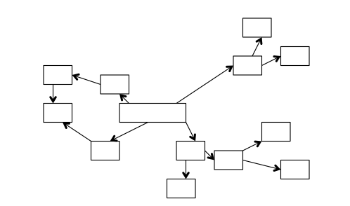

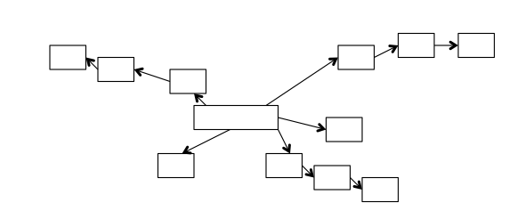
Linear-shape

- In the concept map that looks like a network, more than two lines will attach to several of the nodes. This creates a branching pattern and shows an interconnectedness of the nodes. In addition, crosslinks might connect different branches.

- In the linear map, the nodes (except for one or two central nodes) each have only two connecting lines. In the most simplistic version, the entire map is a single line of one node leading to the next.

Follows standard map conventions:
- Nodes are concepts and are enclosed in some sort of shape (box, circle, etc.)
- Nodes are connected by arrows indicative of the direction of the flow of the concept portrayed
- Arrows are labeled
Content and Relationships and Connections between Concepts

Many of the concepts used in the overall module are listed below. Some of these will be relevant to every mineral resource (commodity), some will not.

Large number of concepts vs. adequate number of concepts
 | Large number | Adequate number
Geologic nature of the resource | ≥8 | 5–7
Factors and people who determine resource demand | ≥6 | 4–5
Resource mining and processing | ≥10 | 7–9

Main concepts
The main concepts for each of the three key topics are italicized in the list below. Under “Geologic Nature of the Resource,” only one rock type and its relevant processes will be listed.

Geologic Nature of the Resource
- mineral (mineral name)
- commodity name (can be many if multiple commodities are mined from same resource)
- chemical formula
- igneous | - sedimentary | - metamorphic
- melting | - mechanical weathering | - hydrothermal fluid
- magma | - chemical weathering | - high T/P
- cooling | - erosion | - plate tectonic setting (divergent plate boundary, convergent plate boundary in the ocean, hot spot)  - Is the setting active today? (e.g., current plate boundary/hot spot/active volcano, or a past boundary/hot spot/volcano?)
- extrusive/intrusive | - deposition
- plate tectonic setting (divergent plate boundary, convergent plate boundary in the ocean, hot spot)  - Is the setting active today? (e.g., current plate boundary/hot spot/active volcano, or a past boundary/hot spot/volcano?) | - crystallization
- place (beach, dunes, stream bed, etc.)
- Is the deposit forming today, or did it form in the past?

Factors That and People Who Determine Resource Demand
- specific uses (multiple) | - price | - population
- possible substitute resource(s) | - amount of mining | - economic development
- recycling/ reuse | - shipping/transporting raw material | - geopolitical issues
- consequences of use—reasons people might not use  - consequences of NOT using the commodity | - what makes the commodity useful (multiple)
Resource Mining and Processing
- underground/surface mining | - primary locations of mines | - people who live in mine area
- reclamation | - job creation/destruction | - tailings
- remediation | - waste rock | - emissions
- exploration | - water use and pollution | - energy use
- miners | - government regulations | - mining companies
- processing (breaking rock, beneficiation, extracting elements) | - potential effects of accidents/natural disasters | - transportation and infrastructure
- land use (what land cannot be used for, including pleasure, worship, and other noneconomic purposes)

