**Arizona Water Data Sets**

Each set of data presents a representation of some aspect(s) of the Central Arizona water system. Instructors should provide each group of students with two or three of these sets for the data set analysis activity to be conducted in class.

1. Map of Ground Water Sources in Maricopa County (Central Arizona): Qualitative
2. Arizona Reservoir Storage: Quantitative
3. Maricopa County Water Supply and Population: Quantitative
4. Phoenix Area Monsoon Rainfall: Quantitative
5. Phoenix Residents’ Perception of Water: Quantitative
6. Deserted Video: Qualitative
7. Photograph of Tempe Town Lake: Qualitative
8. Literary Quotations: Qualitative



*Map by Kate Darby from US National Atlas Data*

*Source: USGS National Water Information System Web Interface*

*Source: USGS National Water Information Systems Web Interface*

*Source: NOAA National Weather Service,* <http://www.wrh.noaa.gov/twc/monsoon/monsoon_phx.php>

|  |  |
| --- | --- |
| Political Attitudes | Respondents Who Believe In  Human Rights To Use All Needed Water |
| **Liberals** | 14.9% |
| **Moderates** | 21.8% |
| **Conservatives** | 28.3% |

*Source: Data Modified from 2006 Community Highlights: Phoenix Area Social Survey: Community and Environment in a Desert Metropolis. Central Arizona-Phoenix Long Term Ecological Research Project, Contribution No. 4, December 2007, Global Institute of Sustainability, Arizona State University (caplter.asu.edu/docs/contributions/2007_PASS2.pdf)*

Video Clip from Deserted: Forgetting Nature, Humanity and History in the Salt and Gila River Beds

Created for the Ecological Society of America Millennium Conference

Watch through 2:37 at *http://www.youtube.com/watch?v=k_3Eg9rUpUs*

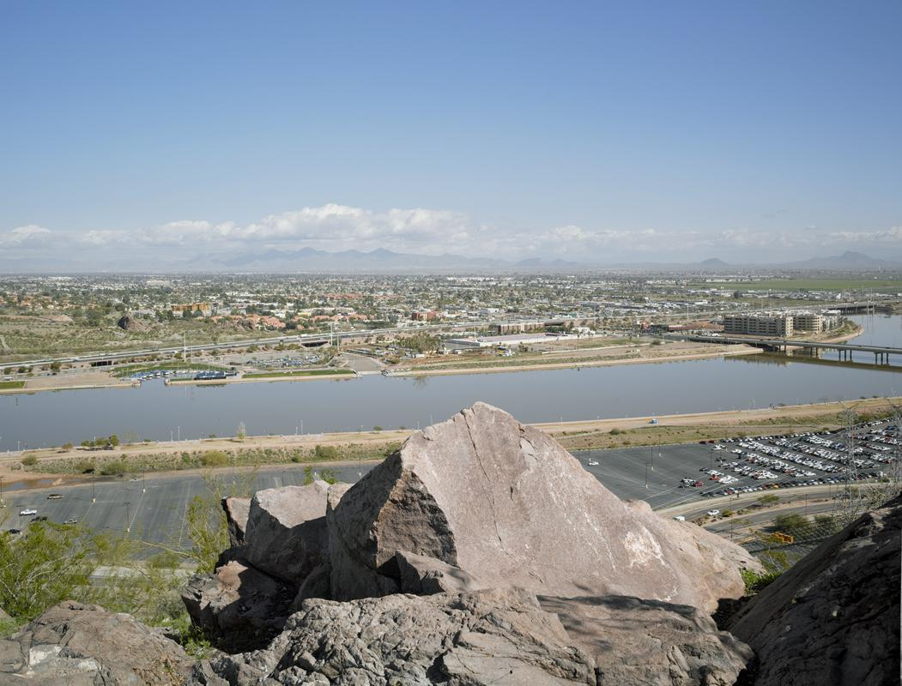

*Modern petroglyph, top of Hayden Butte 2*, March 2008  
Mark Klett

This photograph is part of the Phoenix Transect Project (<http://phoenixtransect.org>), which uses photography to document changes in the Phoenix, Arizona, metropolitan region*.*

**Literary Quotations**

But there is still too much to see and marvel at, the world very much alive in the bright light and wind, exultant with the fever of spring, the delight of morning. Strolling on, it seems to me that the strangeness and wonder of existence are emphasized here, in the desert, by the comparative sparsity of the flora and fauna: life not crowded upon life as in other places but scattered abroad in spareness simplicity, with a generous gift of space for each herb and bush and tree, each stem of grass, so that the living organism stands out bold and brave and vivid against the lifeless sand and barren rock. —Edward Abbey, *Desert Solitaire: A Season in the Wilderness*

Water, water, water. . . . There is no shortage of water in the desert but exactly the right amount, a perfect ratio of water to rock, of water to sand, insuring that wide, free, open, generous spacing among plants and animals, homes and towns and cities, which makes the arid West so different from any other part of the nation. There is no lack of water here, unless you try to establish a city where no city should be. —Edward Abbey, *Desert Solitaire*

I’d forgotten how enlivening it could feel, seeing clearly and far. Aridity frees light. It also unleashes grandeur. The earth here wasn’t cloaked in forest, nor draped in green. Green was pastoral, peaceful, mild. Desert beauty was “sublime” in the way that the romantic poets had used the word—not peaceful dales but rugged mountain faces, not reassuring but daunting nature, the earth’s skin and haunches, its spines and angles arching prehistorically in sunlight. –Julene Bair, *The Ogallala Road: A Memoir of Love and Reckoning*

What makes the desert beautiful is that somewhere it hides a well –Antoine De Saint-Exupéry, *The Little Prince*.

Anything built here, an unrelenting desert, was an act of sheer will imposed on territory unsuited for habitation. —Dave Eggers, *A Hologram for the King*.