Unit 4 Activity: Monitoring Volcanoes

THOUGHT EXPERIMENT
The figures below show map and cross-sectional views of the volcano Mount Gordan in Alaska, with five imaginary GPS stations (triangles) on the surface that record their locations.

- INITIAL INTRUSION Imagine that a body of magma intrudes below the summit of the volcano, without erupting. Draw arrows that represent the motion of each station as a result of the intrusion of that magma. Explain your answer.
Map view
Cross-sectional view
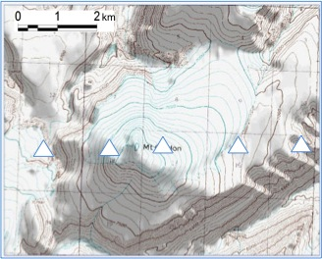

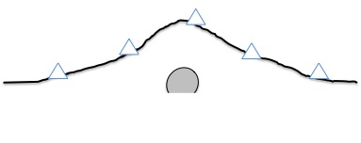

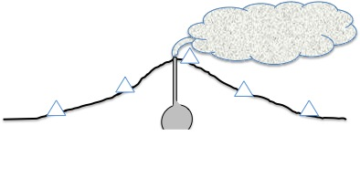

Then, imagine the volcano erupts!

- AFTER ERUPTION: Now assume that intrusion of magma ceases, the eruption stops, and the volcano returns to dormancy. Draw arrows that represent what you thing will happen to the locations of the GPS stations? Do you think they would return to their original location? Why or why not?

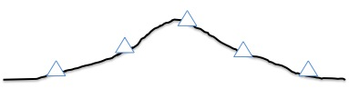

MONITORING EYJAFYALLAYOKULL
The maps below show the study area, including the summit of Eyjafjallajokull (red x at center), the summits of two other volcanoes (red x’s at top and left), and the locations of GPS stations.

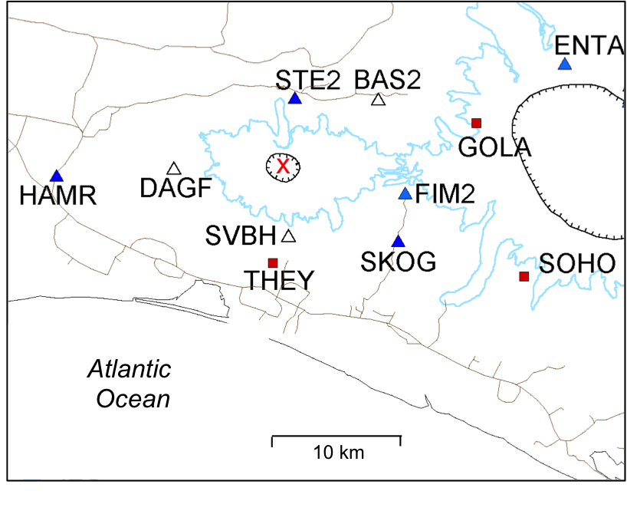
YOUR STATION: _________

- PREDICTED MOTION

With your group, discuss how you think your station will move during the following three time periods, and illustrate/explain your predictions as directed below.

  - Before eruption, as magma intrudes underneath the summit of Eyjafjallajokull - draw a RED arrow to indicate the motion of your station as magma intrudes beneath the summit of Eyjafjallajokull, but BEFORE eruption at the surface. Be sure to indicate compass direction AND the vertical component (UP or DOWN) for the motion. Describe your prediction below:

  - During eruption - what do you think will happen to the position of your station during eruption? (You might assume that material is erupted at the same rate it is intruded.)

  - After eruption ceases - draw a BLUE arrow to indicate the predicted motion of your station after eruption ceases. Again, be sure to indicate compass direction AND the vertical component (UP or DOWN) for the motion. Describe your prediction below:

- ACTUAL MOTION

Analyze the GPS time series and describe the actual motion of your station during the following three time periods:

  - Prior to eruption in mid-March 2010 - draw a RED arrow to indicate the motion during this time period, and describe the motion below. Be sure to indicate compass direction AND the vertical component (UP or DOWN) for each stage of motion. What do you think is happening to cause the motion?

  - Describe the motion of your station during the initial stages of the eruption (between the two red lines on the time series).

  - During the end of the eruption and over the next year (April 2010 to July 2011). Draw a BLUE arrow to indicate the motion during this time period, and describe the motion below. Be sure to indicate compass direction AND the vertical component (UP or DOWN) for each stage of motion.

  - Does your station end up where it started? Describe/explain.

- Reflect on the results for your station - how does the actual motion of your station compare with what you predicted?

- After reports from your classmates, add arrows to the map on the previous page, indicating the motions of the other stations. Is the behavior of the volcano consistent with the scenario you imagined in the thought experiment? Why or why not?

- Describe the extent to which the stations recover their original, pre-eruption locations (it might be different for different stations). If one or more stations did not recover their original location, why not? What does this imply about the shape of the volcano as a result of the eruption?

SEISMICITY AT EYJAFJALLAYOKULL

8. Go to http://vimeo.com/10708403and watch this ~1 minute video several times. Describe the earthquake activity under Eyafyallayokull from January to May, 2010, taking note of numbers, depths and locations of epicenters – especially in relation to the actual eruptions. Note:
  - The date format in upper left is in dd/mm/yyyy
  - The darker the symbol, the deeper the epicenter
  - The larger the symbol, the bigger the earthquake
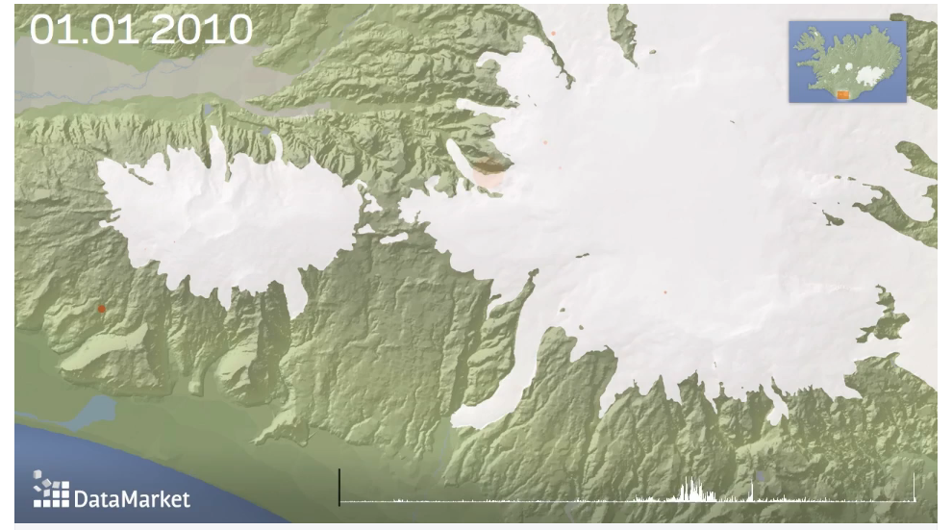
Katla
Eyafyallayokull

- Relate the earthquake activity to the GPS data. What do you think is happening at the volcano to cause the observed earthquake activity?

Assessment Questions

- Monitoring Eyafyallayokull

  - What were the indications that the volcano was "waking up" and entering a phase of eruptive activity?

  - What were the indications that the volcano was not only “waking up” but actually about to erupt?

  - How much warning time was there between the time of the first indications that the volcano was “waking up” and the time it actually erupted?

- At least for the inhabitants of Iceland (if not the airline companies), this was a low-risk eruption. No lives were lost and property damage was limited. What factors helped account for this?

Credit: Alaska Volcano Observatory, the U.S. Geological Survey, BigTopo 7, AllTopo 7 Image source: http://www.avo.alaska.edu/images/image.php?id=2935 Accessed December 2013
Map with GPS station locations used with permission from Sigrun Hreinsdottir. Data source: FutureVolc project (http://futurevolc.hi.is/) accessed at https://notendur.hi.is/runa/eyja_gps.html
This visualization shows earthquakes leading up to and during the 2010 eruptions of Eyjafjallajokull. Made Hjalmar Gislason of datamarket.com using data from the Icelandic Meteorological Office (htty://en.vedur.is). Video publicly available at http://vimeo.com/10708403

