Part 1: Updated volcanic activity data has been collected for Mount Rainer. Considering your observations from the previous class, incorporate new data provided here to complete the following information for use by emergency officials who need to understand the current state of volcanic activity.

1. What is the type of data you are examining?

2. Examine the data from June 8-12. What does this indicate about the activity at Mount Rainier (be specific: date(s), type of activity (increasing/decreasing), trends, etc.)?

3. What is your interpretation of the data for potential volcanic activity in the future? What alert level should the volcano be at today? (Alert levels are shown on the next page). Explain your answer.

Part 2:
4. What is the location you have been assigned?

5. Read the USGS Fact Sheet about Mount Rainier (posted with this assignment) and find the location you have been assigned on the hazard map (included in the Unit 6 Prework data). Describe what geologic hazard(s) is (are) most likely to occur at the location you are assigned if a large eruption occurs at Mount Rainier.

Recall USGS Alert Levels (these do not need to be printed/handed in)

Alert Level | Description
Normal | Volcano is in typical background, non-eruptive state or, if changing from a higher level:  The activity has ceased and volcano has returned to non-eruptive background state.
Advisory | Volcano is exhibiting signs of elevated unrest above known background level; or, if changing from a higher level:  Volcanic activity has decreased significantly but continues to be closely monitored for possible renewed increase.
Watch | Volcano is exhibiting heightened or escalating unrest with increased potential of eruption, timeframe uncertain,  OR eruption is underway but poses limited hazards.
Warning | Hazardous eruption is imminent, underway, or suspected.
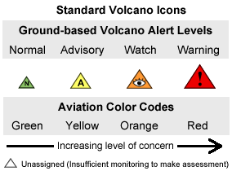

From: http://volcanoes.usgs.gov/activity/alertsystem/index.php#alertlevel

