Activity 1.3
Three sections form this class. Begin with a short discussion on lead and the EPA model to prepare for the interactive activity that follows.
The second section is the use of the EPA model and should take approximately 25 minutes. You should demonstrate on the EPA model various inputs and ways in which it can be used. During this time, students will observe the model and answer guided questions.
Remaining class time should be spent in discussion about the exposure factors and quality of data that go into the model. In section 2, we provide 8 questions for discussion. Some of these questions address inputs used to run the model while other questions address data that are generated from the model. At the end of this session, highlight to the students that this class focused on how exposure factors can influence the distribution of lead within an individual human, while in the next class students will discuss how lead is distributed in the population as a whole.
The homework assignment Evaluation of State Data is a preparation activity for next class. Students evaluate state level lead data and are asked to respond to questions. They will need the data set Lead Levels by State Data and worksheet Preparation Assignment: Evaluation of State Data.
An optional reflection activity for this class is provided that can be assigned as homework, along with the Evaluation of State Data. If you elect to use this assignment, the last few minutes of class should be spent explaining the assignment, which is comprised of a set of questions and a short response. For completion, students need to use their materials from class. The rubric is calculated out of 50 points to assess both the class assignment and homework.
Teaching Tips:
- The collective discussions and analysis of the EPA model are difficult to evaluate at an individual level. This particular discussion often finds students bringing very different levels of experience to the class. This discussion may be most valuable for students who have had no prior experience thinking about social determinants of health (race, ethnicity, poverty, etc.), and very straightforward for students who have spent years applying these concepts into academic practice. An assessment at this stage is not likely to evaluate individuals fairly; therefore, it is not a successful tool for assessing individual student learning on this topic.

The following items are included below:
- Background of lead and the EPA model to be used as a discussion point at the beginning of class
- Walk-through instructions for how to download and use the EPA model
- Possible responses to student questions in Activity 1.3
- Discussion questions with possible responses

Intentionally left blank.
Background on lead and the EPA model to be used as a discussion point at the beginning of class

Lead has toxic effects on everyone. However, it is most dangerous for children, especially children under 6 years of age; women during pregnancy and the developing fetus.

Today, environmental exposure to lead comes primarily from three sources: dust and paint chips in poorly maintained dwellings that have lead-based paint; soil lead; and to a lesser extent, lead in drinking water. Lead in these sources is found as inorganic lead salts, including lead chromate, lead oxide, lead carbonate, and lead arsenate (once used as a pesticide). In the few remaining parts of the world where gasoline still contains tetraethyl lead as an anti-knock agent, lead exposure can also come from lead in the ambient air. In its inorganic form, because it is water soluble, lead is excreted primarily in urine.

The half-life of lead in the blood is approximately 25-30 days. In theory, if the blood lead level indicates a very short time of exposure, when lead is excreted, the blood lead levels will decrease. However, the persistence of elevated blood lead levels is a marker of extended exposure, and suggests that other toxic effects may occur. In bones, the half-life of lead is approximately 50 years. This is especially concerning for mothers that were exposed to lead as children because they have lead in their bones, which is then likely to be transferred to a fetus during pregnancy. Lead also affects soft tissues, which in young children is a special issue of concern because an incompletely formed blood brain barrier allows lead to more easily enter brain neurons and exert toxic neurodevelopment and neurobehavioral effects. These effects frequently have lifetime consequences.

To better regulate environmental exposure as well as to predict outcomes, models have been developed that show the probability of blood lead level distribution given specific exposures to lead. They allow for a number of inputs, such as sources of exposure, duration of exposure, and other parameters to predict the distribution of blood lead levels where exposure has taken place over at least 90 consecutive days. One such model focuses on the most vulnerable members of the general population, namely, infants and children under 6-7 years of age, while considering the ventilation rate of the child. Although blood lead levels do not provide a complete “picture” of the consequences of exposure, they are used clinically because they are the least invasive measure of exposure, and taken together with other factors can serve as a “trigger” to encourage physicians to take more aggressive remediation measures.

In class, we will explore the use of the Integrated Exposure Uptake Bio-Kinetic Model for Lead in Children (IEUBK) software developed by EPA to estimate blood lead levels given certain exposure and activity parameters. The software can be adapted to a number of exposure scenarios and will be referred to as the EPA model from this point forward.

The EPA model considers the ways that lead is distributed to tissues after it enters the body. With information about concentrations of lead in the environment, combined with such factors as time spent indoors, time spent outdoors, and individual ventilation rate, it is possible to determine the probability of given blood lead levels in children. The output can be displayed in a variety of ways: distribution curve; distribution probability density; or a text file that includes information such as time spent outdoors, ventilation rate, and a number of other variables.

The model focuses on the probability of elevated blood lead levels in children given the concentration of lead in various environments. It also considers the probability of intake of a population of children at a given age. Below is a chart summarizing EPA values for lead intake, considering the medium (soil, dust, water, etc.) as well as the age of a child (EPA, 2002). The amount of lead absorbed is calculated by using absorption coefficients that are incorporated into the EPA model.

Media Intake Rates (Pb Intake Rate = Media Pb Concentration x Media Intake Rate)
Soil/Dust | - yr 0.085 g/d 4-5 yr 0.100 g/d  1-2 yr 0.135 g/d 5-6 yr 0.090 g/d  2-3 yr 0.135 g/d 6-7 yr 0.085 g/d  3-4 yr 0.135 g/d | Default intake values recommended. The default intake value for total soil and dust ingestion is a ratio of soil ingestion (45%) to dust ingestion (55%).
Air | - yr 2 m³/d 2-5 yr 5 m³/d  1-2 yr 3 m³/d 5-7 yr 7 m³/d | Default values recommended.
Drinking Water | - yr 0.2 L/d 4-5 yr 0.55 L/d  1-2 yr 0.5 L/d 5-6 yr 0.58 L/d  2-3 yr 0.52 L/d 6-7 yr 0.59 L/d  3-4 yr 0.53 L/d | Default values recommended.
Diet | - yr 5.53 μg Pb/d 4-5 yr 6.01 μg Pb/d  1-2 yr 5.78 μg Pb/d 5-6 yr 6.34 μg Pb/d  2-3 yr 6.49 μg Pb/d 6-7 yr 7.00 μg Pb/d  3-4 yr 6.24 μg Pb/d | Site-specific data may be used to augment default values.
Alternative Sources | Site-specific data may be used to account for intakes of Pb in sources such as Pb paint. | Refer to the IEUBK in User’s Guide and 1994 Guidance Manual for further discussion.

References:
EPA (2002). “Short Sheet: Overview of the IEUBK Model for Lead in Children.” EPA #PB 99-9635-8 OSWER #9285.7-31, August, 2002.

Hogan K, Marcus A, Smith R, and White P (1998). “Integrated Exposure Uptake Biokinetic Model for Lead in Children: Empirical Comparisons with Epidemiologic Data.” Environ Health Perspect 106(Suppl6):1557-1567 (1998)

How to download the EPA model
A PC is necessary as the software is not compatible with Macs
- Download EPA IEUBK software. You can do this by going to the EPA Homepage and establishing the following links:
A. Superfund
B. Contaminated Media, Human Health and Environment Effects
C. Contaminants
D. Addressing Lead at Superfund Sites
E. Software and Users’ Manuals
- The final site will direct you to the latest version of the Integrated Exposure Biokinetic Model for Lead Uptake in Children (2010). Follow the directions to download the software.
- Examine the software. You should use the beginner version of the software, and see what information is available by using the default inputs. If you wish, you can vary the inputs and see what the outcome is.

How to use the EPA model

General Information
- By default, the IEUBK calculates indoor dust lead concentration using Multi Source Analysis. Select set for additional information about Multi Source Analysis.
- Users can choose to enter indoor dust lead concentration if site-specific data are available. Constant value option is used unless the concentration differs for a specific age range.
- Ingestion rates are not typically changed unless site-specific information is available.

Information for running the model
- Use the beginner version of the software.
- Always choose to view the density curve when prompted.
- The model was created before the threshold was lowered from 10 μg/dL to 5 μg/dL. You will need to manually change this value for each time you run the model.
- Specific instructions and screenshots of each model are included by each question with a possible response.
- Consult the IEUBK guidance for more detailed information.

Intentionally left blank.
Student questions with possible responses
Inquiries using the EPA model
1. The newly established CDC BLL of concern is 5 μg/dL. Using default values in the IEUBK model, what percentage of children can be expected to have BLLs at or above the newly established BLL of concern?
The following screenshots show each screen that will appear while entering data for the model. These are the default values. In all other questions you will need to change 1-2 of these values.
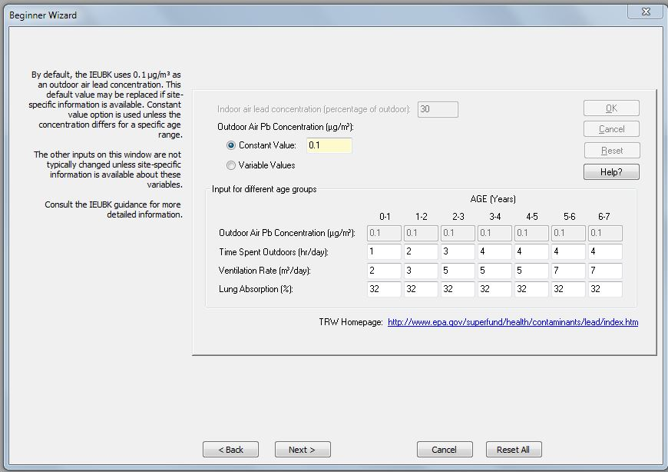
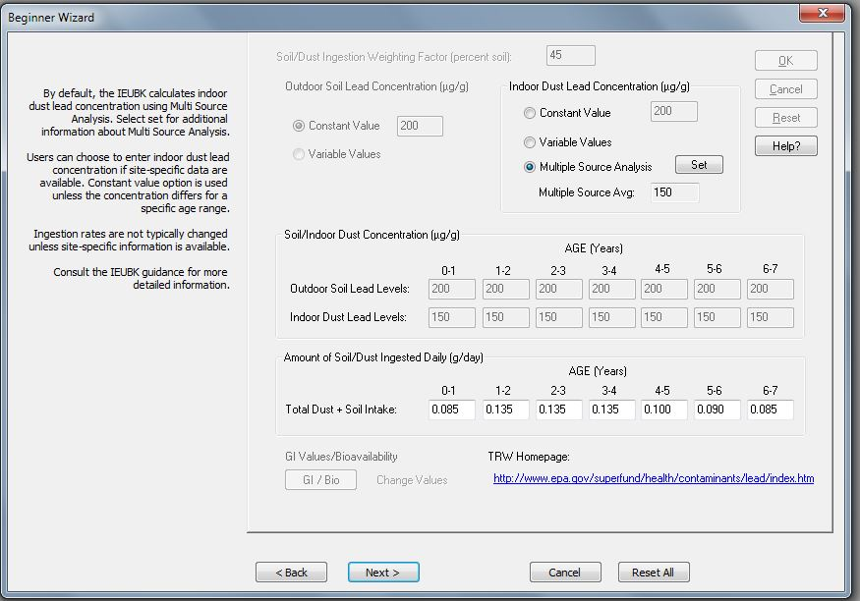
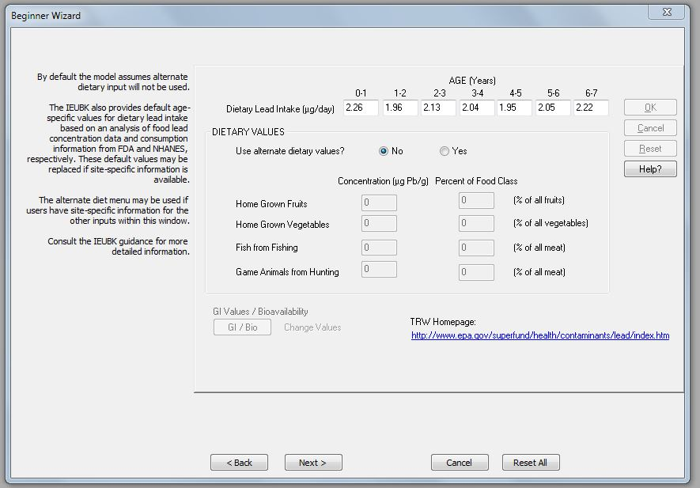

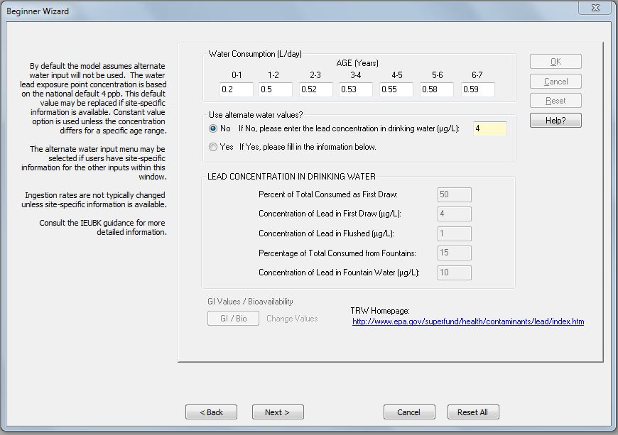
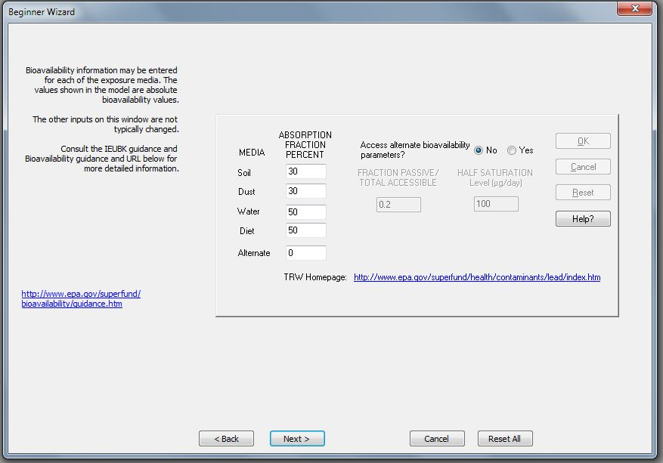

This is the graph the model will produce for this scenario. Students should sketch it and answer the appropriate question on their worksheet.
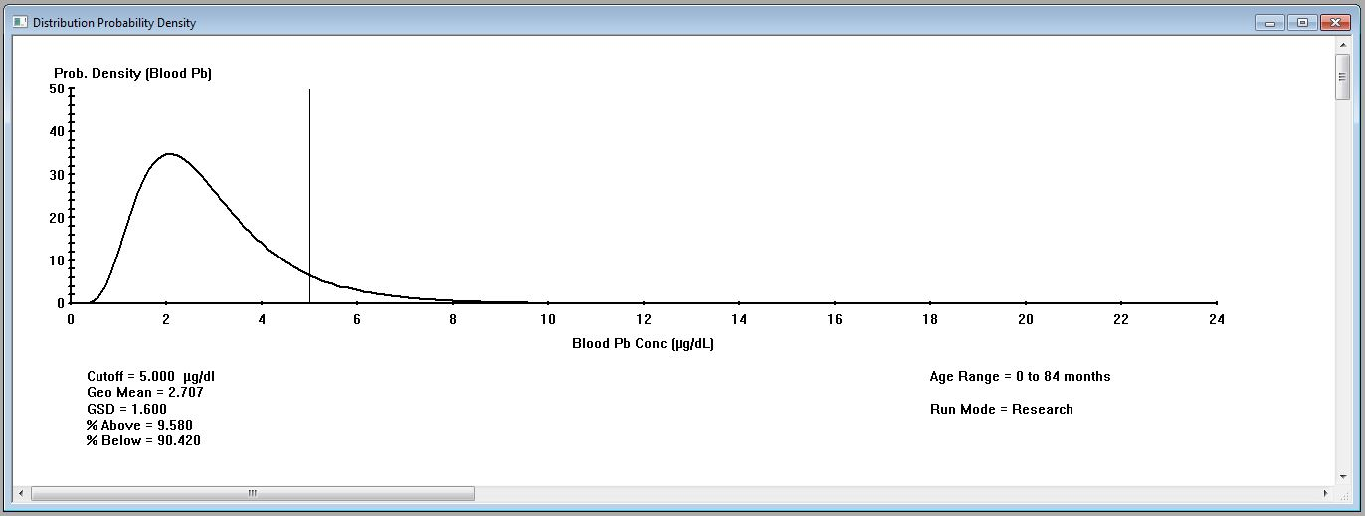

The best result is from using the density curve distribution and setting the cut-off level to 5 rather than 10 μg/dL. It is also possible to have a distribution curve of these data.
2. In 1980 before lead was removed from gasoline, average inner-city ambient air concentrations were approximately 0.8 ug/M^{3.} Consider an inner city environment in 1980 that contains soil lead with a concentration of 1400 ppm. Keeping all other inputs into the model at the default values, what are the mean BLLs of children in each age category?
- Enter outdoor soil lead concentration in the highlighted window. A site-specific soil lead concentration must be entered to calculate risk using the IEUBK.
- Arithmetic mean soil lead concentration is typically used.
- Constant value option is used unless the exposure point concentration differs for a specific age range.
- Ingestion rates are not typically changed unless site-specific information is available.
- Consult the IEUBK guidance for more detailed information.
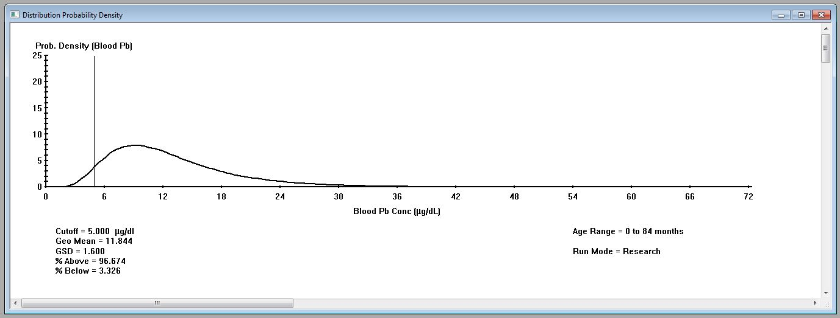

To determine the mean BLLs the output should be in a text file. Note that the mean BLL, with all other parameters kept at default values, for each age group is greater than the present CDC level of concern. Again, the cut-off value could be 5 μg/dL.
3. Predict the effect on the newborn if a pregnant mother lives in housing where the lead dust exposure is four times as high as that of the default model and spends significant amounts of time in the house.
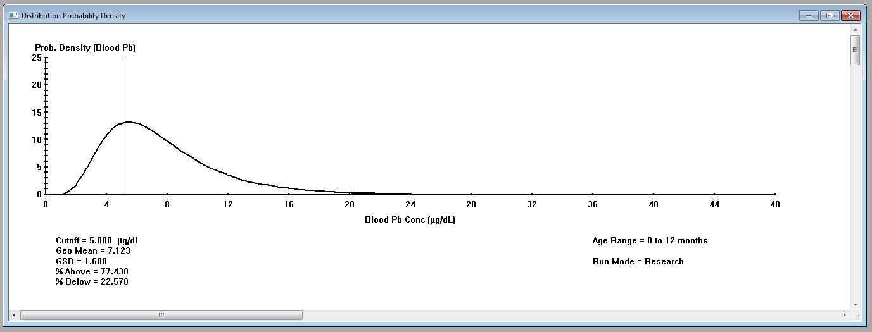
The model provides for input of maternal BLL. Certain assumptions would need to be incorporated into this prediction (as, for example, that the BLL used as a default would be 4 x as high). The model can be adjusted for time spent in and out of doors, and this may alter the output.
Respond to the following thought-based questions.
1. If a pregnant woman had lived from childhood in housing where the lead dust exposure is four times as high as the default model, would this increase the probability of the child having a significantly elevated BLL at birth? Explain.
If the mother lived in the same housing from childhood, she would carry a larger body burden of lead. This would include lead deposition in bone and teeth. During pregnancy, these deposits can be mobilized, resulting in a somewhat higher BLL of the mother. A significant amount of this lead is exchanged with the fetus through fetal-maternal circulation. It is likely that the infant would have an even higher BLL at birth.
2. Do air rates account for respiration rates?
3. Older children tend to eat different foods than younger children. Does the model take these differences into account?
No, the model just deals with standard baseline scenarios unless there is specific food data to input.
4. Are there other areas/populations that will have potential exposures? Can you predict the graph compared to the default?
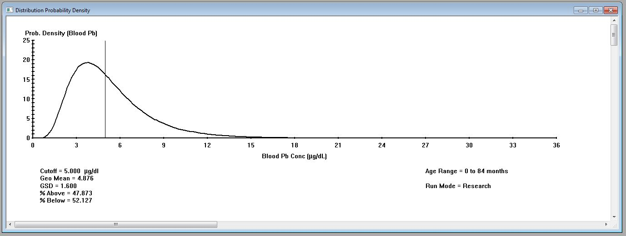
For example, Flint, Michigan, has elevated lead in water. Everyone is exposed but only people with nutritional deficiencies are at high risk, especially with a low socioeconomic status. Additionally, being downwind of a coal power plant exposes all individuals to lead.

Intentionally left blank.
Group discussion questions with possible responses
Assessment of EPA Default Data
This should be a group discussion. The EPA data on the discussion point text should be printed out or projected on a screen for students to reference.
1. List some alternative sources of lead that might be considered as well as the four categories of input.
Alternative sources of lead include lead in cosmetics, children’s toys (esp. imported toys), lead used in pottery, lead from ammunition, and from certain industrial activities. Auto-body shops, on occasion, use lead in repair work. Lead can be brought home from work sites where lead is used, including lead from unsafe renovation activities.
2. Family composition can play a role in exposure. Would you expect an infant who is first-born to be more or less exposed to lead than an infant who is the third child in a family of athletically active children?
To some extent, this is location dependent. If a child lives in an inner-city neighborhood with older housing, it is quite possible that playground soil contains lead. The younger sibling of athletically active children could be more exposed if the older siblings bring leaded soil into the household. In calculating BLL of the infant, soil/dust concentrations should be adjusted for outside soil.
3. What role do you feel parental employment might play in potential variation from default data?
See item 1 above. A parent, occupationally exposed to lead, might bring lead into the home if he/she did not change before returning, or did not clean dust from an automobile that he/she used coming from the place of employment.
4. If you were assessing these data in your community, give at least two examples of other information you would want to have to validate the EPA model.
Validation depends on actual data about BLLs in children, taken together with information about actual time spent in- and out-of-doors, lead in soil/dust, time spent in alternate locations (day-care centers, churches, schools, etc.), and household lead. If a child moves between households, then the values for lead dust as well as time spent in multiple households should be considered. All values are probabilities. Other factors that can influence BLLs include diet and whether (for infant) a child is breast-fed or uses infant formula.
Applications of the EPA model
1. Two samples of lead were taken from a household: one was a wipe sample that contained high amounts of lead; the other a sample from vacuum dust that contained lower amounts of lead. Without using the model, which do you feel is more predictive of a child’s BLL? Why?
Absent other information (such as time spent close to a highly leaded location, ingestion of lead chips, etc.) the vacuum dust is more likely to be the valid model input to determine the child’s BLL.
2. You have used the EPA model with inputs from dust vacuum samples, soil samples, water values, and other information (changing according to the value from your community). The model is predictive. How would you validate the model in your community?
Would need specific information about actual BLLs, as well as lead in ambient air, soil, housing, specific activities of children, etc. All measurements have some variability, but, using accurate inputs, the values should be close to agreement.
3. Identify two or more parameters of lead exposure to children that you would like to investigate in more detail.
From the in-class activities, several points may have come up: (1) in what ways default values that might have been used under 1980 conditions would change, and how this affects BLLs; (2) intake if vegetables and fruits are grown in soil containing large amounts of lead. If students are able to access information about their own neighborhood and housing, they could use this information to predict BLLs and, insofar as possible, check this against available information.
4. The EPA model is predictive of the probable range of children’s BLLs, given specific exposure conditions. Blood lead levels are a marker of exposure, but do not provide complete information about lead deposition and distribution in the body. The half-life of blood lead is approximately 40 days. How might this information be used by a public health official conducting housing and environment inspections to encourage removal/remediation of lead?
If information about lead exposure in soil/dust is available, it could be used to demonstrate to parent the probability of elevated BLLs. Assuming that this issue is remediated (lead removal, or repair and renovation), the BLL should drop within one or two months. If the BLL remains high, this is a “trigger” to investigate other sources of lead exposure. The predictive IEUBK model assumes exposure to lead for at least 1 day/week over a consecutive period of 90 days.

