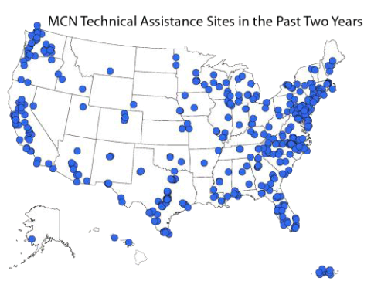

Source: http://www.migrantclinician.org/

**Map 1**

Migrant clinician networks offer assistance and consultations for migrants.

**Map 2**

The distribution of unauthorized Americans in the United States in 2008.

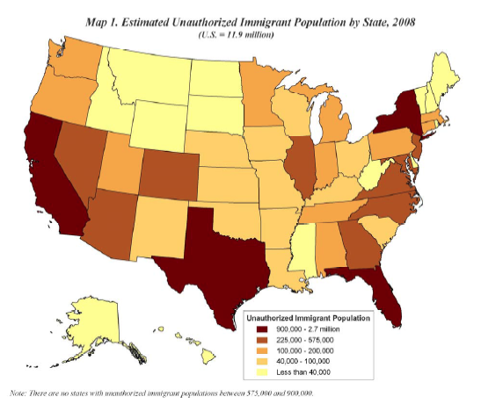

Source: http://www.pewhispanic.org/

**Map 3**

A state level evaluation of quality of health care in 2014.

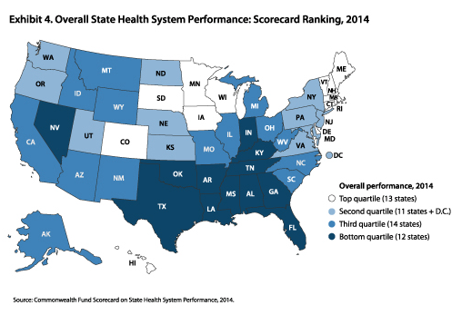

Source: http://www.georgiahealthnews.com/

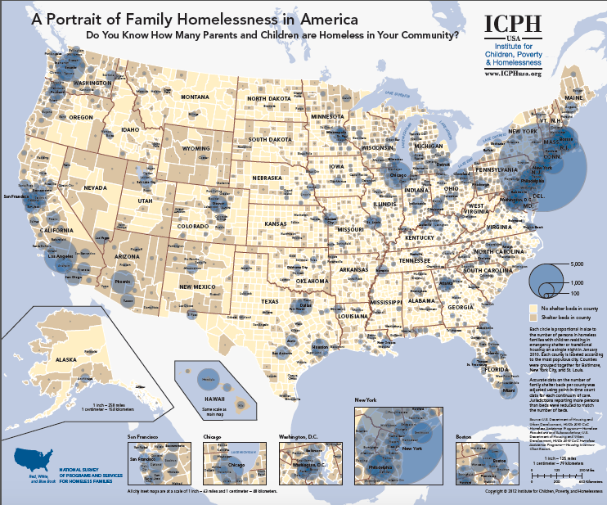

**Map 4**

Source: http://www.georgiahealthnews.com/

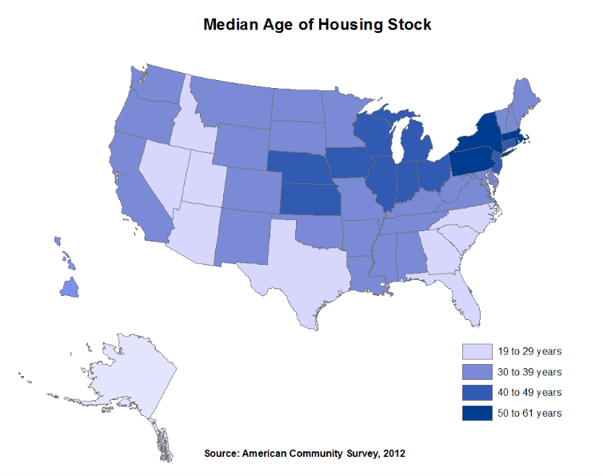

Map retrieved from <http://eyeonhousing.org/>, based on US Census data.

**Map 5**