Activity 2.3 – Risk Assessment Tools

- Visual Inspection
Visual assessments can be completed in any space that is possibly lead poisoned by homeowners, renters, or anyone involved. It is possible to take the HUD Lead Based Paint Visual Assessment Training Course online to become informed on the topic and gauge a preliminary notion of whether your home is at a high risk for lead.

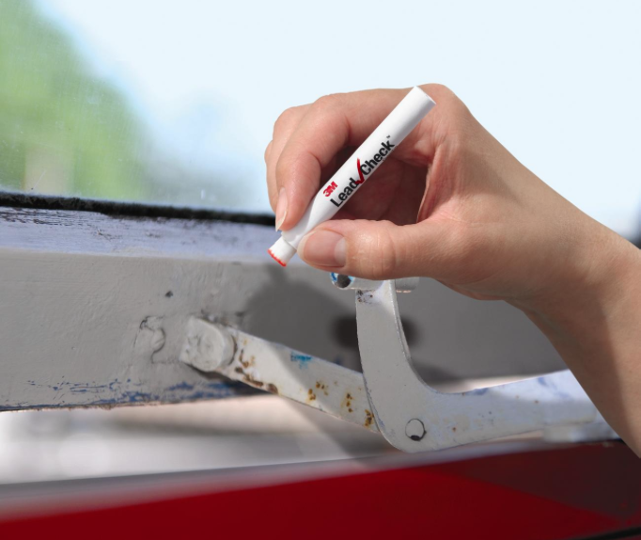
- Lead Test Swabs
A rapid, easily accessible way of testing for lead that is also inaccurate. To use the swabs, you simply touching the tip to a surface (windowsill, paint, etc.) and it is supposed to turn red on contact if lead is detected. However, a study conducted by researchers at the University of Rochester found that these swabs demonstrate false negatives about 64% of the time for a multitude of reasons, including dirt contamination or the ability of the swabs to only detect lead ions, not total lead.
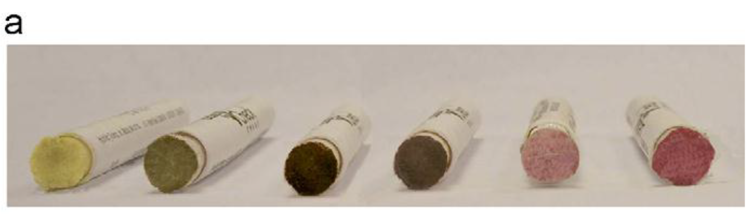
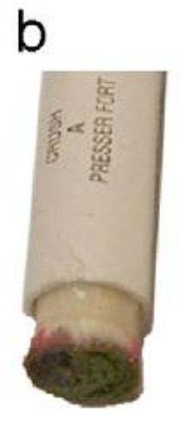

- Laboratory Analysis for Paint Dust Analysis
One of the most important sources of high lead exposure is lead-containing dust. By running analyses of paint dust on the floors, walls, and windowsills in a home or other dwelling, it is possible to understand the extent to which your residency is exposed to lead and can lead you in the proper direction for next steps. The analysis is carried out through atomic absorption spectrometry (AAS) and utilizes the wavelengths that atoms absorb light at to determine if the sample contains lead.

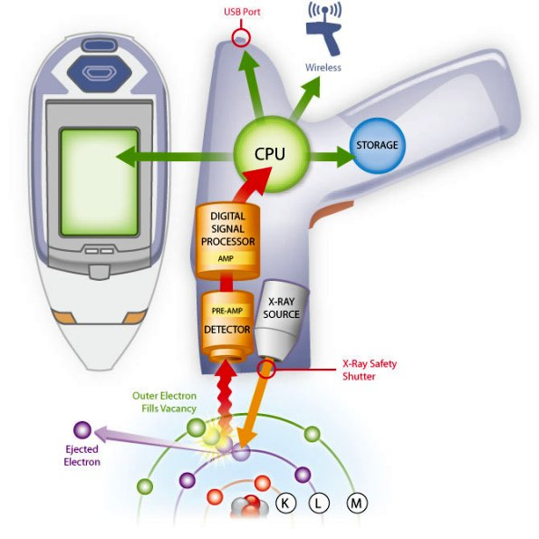
- X-ray Fluorescence Analyzer
This tool is utilized in measuring lead content in products at the limits required under the Consumer Product Safety Improvement Act. When a sample is hit with x-rays, the source x-rays experience scattering or absorption by the atoms in the sample. If the x-rays are absorbed, vacancies are created in the inner shells of an atom, which are in turn filled by electrons from the outer shells that emit x-ray photons, which has a specific amount of energy depending on the atom’s energy and thus allows for the identification of certain elements, like lead, in a sample.

- Certified Lead Detection Personnel
One of the costlier but also common lead detection methods, this involves hiring trained professionals to inspect a home.

Intentionally left blank for submission.
NAME _______________________
Activity 2.3 Questions

- Review the images provided highlighting key areas of each room in the house. Using the photographs provided, fill in the chart based on high, medium, or low risk.

- After completing the chart, make a recommendation about what type of lead risk assessment tool(s) you should use and justify.

- Compare your answers to the actual results of the dust analysis. What were your findings and were your predictions on what elements of the rooms to focus on accurate?

- Before the findings were available, homeowners decided to purchase the house anyway. Given these results, what should their next steps be? One next step could be a more comprehensive lead analysis while another could be complete remediation or lead containment within certain rooms.

- A middle-aged couple that has limited financial resources is thinking of buying this house. They do not have young children, can consider how they wish to conduct home renovations, and are not under time constraints to find housing. How might this affect their decisions? Would they be as thorough in assessing lead hazards?

- Now imagine that a landlord owns this house and is renting to a family with young children. What precautionary measures should be taken in this scenario? What is most likely to happen in this scenario? If the family contacted you, what rights do you think they should have?

- Once you have an understanding of risk, discuss possible management strategies.

