NAME ________________________
Preparation Assignment: Evaluation of State Data

- Choose one state from the list and graph up to 10 years of data showing the percentage of children with elevated blood lead levels (eBLLs). If you have access to a computer and choose to complete the graph in Excel, you may ignore the graphing template below.

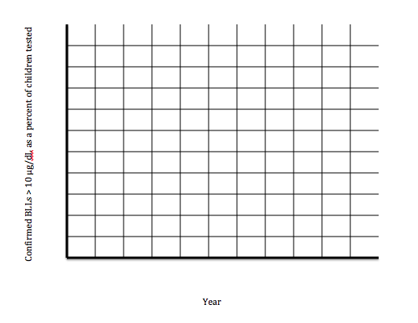

- Describe the trend observed over time.

- Evaluate the quality of the data for this state overall and for each data point? Did you omit any data points from your graph? Why?

