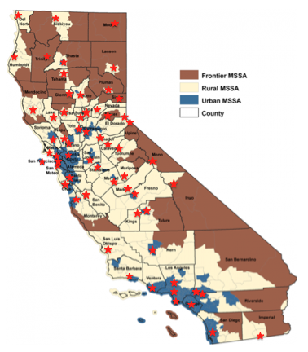
California Medical Service Study Areas

Source: OSHPD Healthcare Workforce Development Division
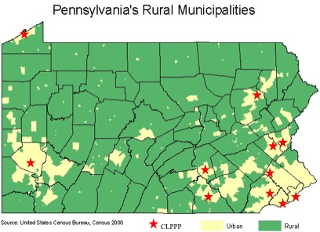
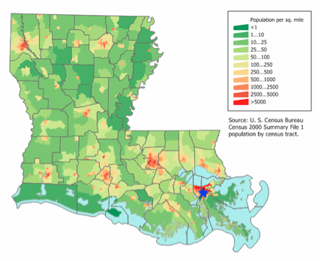
Louisiana’s population per square mile

