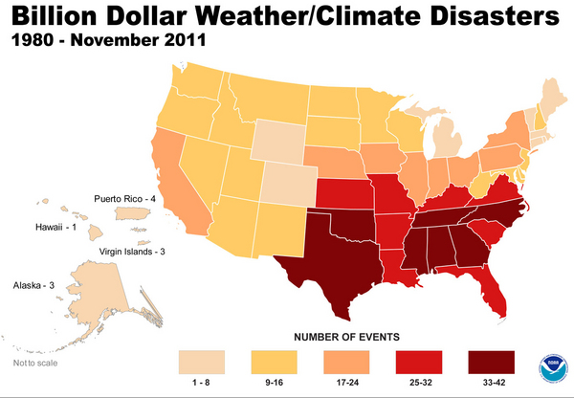
#1: Climate change and the insurance industry

(1) According to the map above, courtesy of NOAA, how many weather/climate-related events from 1980-2011 caused $1 billion or more in damage in Kentucky?

(2) What could explain why the highest number of weather/climate disasters occurred in Texas, Oklahoma, Tennessee, North Carolina, Alabama, Mississippi, and Georgia?

Here are two examples from the United States and abroad of how the insurance industry is responding to climate change. Please read these examples—then, with your group, answers the question below.
- In 2010, State Farm Florida insurance company cancelled 125,000 insurance policies. Most of these policy cancellations involved properties in areas vulnerable to hurricanes. State Farm Florida stated that they were losing $20 million/month and that the cancellations would help “stem State Farm Florida’s deteriorating financial condition.”

- Swiss Re insurance, Oxfam America, and other partners started HARITA (Horn of Africa Risk Transfer for Adaptation), a weather insurance program, in 2008 in Ethiopia. Roughly 85% of Ethiopians make their living by farming—the staple crop is a cereal called teff—but because of phenomena such as increased drought, many small farms in Ethiopia are struggling. Some farmers pay their insurance premiums in cash, but the program also allows poorer farmers to pay their premiums in labor—for example, helping with community tree planting projects. HARITA also requires farmers to take risk-reducing measures such as growing heat-tolerant crops, scheduling planting dates based on past precipitation data, and making compost to use in their fields to increase soil productivity. Finally, each community elects five people to work with the insurance companies on how to improve the insurance package. HARITA participants increased from 200 households in 2008 to 13,000 households in 2010.

(3) Which response—State Farm Florida OR HARITA—do you believe is a more effective climate change adaptation strategy? Explain.

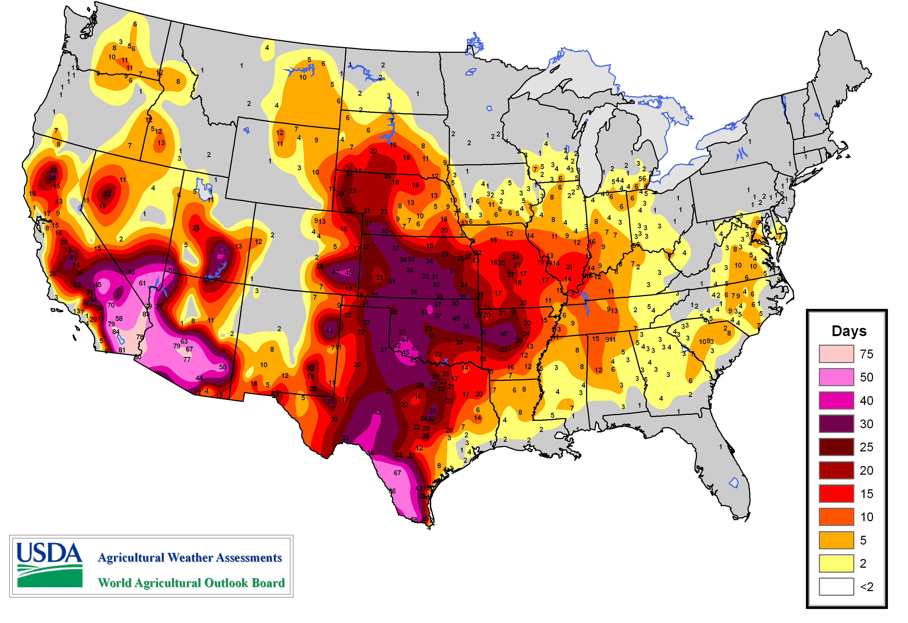
#2: Adaptation to extreme heat waves
The number of days per year over 100°F is increasing in many parts of the United States. The map below illustrates the June 1-August 31, 2012 data.

(4) What do the data show for your area?

Heat waves have several negative impacts, including:
- Heat-related illnesses and deaths. For example, in 1995, 739 people in Chicago died as a result of a 5-day heat wave (Hertsgaard, 2011).
- Greater demand for police, ambulance, and fire personnel.
- Greater demand for electricity to power air conditioners, which may lead to widespread power outages and more cases of heat-related illness and deaths.
- Increased emission of greenhouse gases by air conditioners.
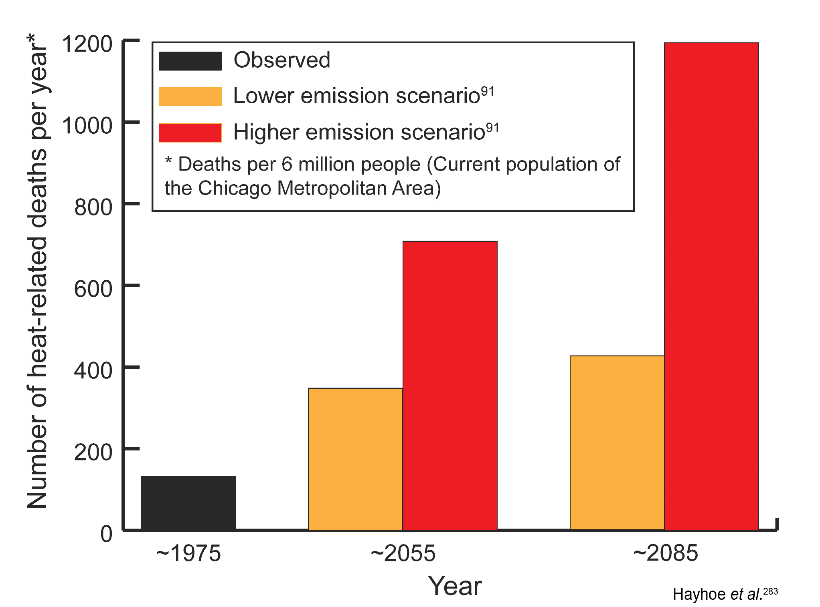
(5) The graph on the right illustrates some predictions for heat-related deaths in Chicago per 6 million people (the current population of the city). Thinking about vulnerability, name two groups that would be particularly susceptible to heat waves and heat wave-related deaths. Why would these groups be most susceptible?

Here are two examples of how the major urban centers, such as Chicago, as well as Wangaratta (a city in southwest Australia with fewer than 30,000 people) are adapting to heat waves. Please read these examples—then, with your group, answer the questions below.
- One of the components of Chicago’s ongoing Climate Action Plan involves identifying which parts of the city are “urban hot spots”—in other words, areas in the city that experience the greatest (top 10%) surface temperatures during the day and/or night. City studies of urban hot spots revealed that many of the urban hot spots corresponded to areas in the city that had the least tree cover. In 1989, Chicago Mayor Richard Daley piloted the Green Streets Initiative to increase the city’s urban tree cover. Since 1991, Chicago has planted over 600,000 trees, with an additional 1,000,000 trees to be planted by 2020.

- The “Rural City of Wangaratta” in Australia developed a Heatwave Response Plan in 2009. While the plan includes long-term responses to heat waves similar to programs in Chicago and New York, it also includes a short-term response plan that is implemented during heat waves. This plan includes extending the hours of operation of areas in which people can seek relief, such as air-conditioned community centers and swimming pools; suspending utility shut-offs for non-payment during heat waves; and establishing a community register. A community register is a list of residents (names, contact information, next of kin, and medical information) who are vulnerable to heat-related illnesses and/or socially isolated. People on the community register may choose to receive phone calls from volunteers or the police to check on their well-being during heat waves.

(6) What are some of the differences between adapting to heat waves in a major metropolitan area like New York City vs. a smaller city like Wangaratta? In which type of settlement do you think that adaptation to heat waves would be more challenging? Why?

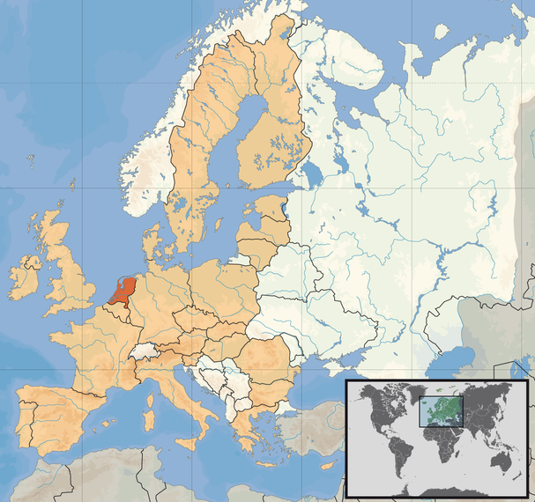
#3: Adaptation to flood hazards
Increased flood hazards are becoming a reality for many parts of the United States, whether the floods are related to increased precipitation, hurricane storm surges, or sea level rises.
http://commons.wikimedia.org/wiki/Atlas_of_the_Netherlands

The Netherlands (see map) is a low-lying country in which roughly 9 million (out of the 16.5 million total population) people are living below sea level (Aerts, 2009). Because of its proximity to the North Sea and the presence of the Rhine River, the Netherlands faces flood-related hazards from sea level rise, storm surges, increased precipitation, and melting of European glaciers that feed the Rhine.

Here are two examples of how the Netherlands is adapting to flood hazards. Please read the examples—then, with your group, answer the question below.

- The Dutch government started a program in 2006 called Room for the River that involves changing the existing landscape and flood infrastructure to give rivers more room to flow. This involves excavating (digging) to lower the elevations of floodplains; excavating the bottom of the river bed in order to make it deeper; removing obstacles like bridges that can interfere with river flow; and in densely populated areas, repairing and fortifying existing dikes. As the rivers are widened, some land that is currently occupied will be used to give the river more room, which will involve “selective relocation”. Some farmers, whose land lies within the floodplains, are being compensated for their land and relocated. In addition, the Dutch government has decided that some areas in an eastern city called Nijmegen through which the Rhine River flows, will be allowed to flood in order to protect more densely populated areas further downstream.
- Cities in the Netherlands are engaging in a variety of projects to adapt to increased flood hazards. In many cities, parking garages that are currently under construction must be built to double as drainage systems and fill with water during floods. Amsterdam, the capital city, is also building floating communities such as Ijburg and Maasbommel to allow houses to withstand floods without being damaged. The houses are made of wood, glass, and synthetic materials. Some are built on concrete tanks stationed in the water, while others are built on “floating foundations”, concrete boxes filled with plastic foam that serve as stable platforms. Docks serve as walkways and contain electric and sewage infrastructure within them. If flooding occurs, the houses rise with the floodwaters without being damaged.

(7) The Netherlands is a wealthy, industrialized country. Which of their adaptations would be feasible in poorer, developing countries? Which of their adaptations would not?

