Decade | Total hurricane strikes | Deaths | Adjusted (2010) cost million $
1901-1910 | 18 | 764 | 691
1911-1920 | 20 | 1,008 | 4,705
1921-1930 | 15 | 2,925 | 2,913
1931-1940 | 19 | 1,197 | 8,181
1941-1950 | 24 | 184 | 7,619
1951-1960 | 18 | 952 | 20,761
1961-1970 | 14 | 531 | 36,038
1971-1980 | 12 | 226 | 25,904
1981-1990 | 15 | 140 | 27,842
1991-2000 | 14 | 242 | 82,130
2001-2010 | 19 | 1,431 | 249,164

Part of Ft. Lauderdale, Florida. Images ~1 mile wide.
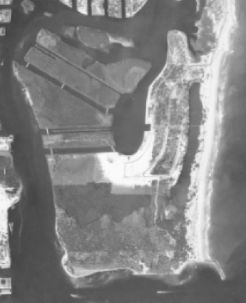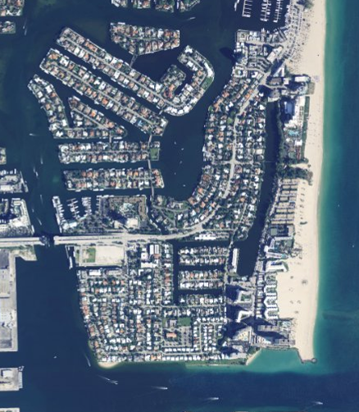
1947 (USDA, from ufdc.ufl.edu) 2008 (The National Map, USGS, nationalmap.gov)

Rockaway Beach, NY (~5 miles east of New York City). Images ~6 miles wide.
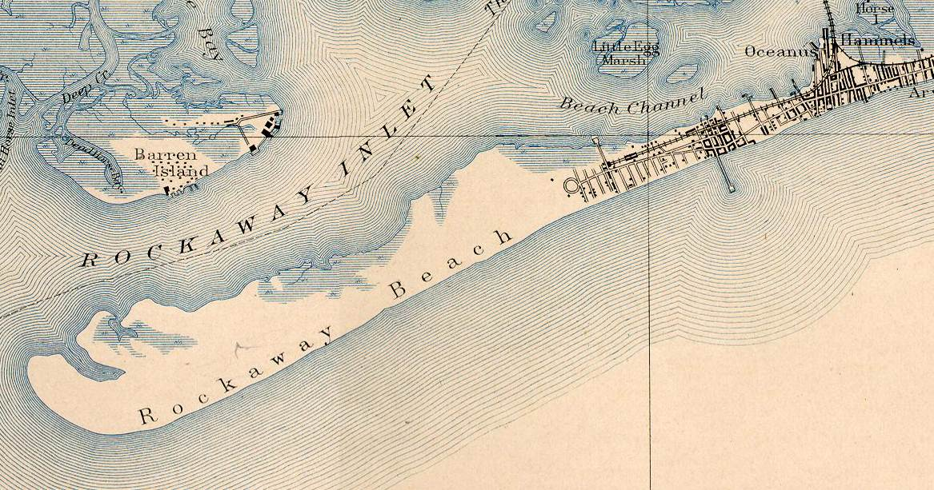
1898 historic topographic map (historical.mytopo.com)

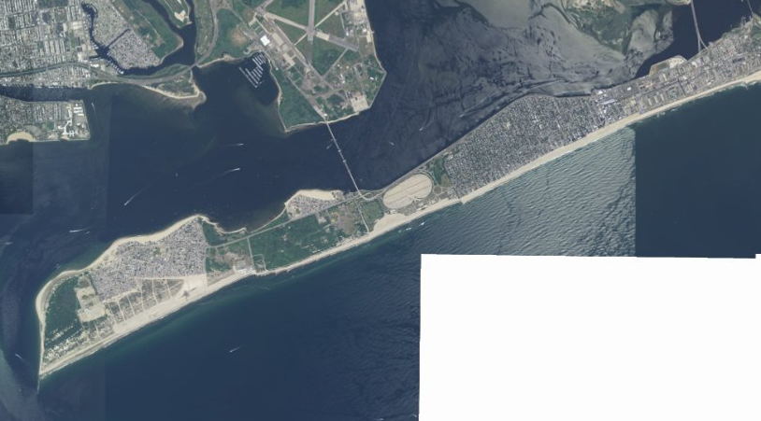

2008 satellite photo (nationalmap.gov).

