Hurricane Hazards Module Assessments Spring 2013

Assessment 1 – Homework Assignment

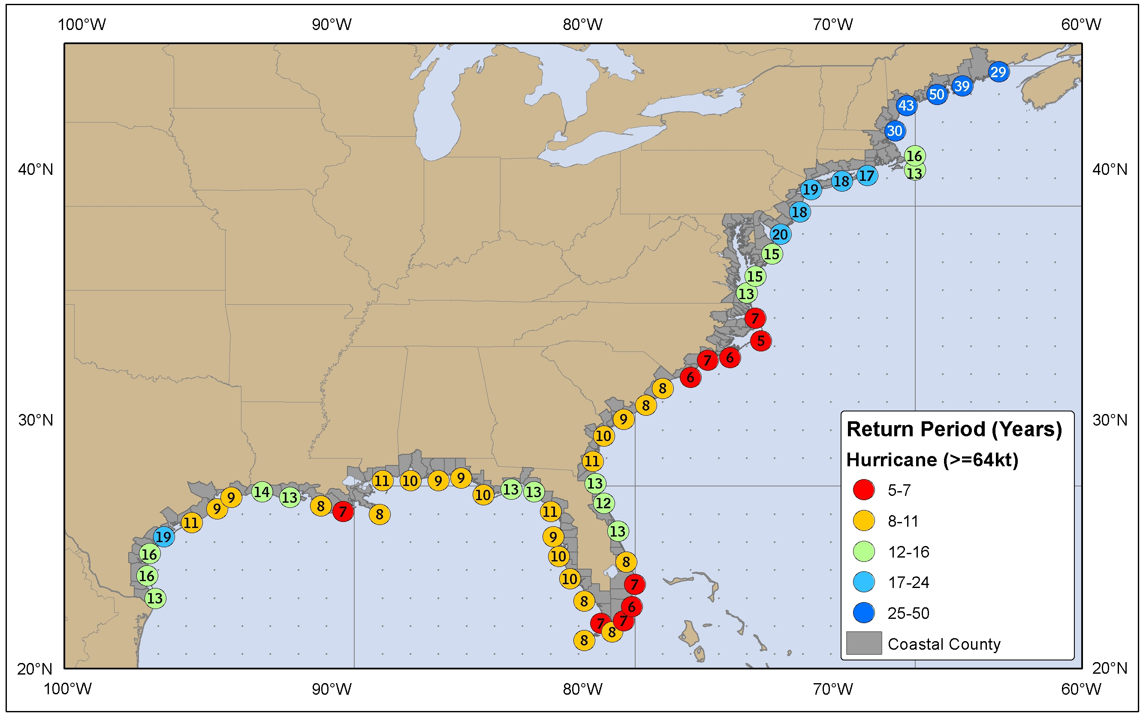
Figure. Return period of hurricanes passing within 50 nautical miles of various locations on the US Coast from the National Weather Service. If the return period is 50 years, the frequency is 1/50y. [Source: http://www.nhc.noaa.gov/climo/]

Question

Determine your own personal risk from hurricanes, using the figure above to determine the frequency of hurricanes in your area. If your house and all your belongings in it together are worth $300,000, what is the risk of being hit by a hurricane this year?
Show your work.

What assumptions did you make?

Calculating Hurricane Risk Rubric (3 points, or scale to your class grading system)

 | Yes | Partial | No
Shows sufficient work: | 1 | 0.5 | 0
Does calculation correctly: | 1 | 0.5 | 0
Lists insightful assumptions: | 1 | 0.5 | 0

Assessment 2 – Exam question

Exam Question 1. (5 points . . . approximately 5 minutes of an hour exam)

Describe the trends over the 20th century for 1) the number of deaths caused by hurricanes, and 2) the damages (in dollars) caused by hurricanes. Explain why any differences exist between these two trends.

Decade | Total hurricane strikes | Deaths | Adjusted (2010) cost million $
1901-1910 | 18 | 764 | 691
1911-1920 | 20 | 1,008 | 4,705
1921-1930 | 15 | 2,925 | 2,913
1931-1940 | 19 | 1,197 | 8,181
1941-1950 | 24 | 184 | 7,619
1951-1960 | 18 | 952 | 20,761
1961-1970 | 14 | 531 | 36,038
1971-1980 | 12 | 226 | 25,904
1981-1990 | 15 | 140 | 27,842
1991-2000 | 14 | 242 | 82,130
2001-2010 | 19 | 1,431 | 249,164
 | Yes | Partial | No
Accurately describes trend in deaths (down) and costs (up): | 1 | 0.5 | 0
States or implies that # landfalls not the relevant factor: | 1 | 0.5 | 0
Gives accurate reasons (coastal development is increasing risk): | 1 | 0.5 | 0
Discusses evacuations and predictions improving: | 1 | 0.5 | 0
Overall: insightful and logical: | 1 | 0.5 | 0
(Data from Blake and Gibney, 2011).

Exam Question Grading Rubric

Assessment 3 – In-class essay (5 minutes)

Question (5 minutes in class)

Explain the challenges of making the decision to evacuate prior to hurricane landfall:
1) from the perspective of a local government official issuing such an order:

and 2) from your own personal perspective, following such an order:

In-class Essay Grading Rubric (3 points)
 | Yes | Partial | No
Thoughtful synthesis of information from class and/or reading: | 1 | 0.5 | 0
Makes connection to their own life: | 1 | 0.5 | 0
Reflects understanding of the difficulty of making decisions with uncertain predictions: | 1 | 0.5 | 0

Assessment A – Concept Map

Concept Map Question (3 minutes in class):

Draw the relationships between the ocean, atmosphere, and people in a hurricane.

Concept Map Grading Rubric (2 points)
 | Yes | Partial | No
Includes all required parts: ocean-atmosphere-people: | 1 | 0.5 | 0
Makes accurate connections with hurricanes: | 1 | 0.5 | 0

Assessment B – Hurricane Tracker Calculations

Question (5-10 minutes in class: weather.com hurricane tracker open, with a partner):

a) How many hurricanes have made landfall in CT 1851–2010? __________

  - Recurrence interval (years/hurricane) __________

  - Recurrence interval of major hurricanes? __________

Calculations Grading Rubric (3 points)
- 11
- 15 y/hurricane
- 40 y/hurricane
(1 point each . . . 0.5 points off for units missing on b and/or c)

