Avoiding a Hurricane: Stay in Port or Continue as Planned?
Student Activity Sheet

Goal: Use data to predict hurricane track and make recommendations for a ship in the potential path of a hurricane at sea.
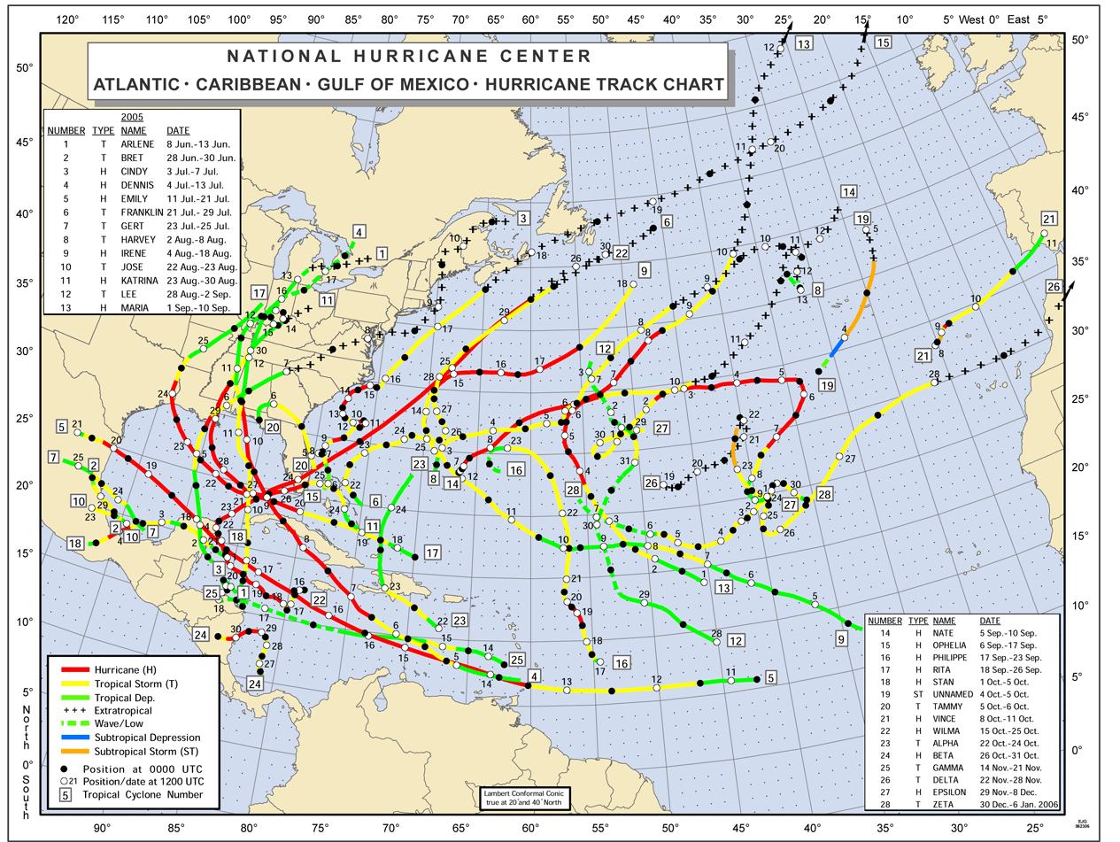
Background: Hurricanes in the North Atlantic can be tracked after they form, and often follow similar routes (Figure 1). Generally, a hurricane will travel from east to west and then north. North of about 30N, a hurricane will often turn to the northeast, following warmer waters of the Gulf Stream. Predictions for a hurricane’s position are made for three to five days into the future, with the hurricane’s likely path represented by a cone (Figure 2). The cone is larger further from the present location of a hurricane because uncertainty increases with forecast time. The entire track of the hurricane is within the cone 60-70% of the time.

Figure 1. North Atlantic hurricane paths from 2005.
(http://www.nhc.noaa.gov/tracks/2005atl.gif)
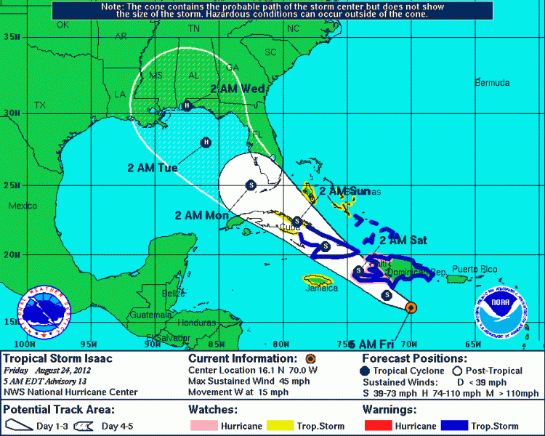
* Miami
* Galveston
Scenario: It is Friday morning and your container ship in Miami is scheduled to sail for Galveston, Texas, this afternoon. It is normally a three-day trip, but a hurricane is predicted to be near Miami by Sunday night (Figure 2). What do you do? Explain the relative risks of staying in port or heading to Galveston on schedule.

Figure 2. Hypothetical hurricane track. (http://www.nhc.noaa.gov)

