Name(s) ________________________
CO₂ in the Atmosphere
Learning goals:
- Analyze time series data of atmospheric CO₂
- Describe how changes in society have changed atmospheric CO₂
- Calculate individual contributions to anthropogenic CO₂ emissions
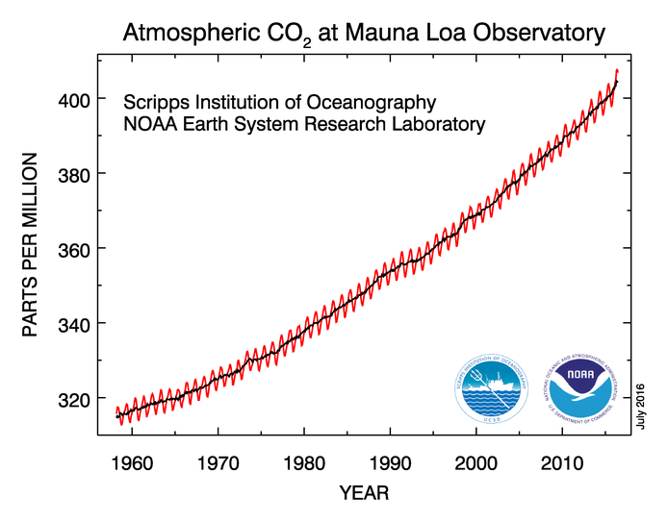
The above figure shows the amount of CO₂ in the atmosphere at Mauna Loa, Hawaii, the longest continuous direct measurements of CO₂ in the world. The line with the up-and-down pattern shows monthly values, the smooth line is the seasonally corrected version of the same values. They are presented in parts per million (ppm). The data are the most recent available from the National Oceanic and Atmospheric Administration's Earth System Research Laboratory, and are continually updated at http://www.esrl.noaa.gov/gmd/ccgg/trends/#mlo_full .
1. Assume that the growth rate in the most recent decade of data continues into the future. What will the concentration of CO₂ be 20 years from now?

2. Calculate your personal carbon footprint using the Environmental Protection Agency’s online calculator, available at http://www3.epa.gov/carbon-footprint-calculator/. What is your annual carbon footprint? Be sure to include whether your value is for yourself or your whole household.

3. Based on your footprint results, what practical action can you take to reduce your carbon footprint the most?

4. What do you predict will happen to atmospheric water vapor (H₂O; another greenhouse gas) if rising CO₂ leads to rising temperatures? How will changes to atmospheric water vapor further affect global temperatures? Be sure to explain your reasoning.

