Large Volcanic Eruptions
Guidelines for teamwork
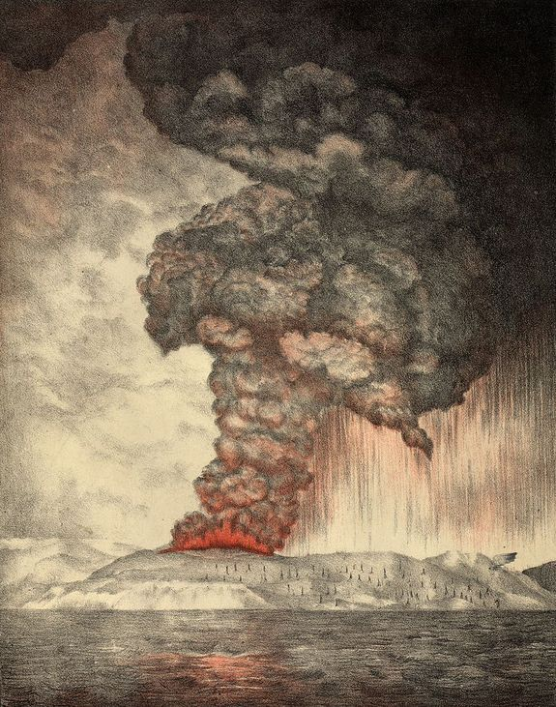
An 1888 lithograph of the 1883 eruption of Krakatoa.
Originally published by the British Royal Society in
“The eruption of Krakatoa, and subsequent phenomena”, 1888 https://archive.org/details/eruptionkrakato00whipgoog

You and your teammates have researched the same post-1800 volcanic eruption. In your group, combine your research results into one executive summary (see outline on the next page).

Rubric

Level of participation | absent | Little indication of group involvement | Fully participated in group
points | 0 | 2 | 5

Outline for Teamwork Summary
Eruption Name ________________________ Eruption Date _______
Geographic location of the event (lat/lon)___________________
Total eruption volume or mass
A qualitative estimate of sulfur content
An estimate of its influence on global and regional temperatures

Specific societal impacts including economic, public policy, human health and mortality effects.

Art inspired by the event: paintings, drawings, poems, books, movies, or music.

