Module Capstone Project:
Toba-like eruption in 2020
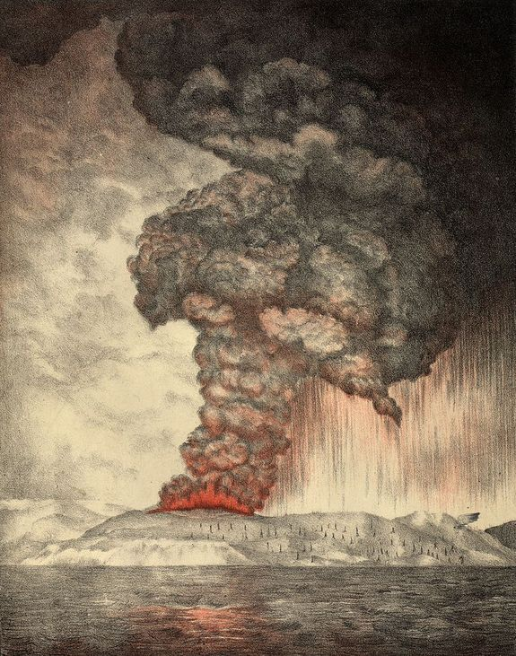
An 1888 lithograph of the 1883 eruption of Krakatoa.
from: "The Eruption of Krakatoa and Subsequent Phenomena", published 1888
https://archive.org/details/eruptionkrakato00whipgoog

Learning objectives: Students will
- Design a conceptual model to estimate the climatic and societal implications of a large Toba-type volcanic eruption in the year 2020.
- Compare and contrast the similarities and differences between the expected climatic effects of a Toba-sized eruption and the climatic effects possible from anthropogenically induced global warming.
- Communicate research findings, conceptual model, and compare and contrast exercise in a written summary.

1. Investigate Mt. Toba eruption.
The super-eruption of Mt. Toba is thought to be one of the most significant events of the past 100,000 years. Utilizing the same research techniques you used in Part A, write a brief summary of the Toba event (150 word minimum). Include at least two references for this summary.

2. Develop a conceptual model to explore the climatic and societal effects of a Toba-like eruption occurring in the year 2020.
Use the information from your Toba summary, relevant data relating volcanic eruption events to global and regional temperature changes, and your understanding of energy exchanges within the climate system to develop a conceptual model designed to explore the possible consequences of a Toba-sized eruption occurring in the year 2020. (note: it is estimated that the probability of such an event is very rare, less than once every million years, see Self 2006)
In your conceptual model you will form hypotheses regarding the magnitude and duration of all effects associated with this eruption scenario. Make sure to include a concept map (see Figure 1 and 2 in Appendix III), a concept sketch of your model (see Figures 3 and 4 in Appendix III), and use a system diagram to describe at least one relevant feedback process (see Figure 7 and 8 in Appendix III).
Your conceptual model should include your hypotheses of:
- The effects of the eruption on Earth’s atmosphere.
- The effects of the eruption on Earth’s energy balance.
- How the effects on Earth’s energy balance may alter Earth’s mean surface temperature. (see Figure 5 and 6 in Appendix III)
- Possible differences in effects on a regional and global scale.
- Possible impacts on local, regional, and/or global economy, changes in public policy, effects on human health and mortality.
- The magnitude and the duration of all effects associated with this eruption scenario.
The written summary of your conceptual model and the implications of a large modern day volcanic eruption should be at least 400 words. In addition, a major contribution to communicating your conceptual model is the completion of Figures 2, 4, 6, and 8 from Appendix III. These templates have been given to you to help your better understand the term “conceptual model” as used in this activity. Figures 1, 3, 5, and 7 from Appendix III show corresponding figures for anthropogenically induced global warming. They are included to both summarize some of the expected future effects from increasing greenhouse gases and as examples to help you complete the templates of Figures 2, 4, 6, and 8 from Appendix III.
A minimum of four references must be included with at least two of these must come from scientific journals. Appendix IV has a link to resources related to evaluating the quality of research resources that may also be helpful.
To gain additional perspective, write 150-word summary to compare and contrast the similarities and differences between the expected climate related effects of a Toba-sized eruption and those possible from anthropogenically induced global warming throughout this century. Identify and discuss at least two features that they would likely have in common and two features that are quite different. For example, it may be useful to think about ideas related to possible mitigation strategies, adaptation strategies, public policy before and/or after the event, socio-economic classes most affected, required changes in infrastructure before or after the event, and spatial coverage and duration of the climatic effects of each event.
You may work alone or in a team with up to 2 other people. If you choose to work in a team, a paragraph describing the responsibilities of each team member is required. (The Appendix has some useful resources related to conceptual model development)
Research on student learning suggests that students do better when they think about their learning process; this is referred to as metacognition. Before you start, please take a few minutes to answer the planning questions from the metacognition guide in Appendix II. Please also revisit this metacognition guide after you have made significant progress and take a few minutes to answer the progress phase questions, and after you’re near completion, please answer the evaluation phase questions from the metacognition guide.
References cited:
For journals or magazine articles references should include:
Author, publication date, title of article, journal name, volume, number, and page number.

For books the reference should include:
Author, title of book, chapter, page number(s), publisher with city, publication date

For websites, the reference should include:
Title, author, affiliation, complete URL address, retrieval date. If the website takes you to a PDF of a published journal article include the URL but also site it as for journal articles above.

*Examples of Acceptable Scientific Journals (a good source of scholarly papers is https://scholar.google.com/ ).
Nature  Science  Journal of Climate  Journal of Geophysical Research  Earth and Planetary Science Letters | Geology  Geophysical Research Letters  American Geophysical Union EOS  Bulletin of the American Meteorology Society

Rubric: Module Capstone Project: Toba-like Eruption.
(created from http://rubistar.4teachers.org/ )

CATEGORY | 100% | 75% | 50% | 0 to 50 %
Organization  (4 pts) | Information is very organized with well-constructed paragraphs and subheadings. | Information is organized with well-constructed paragraphs. | Information is organized, but paragraphs are not well-constructed. | The information appears to be disorganized.
Amount of Information  4 pts) | All topics are addressed and all questions answered clearly. | All topics are addressed and most questions answered clearly. | All topics are addressed, and most questions answered. | One or more topics were not addressed.
Quality of Information  (8 pts) | Information clearly relates to the main topic. It includes several supporting details and/or examples. | Information clearly relates to the main topic. It provides 1-2 supporting details and/or examples. | Information clearly relates to the main topic. No details and/or examples are given. | Information has little or nothing to do with the main topic.
Concept Map  (4pts) | A clear and organized concept map is presented and discussed. | A complete concept map is presented and discussed. | A complete concept map is presented. | No concept map is included.
concept sketch  (4 pts) | A clear and organized concept sketch is presented and discussed. | A complete concept sketch is presented and discussed. | A complete concept sketch is presented. | No concept sketch is included.
system diagrams  (4 pts) | A clear and organized system diagram is used to explain a feedback process relevant to your conceptual model. | A system diagram is used to explain a feedback process relevant to your conceptual model. | A complete system diagram is presented. | No system diagram map is included.
Mechanics  (4 pts) | No grammatical, spelling or punctuation errors. Achieved word count. | Almost no grammatical, spelling or punctuation errors.  Achieved word count. | A few grammatical spelling, or punctuation errors.  Less than stated word count. | Many grammatical, spelling, or punctuation errors.  Less than stated word count.
Sources  (4 pts) | All sources (information and graphics) are accurately documented in the desired format. | All sources (information and graphics) are accurately documented, but a few are not in the desired format. | All sources (information and graphics) are accurately documented, but many are not in the desired format. | Some sources are not accurately documented.
Metacognition guide (4 pts) | Thoughtful, clear, and honest reflection on your self-evaluation from the Appendix II metacognition guide. | Thoughtful reflection on your self-evaluation from the Appendix II metacognition guide. | Reflection on your self-evaluation from the Appendix II metacognition guide. | Very little to no reflection on your self-evaluation from the Appendix II metacognition guide.
This assignment is worth 40 points total.

Appendix I. Some useful resources for conceptual model development.
The effects and consequences of very large explosive volcanic eruptions. S Self. Philosophical Transactions A, The Royal Society Publishing. Published 15 August 2006. Access at: http://rsta.royalsocietypublishing.org/content/364/1845/2073
Conceptual Model: http://serc.carleton.edu/introgeo/models/WhatIsAModel.html
Concept Maps: http://serc.carleton.edu/introgeo/assessment/conceptmaps.html
Concept sketches: See Figure 1. From “The Atmospheric Effect of the Pinatubo Eruption” http://www.nuclear.lu.se/fileadmin/nuclear/Undervisning/Atmosfaerskurs/P04.pdf
and
http://serc.carleton.edu/NAGTWorkshops/careerdev/AcademicCareerTeach2013/march.html
Causal loop Diagrams: http://serc.carleton.edu/resources/14127.html
Power Point Review for this assignment used in class.

Appendix II. Metacognition guide for Conceptual Model development.
Use this to monitor yourself during the three key phases of your conceptual model development: 1) planning; 2) progress; and 3) evaluation. This will not be graded.
Planning phase. (Before you start, take 5 minutes to answer the following questions. Be brief and concise.) Submit this by our next class meeting (5 pts).
- What prior knowledge will help me develop my model?
- What assumptions must be made?
- What should I do first?
Progress phase. (After you get started, take a few minutes to reflect on your development process. Please include brief statements.) Do not submit this but do take some time for self-reflection.
- How am I doing?
- How should I proceed?
- Are my goals for this project too ambitious or not ambitious enough?
Evaluation phase (Near the wrap-up phase of this activity take a few minutes to ask yourself) Submit this with your final report.
- How well did I do relative to the rubric?
- What did I learn?
- What could I have done differently?
- Do I need to go back through the task to fill in any gaps in understanding?

Appendix III (figures to help guide you)
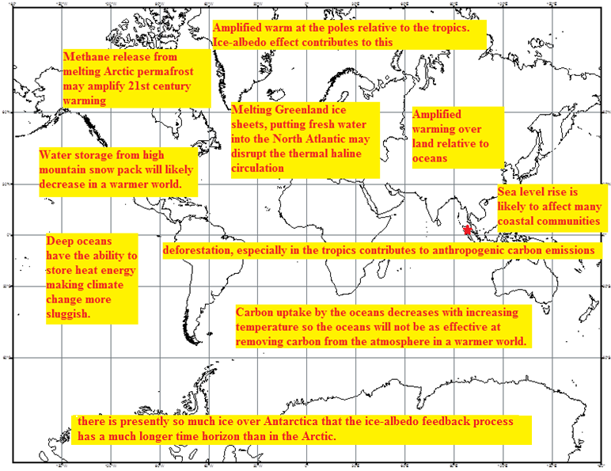
Figure 1. An annotated map highlighting some aspects of anthropogenic climate change expected over the 21st century.
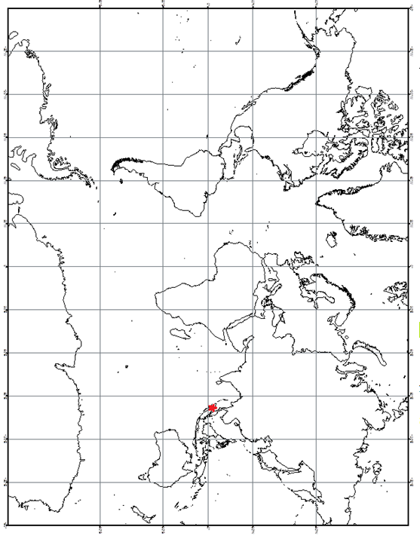
Figure 2. For your conceptual model, you could annotate this map with how a Toba like eruption may influence Earth’s energy balance and/or disrupt the climate system. The star in northern Sumatra show the assumed location of this event (3º N, 99º E)

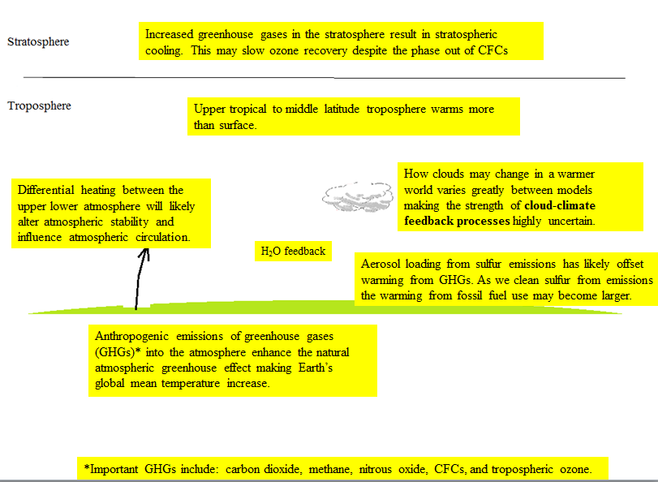
Figure 3. An example concept sketch showing six ideas related to anthropogenic warming.
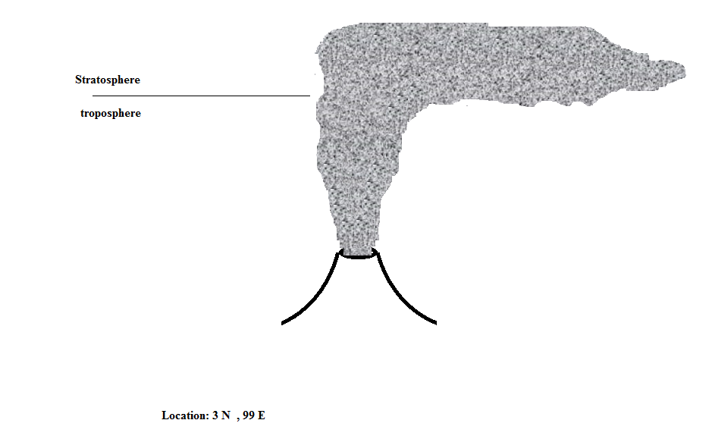

Figure 4. For your conceptual model, you could annotate this figure with your ideas on how a Toba-like eruption may influence Earth’s energy balance and/or disrupt the climate system.

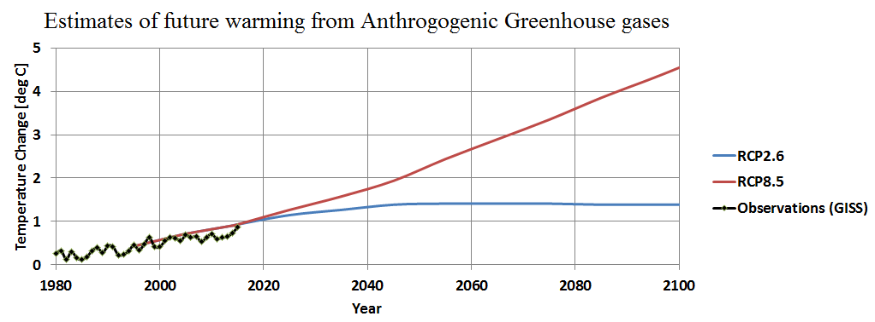Figure 5. Model based representative concentration pathways (RCPs) temperature estimates are references to 1986-2005 mean Global temperature. GISS anomalies are reference to 1951 to 1980 mean Global temperature. RCP2.6 is based on an aggressive emission reduction scenario keeping Global Carbon dioxide equivalent levels below 450 ppm and global warming less than 2.0 deg C above preindustrial levels. Carbon emission levels drop to zero by around 2080 for RCP2.6. RCP 8.5 is a business as usual scenario in which carbon emission reduction are driven primarily by economic factors and approximately triple by the year 2100. (See IPCC AR5 2013 summary for policy makers https://www.ipcc.ch/pdf/assessment-report/ar5/syr/AR5_SYR_FINAL_SPM.pdf .)

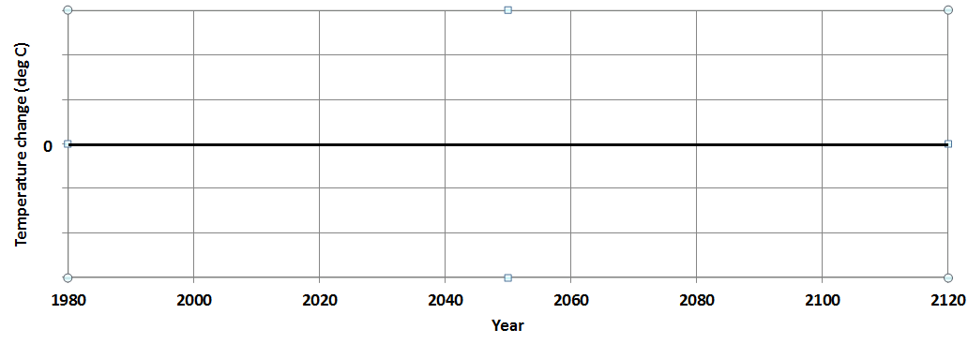
Figure 6. On the graph above include your hypotheses for the global average temperature change expected from a 2020 Toba like eruption. Make sure to include numerical labels for the vertical axis.

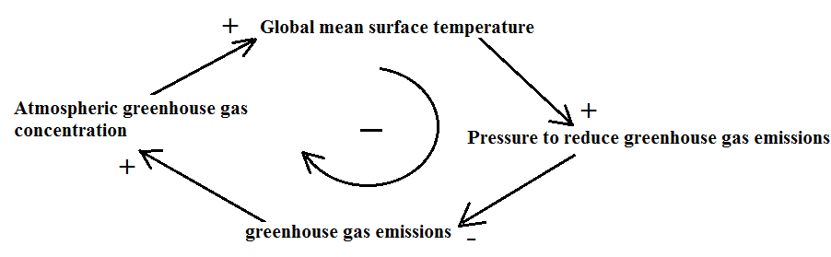

Figure 7. A system diagram showing one possible feedback process related to anthropogenic climate change during this century. Create one of your own for the climatic effects related to the Toba like eruption.

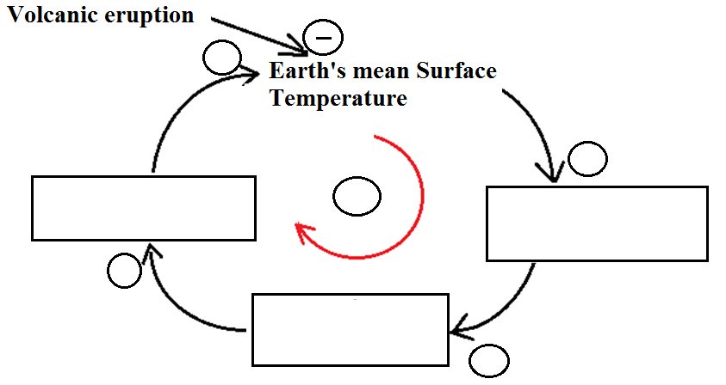
Figure 8. A possible template for a system diagram connecting 4 system variables in a causal loop. For you system diagram you could start with this diagram or even make a simpler diagram connecting only 3 system variables. To use this diagram include system variables in the boxes, and connection polarities and the sign of the overall loop feedback in the appropriate circles.

Appendix IV: Information and research tips
Clark College Library has compiled some excellent resources for student research.
http://libraryguides.library.clark.edu/ click on By Type and then Tutorials
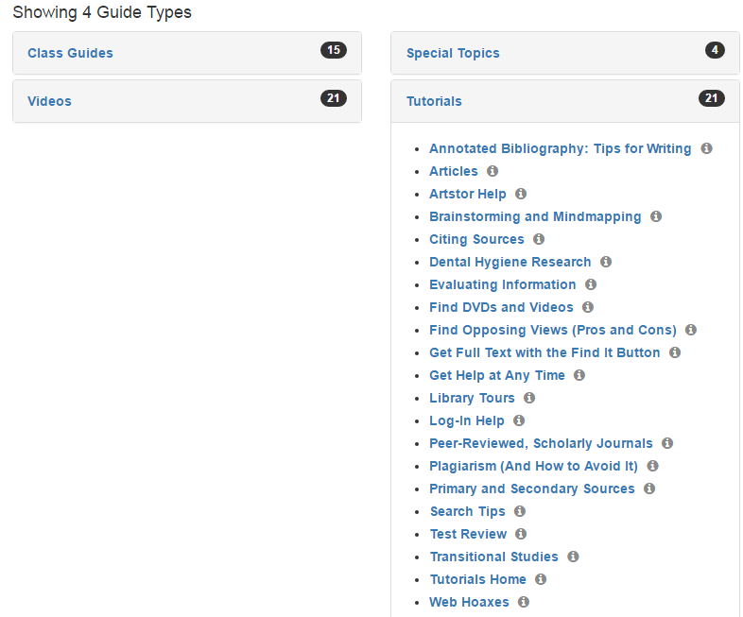
The evaluating information link http://libraryguides.library.clark.edu/evaluating-information is particularly useful and generic (not institutional specific), and the link to Peer-reviewed, Scholary journals is quite relevant. http://libraryguides.library.clark.edu/peer-reviewed-scholarly-journals .

