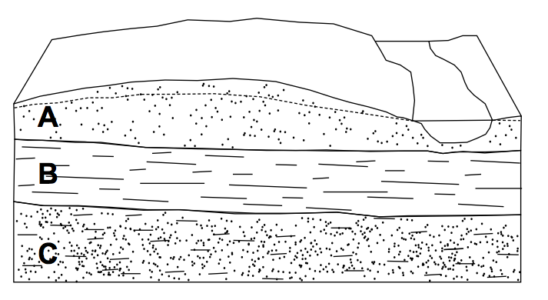
Lithologic symbols:

Sandstone (A)

Shale (B)

Silt (C)

Indicate which layer is the confined (closed) aquifer: A B C
Indicate which layer is the unconfined (open) aquifer: A B C
Indicate which layer is the confining layer (also aquiclude or aquitard): A B C

