Assessment rubric for Unit 4

Possible answers:
El dibujo y la explicación del efecto orográfico deben basarse en los elementos del diagrama que sigue:
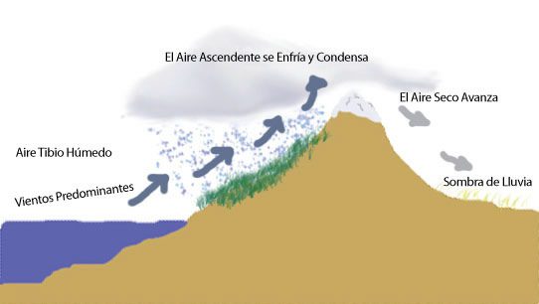

Factores que causaron las guerras del agua en Cochabamba:
La subida rápida de tarifas con la privatización del agua
Las creencias de la gente de que el agua es un bien común
La escasez del agua a causa del efecto orográfico de la región
La privatización de toda el agua – hasta la lluvia
Quitarse la práctica de gestionar el agua a nivel local, en los barrios

Criteria | 0 | 1 (Poor) | 2 (Acceptable) | 3 (Good) | Score
Identification of 3 factors | None | 1 factor is correctly identified | 2 factors are correctly identified | 3 (or more) factors are correctly identified
Create a version of a rain shadow and explain how it works | None or diagram and/or explanation show clear inaccuracies or misunderstand ing of rain shadows | Student can explain and create a labeled diagram that illustrates some of the components of a rain shadow OR student successfully completes only the diagram or only the explanation (but not both) | Student can explain and create a labeled diagram that illustrates most of the principal components of a rain shadow | Student can explain and create a labeled diagram that illustrates the principal components of a rain shadow
Language | None, incomprehens ible | Language errors are a major obstacle for comprehending the student’s writing OR language production is minimal | Student able to communicate ideas with some errors and language gaps | Student is able to express ideas clearly and/or with detail using specialized vocabulary from the unit. Writing shows few errors.

