Module 2 Summative Assessment Name: ______________________________
Date: _______________________________

Identifying Combined Natural and Human Drivers in a CNHS model of the Transition from Hunter-Gatherers to Domestication and Early Agriculture.

We first present a detailed version of the interaction of human and natural systems at the onset of agriculture at the end of the last ice age. This was presented in less detailed form at the end of Module 2.1. This diagram will provide you an example in the use of these diagrams as you answer the questions in the worksheets. There are four questions in this worksheet, some of them with multiple parts.
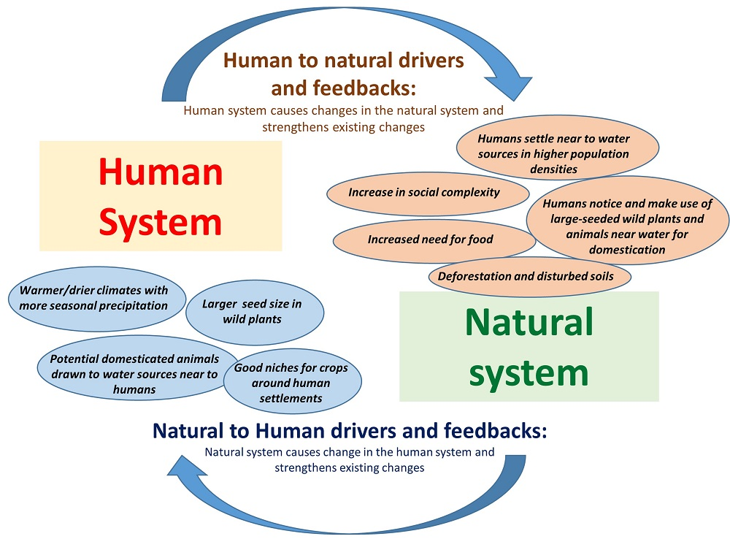
Figure 1. Example of human and natural system drivers around domestication in human food systems, to guide responses in this summative assessment.
Question 1: based on Fig. 1 above, the definition of feedbacks at the end of module 2.1, and the history presented in module 2.2 around the emergence of agriculture, name two examples of positive feedbacks that could result from the human and natural drivers in this diagram and explain how these acted to hasten the transition to agriculture. Each response should be one to two sentences.
  - Feedback example 1:

  - Feedback example 2:

Question 2: Below you will see a blank diagram based on Fig. 1 above, and a corresponding table to help in filling in the blanks (see also the concepts on the next page). Based on the accounts of food systems history, “Period 2: Independent States, World Trade, and Global Colonial Empires” use the examples of drivers and feedbacks cited in the reading regarding the spread of European species and agriculture to other areas of the world. You are given a listing of drivers below the diagram that you may use to fill in the ovals, along with others you may note from the readings. You should fill in the name of drivers in the table below the diagram, so that you can fill the worksheet in electronically. The numbered cells of the table will then correspond to the ovals linked to “Human to Natural Drivers” and “Natural to Human Drivers”.
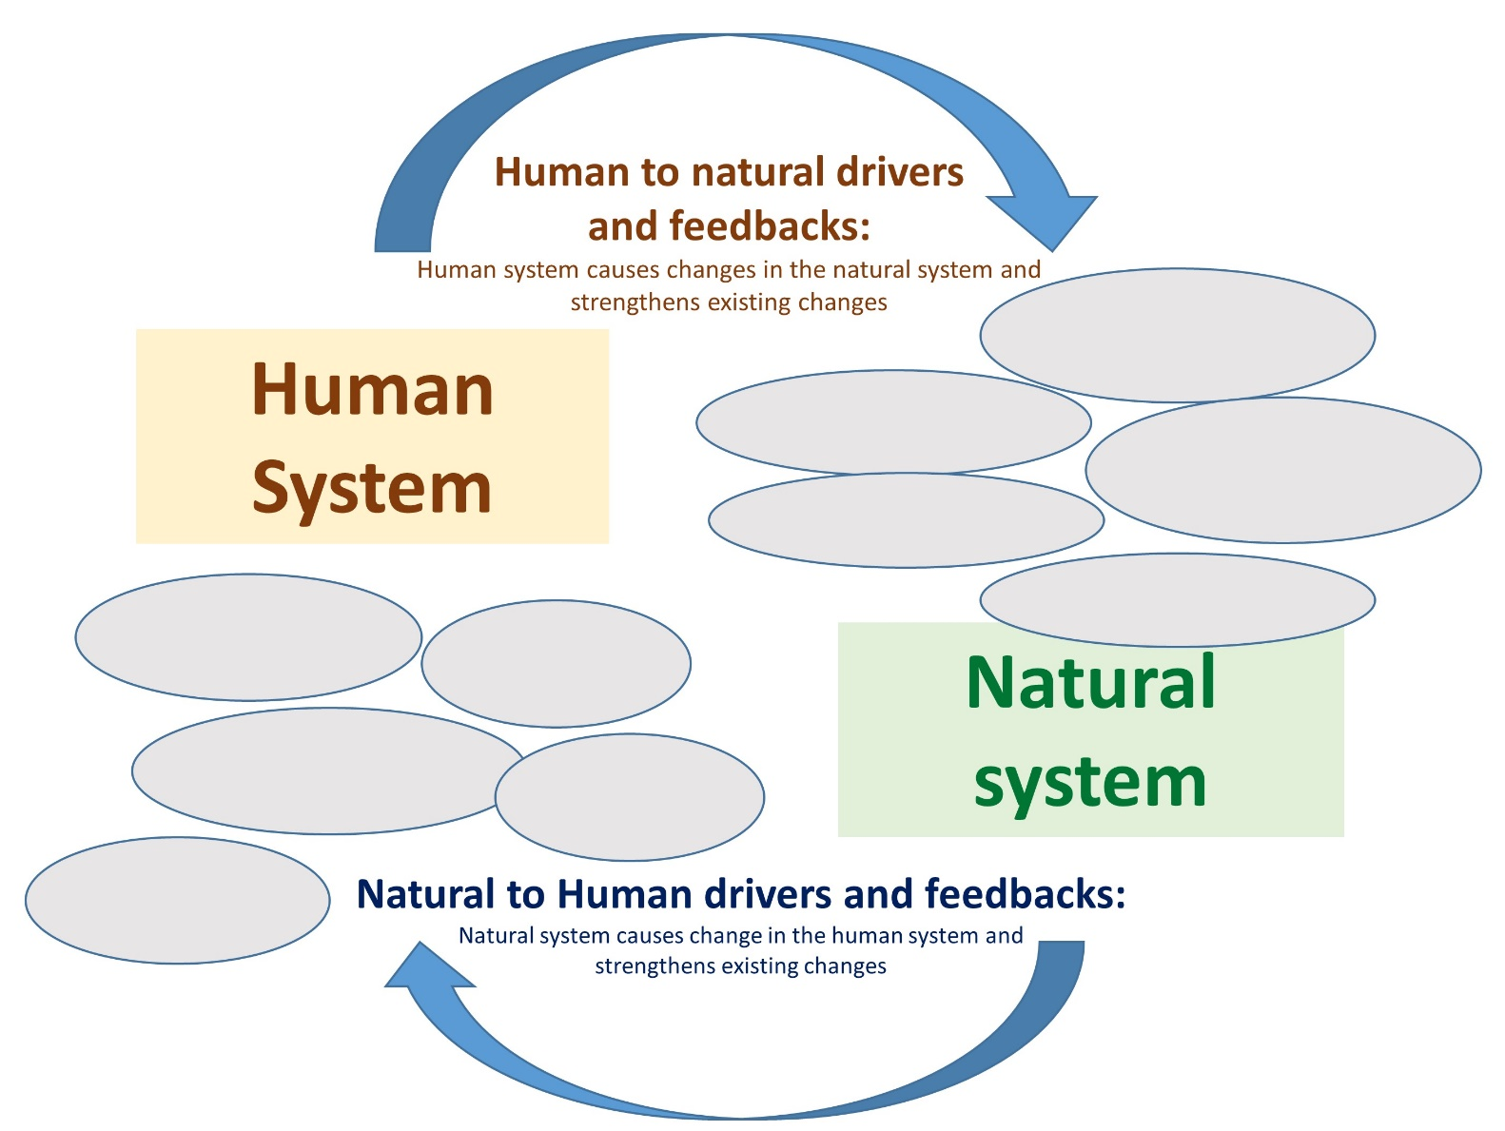
4.
5.
3.
2.
1.
5.
3.
3.
2.
1.
Figure 2. Blank diagram to be used for diagramming drivers and feedback in the case of the spread of agriculture to colonial areas as part of the expansion of European empires.
Natural to Human drivers | Human to natural drivers
1. | 1.
2. | 2.
3. | 3.
4. | 4.
5. | 5.

(Check next page) Concepts you can utilize from the diagram in the text (Period 2: Independent States, World Trade, and Global Colonial Empires) on to fill in the table:
- Introduction of Eurasian livestock (cattle, sheep, and goats, for example) to colonies in the Americas and the Pacific (e.g., South America, New Zealand, Australia.
- Introduction of crops and pasture plants from Europe to colonies, including those that were tolerant of grazing
- Establishment of crop and grazing areas, replacing wild ecosystems in colony areas.
- Further expansion of the introduced European livestock and pasture systems.

Note: you can also add other changes that accompanied these drivers in the human and natural systems as well, in the table above. It is ok to summarize the concepts from the text above, or others you take from the readings, to place them in the table.
Question 3: as you did for the first diagram above, explain in one to two sentences how these factors and others you placed in Figure 2 (blank ovals and the table above) would interact to create a positive feedback hastening the expansion and adaptation of European species and agricultural management in colonial areas of these empires:

Question 4: Next to each of the following terms, find two examples of each in the history of food systems that is summarized in the summary of food system histories that is summarized in module 2.2.
- Spatial diffusion (give two examples and explain in one sentence)

2.

- Niche construction:

2.

