Formative Assessment Module 10 Worksheet:
- Choose a case example on which to do your assessment . The cases we give here are Colorado, Pennsylvania, Peru, Ethiopia. Some of the cases may closely match your capstone region and you can choose these if the results will be of interest to you in developing your project. You can also do your exact capstone region. If you choose to do this last option, be sure to look briefly at one of the four cases given here to see what sort of information may be interesting in answering the assessment.
- Look at the text materials and the powerpoint file of images and figures given in the zipped packages off of the course website. Try to develop a sense for the overall components of the food system: human and natural subsystems; production, distribution, and consumption aspects. You should be reminded of different aspects of the material in the course up to now as you read these (Natural system factors, agroecosystems, food systems)
- Although the descriptions here have a good amount of detail for this assignment, if you are curious about additional information about this case then you can use google and cite any additional resources you find.
- Look at the diagram depicting the emergence of the food system over time in the case example you have chosen. Fill in the responses on the worksheet that continues below the diagram. The spaces in what follows refer to the boxes in the diagram. There is not space on the diagram so use the responses in what follows.
More below diagram……

Worksheet diagram: you can fill in responses by using the blanks 1, 2, 3 below where you will have more room to briefly explain your choices.
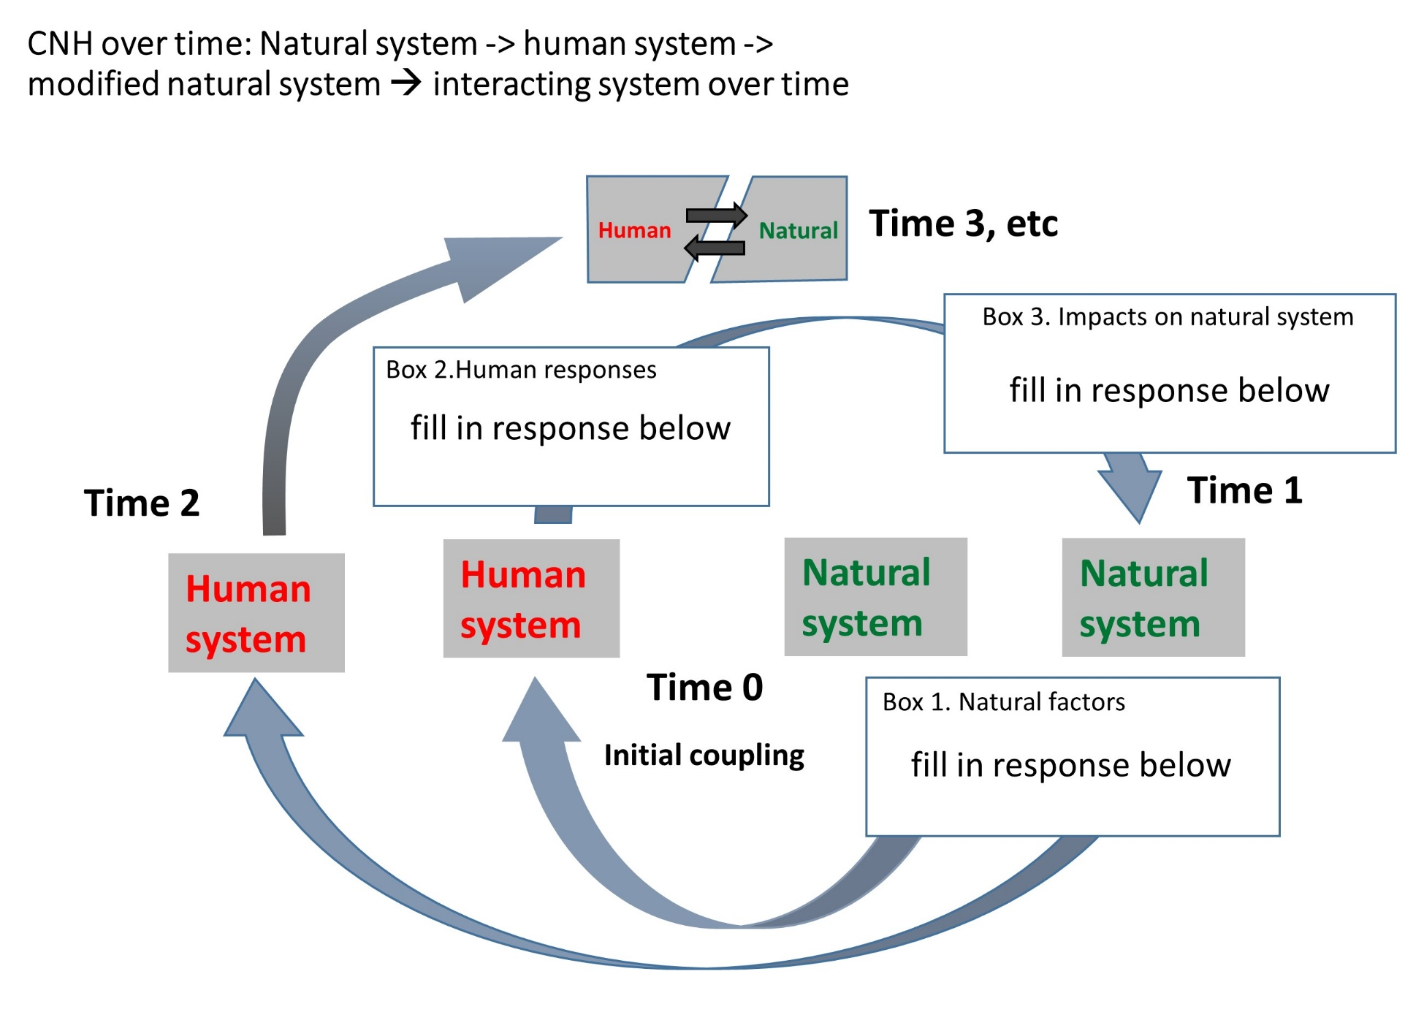

- At time zero in the blank box provided on the diagram (Box 1), give two natural system characteristics that contributed to the development of this food systemThen, describe in detail one of these natural system factors:
    - Natural system feature: ______________________________
    - Natural system feature: _______________________________
    - How did one of these contribute to the development of the food system:

- At “time zero” in the box provided (Box 2), give three ways that the human system responded to the natural system in the development of the food system, through farm management practices, local or national government policy, or other human system factors. Note that you may not be used to thinking of a management method or a policy as a “response”- you may think of them a “just existing” – but that is what the CNHS diagram helps us to notice.
- Human system response: ______________________________
- Human system response: _______________________________
- How did one of these contribute to the development of the food system:

- In the box provided at “Time 1” (Box 3), give two major impacts of human management on the natural system. In the blank below on the worksheet, state how these impacts are likely to change interactions within the natural system.
  - Impact on natural system 1.___________________________________
  - Impact on natural system 2._____________________________________
  - How do these impacts change interactions in the natural system:

- Give and describe briefly (3 sentences) the dominant type of food system discussed in the text (global, smallholder, alternative) that emerges from the interactions of human and natural systems in these examples:

- Give and describe briefly (3 sentences) one overlapping type of food system that may be present in these examples, though less central or visible:

- Diagram a food supply chain like the one in the introductory activity for one product within the system you chose using the blanks below, but without the social and ecological dimensions which are already addressed here. Be sure to include as many processing or other steps as seem appropriate:

Food product from this case region: __________________
Food supply Chain:
  - Source: Where main raw material is produced, fished, hunted: ___________________________
  - Intermediate destination 1: ___________________________
  - Intermediate destination 2: ___________________________
  - Intermediate destination 3 (if needed): ___________________________
  - Consumption point: _______________________________

- Do you see evidence for possible poverty traps or a case to be made for defending agriculture of the middle as these are discussed above in the online module 8.1 text? What makes you think this? (3-4 sentences)

9. Go to the last page of your case description for the case and consult the list of links for the “Efforts and organizations focusing on the future” go to these links and choose one of the organizations in the assignment group. Describe in 4-5 sentences one way that they are either (not all three) :
  - changing the relationship of the human system (community, farmer, local food system components) to the natural system (soil, water, etc) to the benefit of the farmer, with a mind towards sustainibility.
  - ameliorating negative impacts from the human system on the natural system
  - improving the relationship of famers to the food supply chain in terms of productivity, access to markets, or prices for products.
Begin by stating the organization or effort you chose and whether you think they are responding to a, b, or c.. You can use this activity to start thinking about the future scenarios for sustainability you will identify in your capstone project. Then describe in 4-5 sentences how you think they are doing this.

