Map Activity: Climate Change and cOcOA production in West Africa

If you want to examine and analyze changes in spatial data over time, there’s no better way than to do so than in an interactive map. This week we are looking at climate change data in a variety of formats. This activity does two things: you look long and hard at projected differences in climate in the West African chocolate growing region, and you will gain familiarity with ArcGIS online capabilities, including making a "Time Aware" Webservice. Before doing the actual climate change modeling using ArcGIS, you will be learning about the Köppen climate classification and global climate change modeling scenarios. Having a basic understanding of the Köppen climate system provides the context for how to use the geospatial technologies for climate change applications.

Outcomes
- Familiarity with Köppen climate classification
- Familiarity with the IPCC global model scenarios
- Ability to create and share a web application in ArcGIS

Background and Exploration
IPCC
The Intergovernmental Panel on Climate Change (IPCC) recently (2013) published an extensive report on the status of climate change science and global model predictions of how climate change will occur around the world. In doing these predictions, the IPCC scientists provide different scenarios that incorporate different inputs and trends or natural and social factors. There are four main “families” of scenarios (A1, A2, B1, and B2).

Why are there different emissions scenarios? The physics of climate change is predictable and fairly well understood, but human behavior is a big question mark! For this reason, computerized global climate models (GCMs) are run using multiple scenarios. The steps that humans take today to reduce CO2 emissions and mitigate climate change will determine what the climate outcome in 2050 or 2100 will be. Note that the differences between these scenarios are the result of uncertainties in human behavior, not uncertainties with respect to the accuracy of the climate model used.

The Emissions Scenarios of the Special Report on Emissions Scenarios (SRES)
A1. The A1 storyline and scenario family describes a future world of very rapid economic growth, global population that peaks in mid-century and declines thereafter, and the rapid introduction of new and more efficient technologies. Major underlying themes are convergence among regions, capacity building and increased cultural and social interactions, with a substantial reduction in regional differences in per capita income. The A1 scenario family develops into three groups that describe alternative directions of technological change in the energy system. The three A1 groups are distinguished by their technological emphasis: fossil intensive (A1FI), non-fossil energy sources (A1T), or a balance across all sources (A1B) (where balanced is defined as not relying too heavily on one particular energy source, on the assumption that similar improvement rates apply to all energy supply and end-use technologies).

A2. The A2 storyline and scenario family describes a very heterogeneous world. The underlying theme is self-reliance and preservation of local identities. Fertility patterns across regions converge very slowly, which results in continuously increasing population. Economic development is primarily regionally oriented and per capita economic growth and technological change more fragmented and slower than other storylines.

B1. The B1 storyline and scenario family describes a convergent world with the same global population, that peaks in mid-century and declines thereafter, as in the A1 storyline, but with rapid change in economic structures toward a service and information economy, with reductions in material intensity and the introduction of clean and resource-efficient technologies. The emphasis is on global solutions to economic, social and environmental sustainability, including improved equity, but without additional climate initiatives.

B2. The B2 storyline and scenario family describes a world in which the emphasis is on local solutions to economic, social and environmental sustainability. It is a world with continuously increasing global population, at a rate lower than A2, intermediate levels of economic development, and less rapid and more diverse technological change than in the A1 and B1 storylines. While the scenario is also oriented towards environmental protection and social equity, it focuses on local and regional levels.

From:
https://www.ipcc.ch/pdf/special-reports/spm/sres-en.pdf

Köppen climate classification
The Köppen climate classification is based on the idea that vegetation associations seen on the landscape are the expression of the climate in which they evolved. Climate classification maps created using the Köppen climate classification system display boundaries that are based on vegetation distribution, which in turn provides a “proxy” indication of seasonal temperatures and precipitation. Today the classification also employs quantitative climatological data in assigning boundaries between units.

Here are two references to help you with understanding the Köppen climate classification system.
- Pidwirny, M. (2011). Köppen Climate Classification System. Retrieved from http://www.eoearth.org/view/article/162263
- What are the characteristics of Af, Aw, and Am climates? See description and graphs at http://www.eoearth.org/view/article/162264/

To learn more about the classification scheme, go to the website above and look at the designations around the world. For instance, for its designator B, the Sahara desert in North Africa has dry arid and semiarid climates, characterized by actual precipitation less than a specified threshold value set equal to the potential evapotranspiration. If you do not understand some of the terms (e.g., potential evapotranspiration), do not worry. You can certainly do some exploration on your own. Since the annual precipitation of this area is less than 50% of this threshold, it is BW (desert climate). The third letter “h” indicates that the coldest month has an average temperature above freezing.

Find your location on the map. What is the letter designation of your area of interest, and what does it describe, in climate terms?

PART 1: Map Creation

Note: Your instructor will provide you with the details to access ArcGIS online through either an organization or a personal account.

Step by step instructions
1. Go to the ArcGIS Online website location provided by your instructor. Sign in with your password and username. On the top line, there is a menu, HOME GALLERY MAP GROUPS MY CONTENT MY ORGANIZATION
2. Click on MAP. You are now accessing the ArcGIS online map server. You can explore this interface if you wish by clicking on Basemap and changing the basemap, changing the spatial extent of the map, and so on.
3. In the Basemap menu option, select terrain with labels.

4. Zoom using the magnifying glass tool on the left of the map, and set your map area so that you can see the detail in West Africa easily. Set this as your base map, name it ClimateAwareWestAfrica_yourname and save. Provide some tags to make it easy for you to find later (e.g., climate change, chocolate, yourname). You can now use this map for all the next steps.
5. Next, go to HOME, on the upper left, click on my content, and you will see your map listed. Open it up and begin!
6. Next, add a data layer. Go to the Add button on the top navigation bar, and pull down. Select search for layers (at the top of the drop down list). Write
Find: Climate change
In: (pull down list) Arcgis online
7. You will see that one of the choices in the list is Köppen-Geiger Observed and Predicted Climate Shifts (IPCC). Click on the Add button by the name of the file. This is an interactive layer that will eventually allow you to explore predicted changes resulting from modeling runs (You can select A1, A2, B1 or B2). You are now Done adding layers, so click this box. You should now have in your Contents to the left the layer “Köppen-Geiger Observed and Predicted Climate Shifts (IPCC). Click on this and you will see several options. Check the box, observed. If other layers are checked, uncheck them so that only observed is checked in addition to the other box for Köppen-Geiger Observed and Predicted Climate Shifts (IPCC).

You will see a legend on the left. The map displays the different biomes. If you click on an area of the map, a map note will come up with a description of the characteristics of the zone. Here is a reference to help you know what you are viewing:
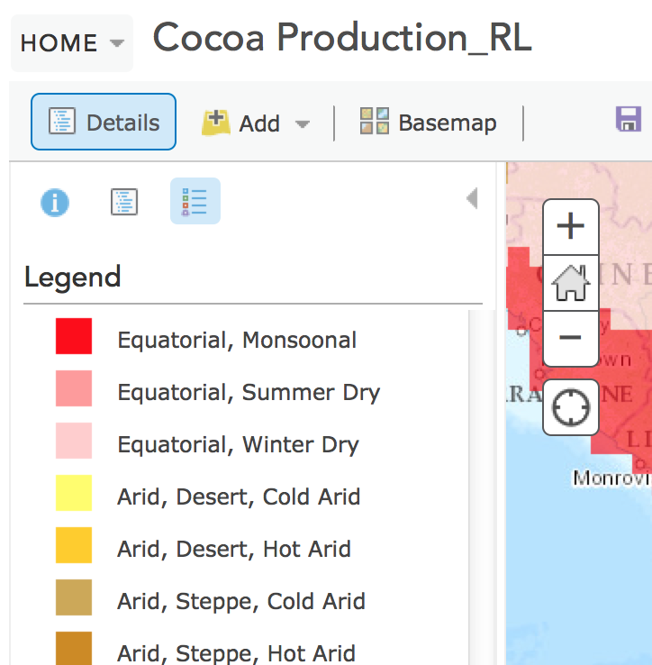

- Brown; Equatorial, Fully Humid. (Af)
  - All 12 months have average precipitation of at least 60 mm (2.4 in). These climates usually occur within 5–10° latitude of the equator. In some eastern-coast areas, they may extend to as much as 25° away from the equator. This climate is dominated by the doldrums low-pressure system all year round, so has no natural seasons.

- Red: Equatorial, Monsoonal (Am)
  - This type of climate, most common in South America, results from monsoon winds that change direction according to the seasons. This climate has a driest month (which nearly always occurs at or soon after the "winter" solstice for that side of the equator) with rainfall less than 60 mm, but more than 1/25 the total annual precipitation.

- Pink: Equatorial, Winter Dry (Aw)
  - These climates have a pronounced dry season, with the driest month having precipitation less than 60 mm and less than 1/25 of the total annual precipitation.

Analysis Activity, Part 1:
Based on what you did above, select “observed change”, and explore the map using three different 20-year intervals of your choice between 1900 and 2000 (there are no data shown for other time intervals beyond 2000) using the slider at the bottom of the screen. Be sure to select one 20-year increment at a time. Select one of one of the three countries: (Ivory Coast, Ghana, or Cameroon) and identify the changes in climate and biomes from 1900 to the present.

PART 2: MAP ANALYSIS

Your instructor will assign you one of four Intergovernmental Panel on Climate Change (IPCC) scenario projections: A1, A2, B1 or B2. Make a new map, this time displaying the projected change in climate from your assigned emission scenario. Select now a different base layer. You will be making a map, one displaying your emissions scenario, and comparing to the "observed" map created in part 1. Refer to the scenario descriptions in the Appendix at the end of this document.
- Save the map to my content with a new name. The name should be descriptive: Climate Aware_emissions scenario_your name. Make sure that the observed box is checked in the legend.
- Share your map (you will see a icon that is a chainlink next to it). In the next box that appears, select everyone.
- Click on the option to make a web application. It will take you to a page where there are a series of map service options.
- Go to page 3 of map service options. You will see the selection to make a “time aware” application. In the drop-down list for publish options, select Publish. In the next box that appears, click on View Item.
- Repeat steps 1-4. In the first step. Make sure that the appropriate emissions scenario is checked in the legend.

Analysis Activity, Part 2: Using the magnifying glass on the side of your map, center your map on a close up view of West Africa, where the majority of the world’s cocoa is produced. Identify the West African country you will be examining. Now using your time aware maps, compare the observed record (Was change observed during the last century in this area?) to the projection provided your emission scenario for the future. If there are projected changes for your area, do they appear to be similar in scope to those of the past, or different? What questions could you pose that might make for interesting research questions related to change in the past and the future? Note your responses to these questions in your notebook.

Why are there different emissions scenarios? The physics of climate change is predictable and fairly well understood, but human behavior is a big question mark! If you would like to see the data that is used in the different scenarios, this link has tables at the end of the chapter describing the parameters used in each of the scenarios.

https://www.ipcc.ch/pdf/special-reports/spm/sres-en.pdf

After completing your assignment, wait for your instructor to give further instructions.

