Armstrong State University
GEOG 1100: World Regional Geography
Spring 2016

Dr. Amy E. Potter
E-mail: amy.potter@armstrong.edu
Office: Hawes Hall 109c
Office Hours: Mon 2:45-4:45, Tue 1-4, and By Appointment

Facebook Page: Armstrong Geography
Librarian Liaison: Caroline Hopkinson 344.3019

Class Contact____________________________________________

Welcome
Upon completion of the course, the student will be able to:

1) Demonstrate knowledge of basic geographic terms, locations, and concepts.
2) Apply these basic geographic terms and concepts to understand the processes shaping the world's major regions.
3) Apply the knowledge of basic geographic terms, locations, and concepts to begin to critically explain global events.

OPTIONAL TEXT: Rowntree et al. Diversity Amid Globalization: World Regions, Environment, Development, 6th edition.

COURSE LOGISTICS

Assignments

The professor does not accept assignments via email. The professor will not accept late work. All assignments unless otherwise indicated should be submitted via Dropbox on D2L.

Absences
Students are expected to attend class, as regular attendance is needed to successfully complete this course. If a student misses a class, s/he is responsible for all announcements, class discussions, changes in the course, etc., which may be outlined in class. Students are responsible for also checking their armstrong.edu email several times a week as the professor may also communicate important announcements through email.

If the student has a university-sanctioned excuse, s/he has one class period to make up the missed work (map quiz, exam etc.) otherwise it will become a zero. In the event a student misses class; s/he will submit a scanned university sanctioned excuse via email (amy.potter@armstrong) on or before the day of his or her return otherwise it will become a zero.

To recap: if a situation arises that impairs your ability to attend this class, it is your responsibility as an adult to communicate with me your professor (ideally in person). I do not communicate with parents unless it’s dire. Email me as soon as possible. I cannot help you if you do not communicate with me.

Lecture Notes
I do not post PowerPoint lectures to D2L but will provide the text to each PowerPoint. Check Desire to Learn before class to print out notes. Because I provides notes, there will on occasion be participation checks in order to encourage class attendance.

Grades
All grades will be posted to Desire to Learn. All grades on the day of the final exam (including tests, homework, and participation) are absolute and cannot be changed. Your final grade, unless there is an erroneous error on my part, is non-negotiable, and I will not respond to emails requesting grades to be “bumped up.”

Special Accommodations
Students with disabilities or special needs must see me as soon as possible so that arrangements can be made.

Email
All correspondence regarding attendance, make-ups or erroneous grades must go through the professor’s email amy.potter@armstrong.edu (not D2L). During the weekday, please allow up to 24 hours for a response (please resend if more than 24 hours have passed). If it is the weekend, you may not receive a response until Monday.

In the subject line, please include the course number Geog 1100 and section number.

Lagniappe (Louisiana for a little something extra!)
The professor must approve any video, photographic or audio recordings of the class.

Syllabus is subject to change as well as exam dates. Course schedule is approximate.

If you have any concerns regarding geography or actual course material please see the professor. Please do not hesitate to make an appointment.

COURSE REQUIREMENTS AND GRADING POLICY:
A. There will be three examinations. Combined, they encompass 55 percent of the final grade. Make-up exams will not be subject to any overall class-added points because of the unfair nature of taking the exam at a later date. Valid reasons for missing exams correspond to the university’s policy on valid reasons for class absence, which includes illness, serious family emergency or religious observances.

B. Map Quizzes— For each world region, there will be a map quiz. I have provided a list of places and base maps in the Map Quiz folder on Desire to Learn. Map quizzes will be given out promptly at the start of class. If you arrive to class after the quizzes have been handed out, you will not have the opportunity to take the quiz and will receive a grade of zero. However, if you miss a map quiz because of tardiness or unexcused absence, you will have an opportunity later in the semester to replace that zero.

C. Participation Grade: Students will earn a participation grade for the semester based upon in-class participation, short reading/writing assignments, and a focused final project on food security. Students will forfeit their participation grade for laptop use other than note taking, use of a cell phone and musical devices, excessive tardiness, and unsolicited conversation during lecture. If students leave class early without a documented excuse, they will also forfeit their participation for the day.

STUDENT EVALUATION SYSTEM:
Exam 1 15%
Exam 2 20%
Exam 3 20%
Map Quizzes 20%
Participation 25%

90.00-100% A
80.00-89% B
70.00-79% C
60.00-69% D
0-59% F

Course Calendar
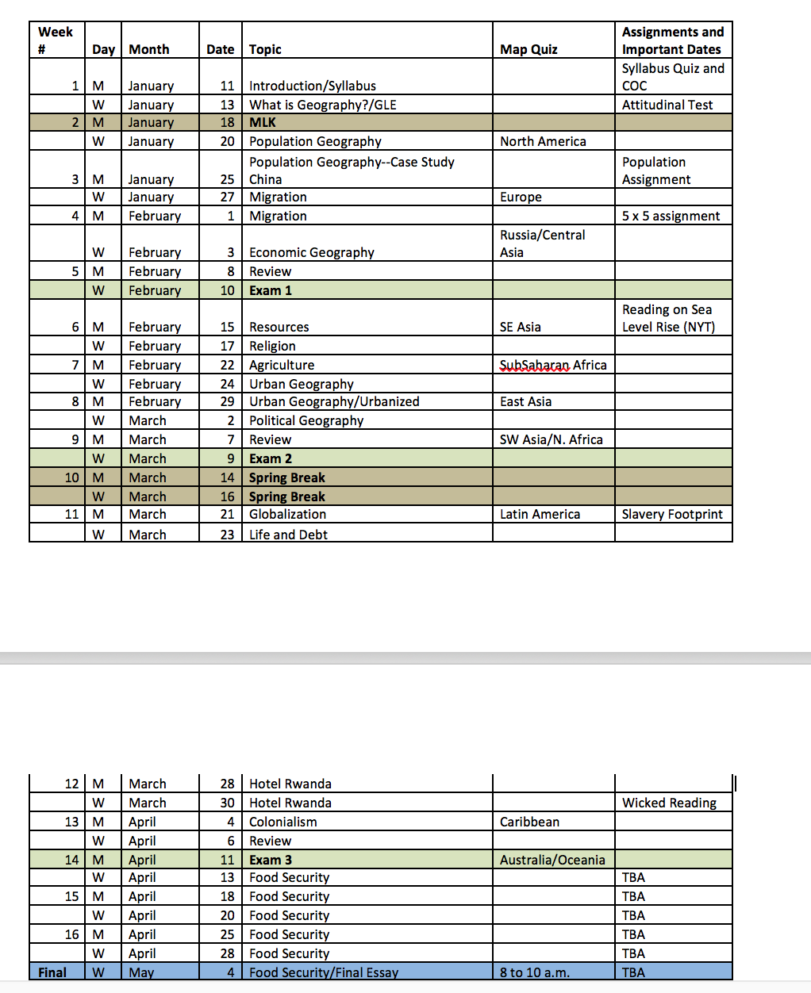

Other Policies

Special Needs:
Armstrong State University is committed to accessibility and providing accommodations for all persons with disabilities if notified. If you plan to request accommodations for a disability, please register with the Office of Disability Services at memorial college center, Room 208, or contact Kelly Woodruff at kelly.woodruff@armstrong.edu. Phone: 912-344-2744.

Sexual Misconduct Policy:
Armstrong’s Sexual Misconduct policy, following national guidance from the Office of Civil Rights, requires that faculty follow Armstrong’s policy as a “mandatory reporter” of any personal disclosure of sexual harassment, abuse, and/or violence related experiences or incidents shared with the faculty member in person, via email, and/or in classroom papers or homework exercises. These disclosures include but are not limited to reports of personal relational abuse, relational/domestic violence, and stalking. While faculty are able to help students locate appropriate channels of assistance on campus, disclosure by the student to the faculty member requires that the faculty member inform appropriate Armstrong channels to help ensure that the student’s safety and welfare are being addressed, even if the student requires that the disclosure not be shared.

University Counseling Center offers support and assistance: counseling@armstrong.edu or 912-344-2529.

Academic Integrity:
Any form of academic misconduct during any class activity or assignment will not be tolerated. There will be no hesitation to report any academic misconduct cases to the Honor Court. Armstrong State University’s Honor Code and Code of Conduct states,

Plagiarism is the intentional offering of the words, ideas, or computer data programs and/or graphics of others for ones’ own in any academic exercise.
Examples of plagiarism include (but are not limited to):
- The offering of another’s work, whether verbatim or paraphrased, as original material in an academic paper;
- The offering of another’s original ideas or concerts as one’s own, in an academic paper or assessed exercise;
- The inclusion of another’s material in one’s own work without appropriate or accurate citation or credit;

Cheating is (a) the intentional use or attempted use of unauthorized materials, information, or study aids in any academic exercise; and/or (b) intentional actions taken to gain unfair or undue advantage over others. Examples of cheating include (but are not limited to):
- Receiving or providing unauthorized assistance on any work required to be submitted for any course.
- Using unauthorized materials or assistance during an examination, including looking at another’s paper.
- Alteration or insertion of any academic grade or evaluation so as to obtain unearned academic credit.
- Taking, or attempting to take, an examination for another student. This act constitutes a violation for both the student enrolled in the course and for the proxy or substitute.
- Tampering with another student’s work or impairing the professor’s ability to assess the academic performance of another student.
- Using false excuses to obtain extensions of time or other considerations which would or may yield an unfair advantage over other students.
- Impeding the ability of students to have fair access to materials assigned or suggested by the professor (e.g., removal or destruction of library or other source materials).

Plagiarism, as well as other forms of cheating, is a major offense, which may result not only in a failing grade on the assignment, but also a failure of the entire course.

