Unit 3 – How Do Rivers Change?
In this activity, you will use Google Earth to observe a river from its source to its mouth. You will use those observations to find areas where the river is eroding its bank and measure how steep the stream is in several places. You will also relate your findings to the types of rocks and faults in that area. This section has several related tasks centered on the concept of how real-world streams are influenced by 1) the local climate, 2) the hydrologic cycle, and 3) the underlying bedrock.

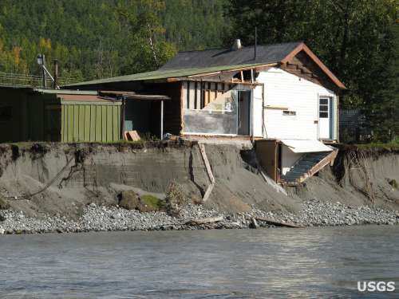
Opening Thought
Look closely at this photo. What do you see? What appears to have happened to this house? Could the owners have predicted this would happen?

Initial Ideas
Suppose the river in the photo has two bends in it. What is a likely location for the house in the previous question? Mark that location with a large X, and explain why that location would experience erosion.
Current

Suppose you floated the entire length of a river starting at its source and traveling to its mouth. During the float trip, you use the GPS in your phone to record the elevation of the stream every kilometer. A trip over Niagara Falls might result in the graph in Figure 1.
Figure 1 – Graph of water level over Niagara Falls.
Meters Above Sea Level
200
Downstream
Upstream
100
300
Falls
River Level

Now suppose you floated a river near you from its source to its mouth. Which of these four graphs would best represent the profile of your river? Explain why that is the best choice.
Mouth
Source
A
Mouth
Source
B
Mouth
Source
C
Mouth
Source
D

Compare your answers with someone else. What is one difference in your answers? (Be ready to share your answers with the class.)

