Unit 2: Fluvial Processes that Shape the Natural Landscape
In this activity you will create a scale model of a river system using a stream tray to observe how fluvial processes shape the surface of Earth by erosion, transport, and deposition of sediment. The key consideration of this unit is the sustainability of a river system and the affect of human activity on the quality of water that is readily available for human consumption.
Essential question to frame your focus of inquiry:
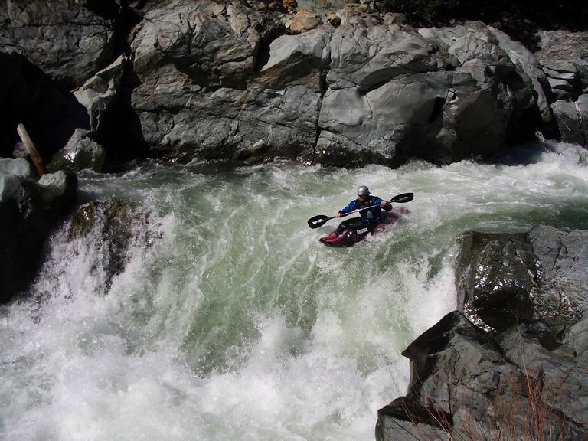
- How does the interaction between the hydrologic cycle and fluvial systems result in the formation of sedimentary rock?
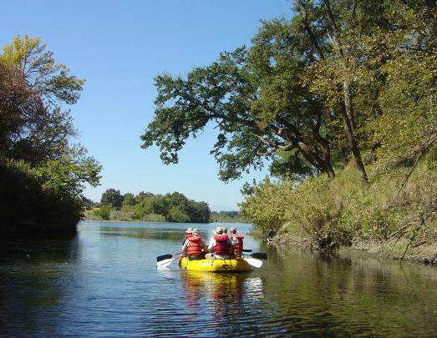
Initial ideas – on your own
Photo credit: U.S Department of the Interior Bureau of Land Management. Downloaded from:
http://www.csuchico.edu/our-region/day-trips/sacramento-river.shtml
Photo credit: Darwin McQuoid
Downloaded from: http://cacreeks.com/sac-dun.htm
Q1. Both pictures above were taken during the same season along the Sacramento River. What factors do you think would cause the water to flow faster in one area of the river compared to another?
_______________________________________________________________________________________________________________________________________________________________________________________________________________________________________
Q2. You are planning a rafting trip requiring only basic rafting skills. Where along a river system do you think would be a good place to start — at the beginning, middle or near the end — and why? __________________________________________________________________________________________________________________________________________________________________________________________________________________________________________
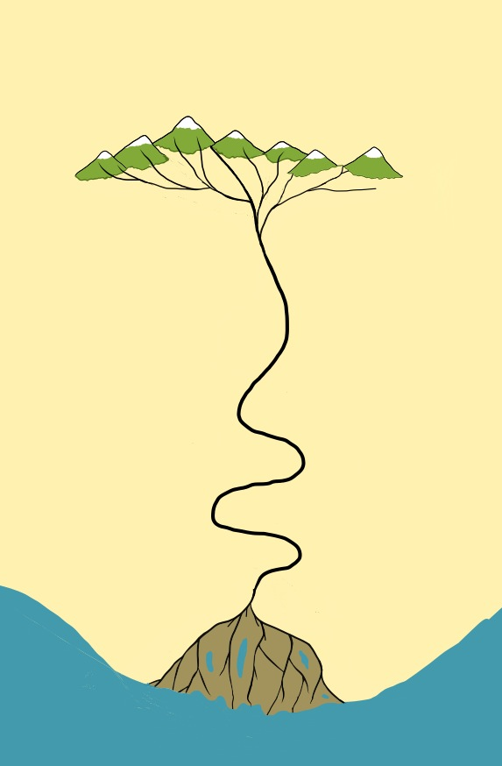
Part 1:
Zone 1
Zone 2
Zone 3
Meanders
Tributaries
Delta
Distributaries
Collecting system
Transporting system
Dispersing system
Sediment source area
Main Trunk
Characteristics of a River System
Background
Fluvial systems are the main factors in shaping the surface of the continents as they drain the water on the continents and move weathered material (gravel, sand, silt, mud) to the ocean basins.
The appearance of rivers and streams is strongly influenced by the climate, geology, and the topography of the region. Although the appearance of rivers may differ from one to the next, all rivers have three subsystems (or zones) that define the entire river system: 1) collecting system, 2) transporting system, and 3) dispersing system.
The diagram to the left is a sketch of a prototypical river system with a dashed line between zones. Although there is typically only a gradual gradation between the subsystems, when you view them at a regional scale, you can recognize patterns characteristic of each subsystem.
Directions: To answer questions 1-1 through 1-3 you will need to find a river on a topographic map of the state or county where you live.
Collecting system (Zone 1)
The collecting system is where the headwaters are located in the region where the river begins. The collecting system is typically a mountainous region containing a network of small tributaries that are created as water and sediment is funneled toward the main stream.
1-1. What is the name of the town, county, or area where the river begins? ______________________________________________________________________________
Transporting system (Zone 2)
This part of the river system consists of the main channel (trunk) and the major tributaries. The transporting system is where water and sediment that has collected in the headwaters is transported downstream to a lake or ocean. This section of the river system will often contain meanders. These are formed by the combination of erosion and deposition of sediment. As the slope (gradient) of the stream channel decreases, so does the velocity.
1-2. What are the names of towns or cities located along the transporting system? _____________________________________________________________________________
Dispersing system (zone 3)
This part of the river system is at the end of the river where the elevation of the river is nearing sea level. Here you can observe a network of distributaries that redistribute the water and sediments into the ocean. The fine-grained sediments (clay, mud) remain suspended in the water and continue to be transported and finally deposited into the bay or ocean. The coarser material is deposited at the shoreline and forms a delta.
1-3. What body of water does the river empty into at the end of the dispersing system?
_____________________________________________________________________________
Observations:
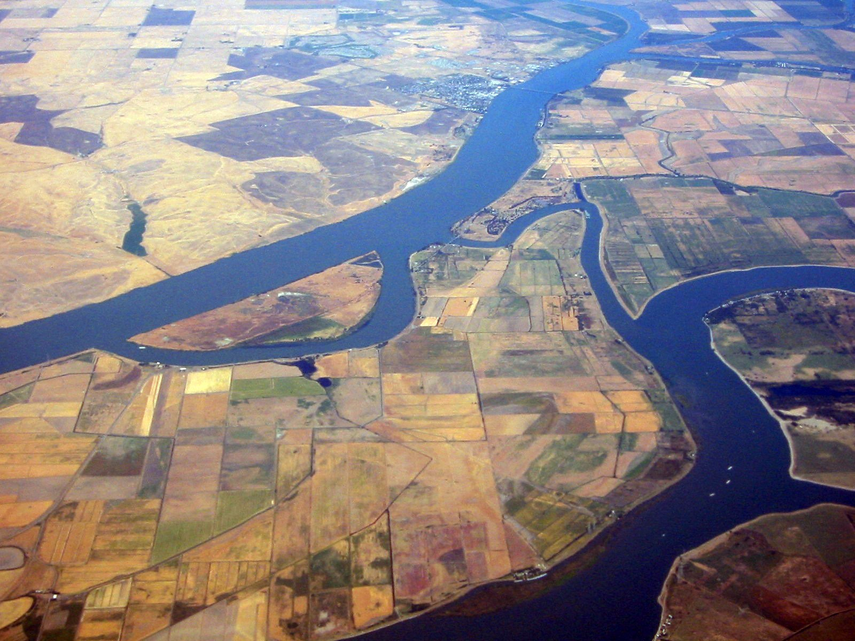
1-4. Each of the following images illustrates one of the three subsystems in a river system. Identify under each image the type of subsystem and the zone in which it is located. If you need more information, refer to the general description of each subsystem in the previous section.
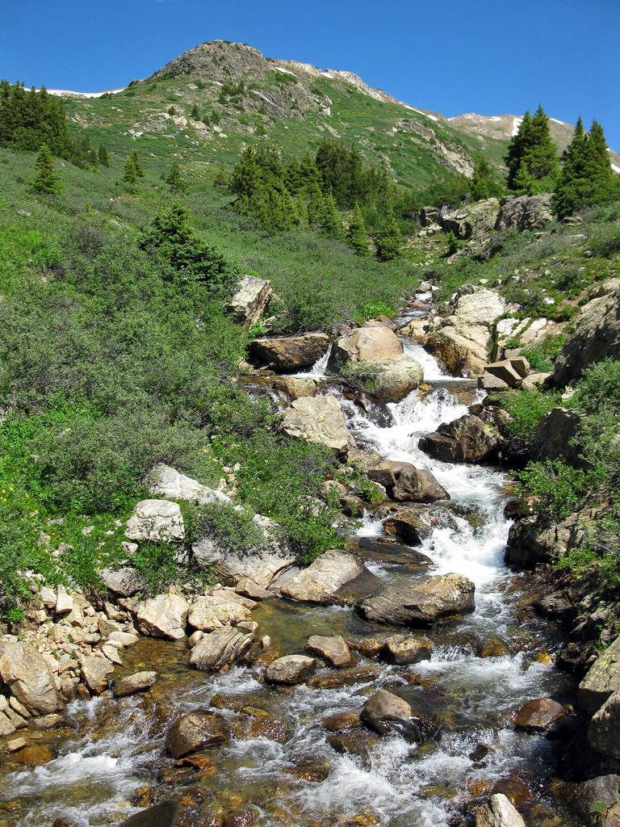
Sacramento River
Roaring Fork River
Subsystem: ______________________ Subsystem: ______________
Zone: ____________________ Zone: ___________

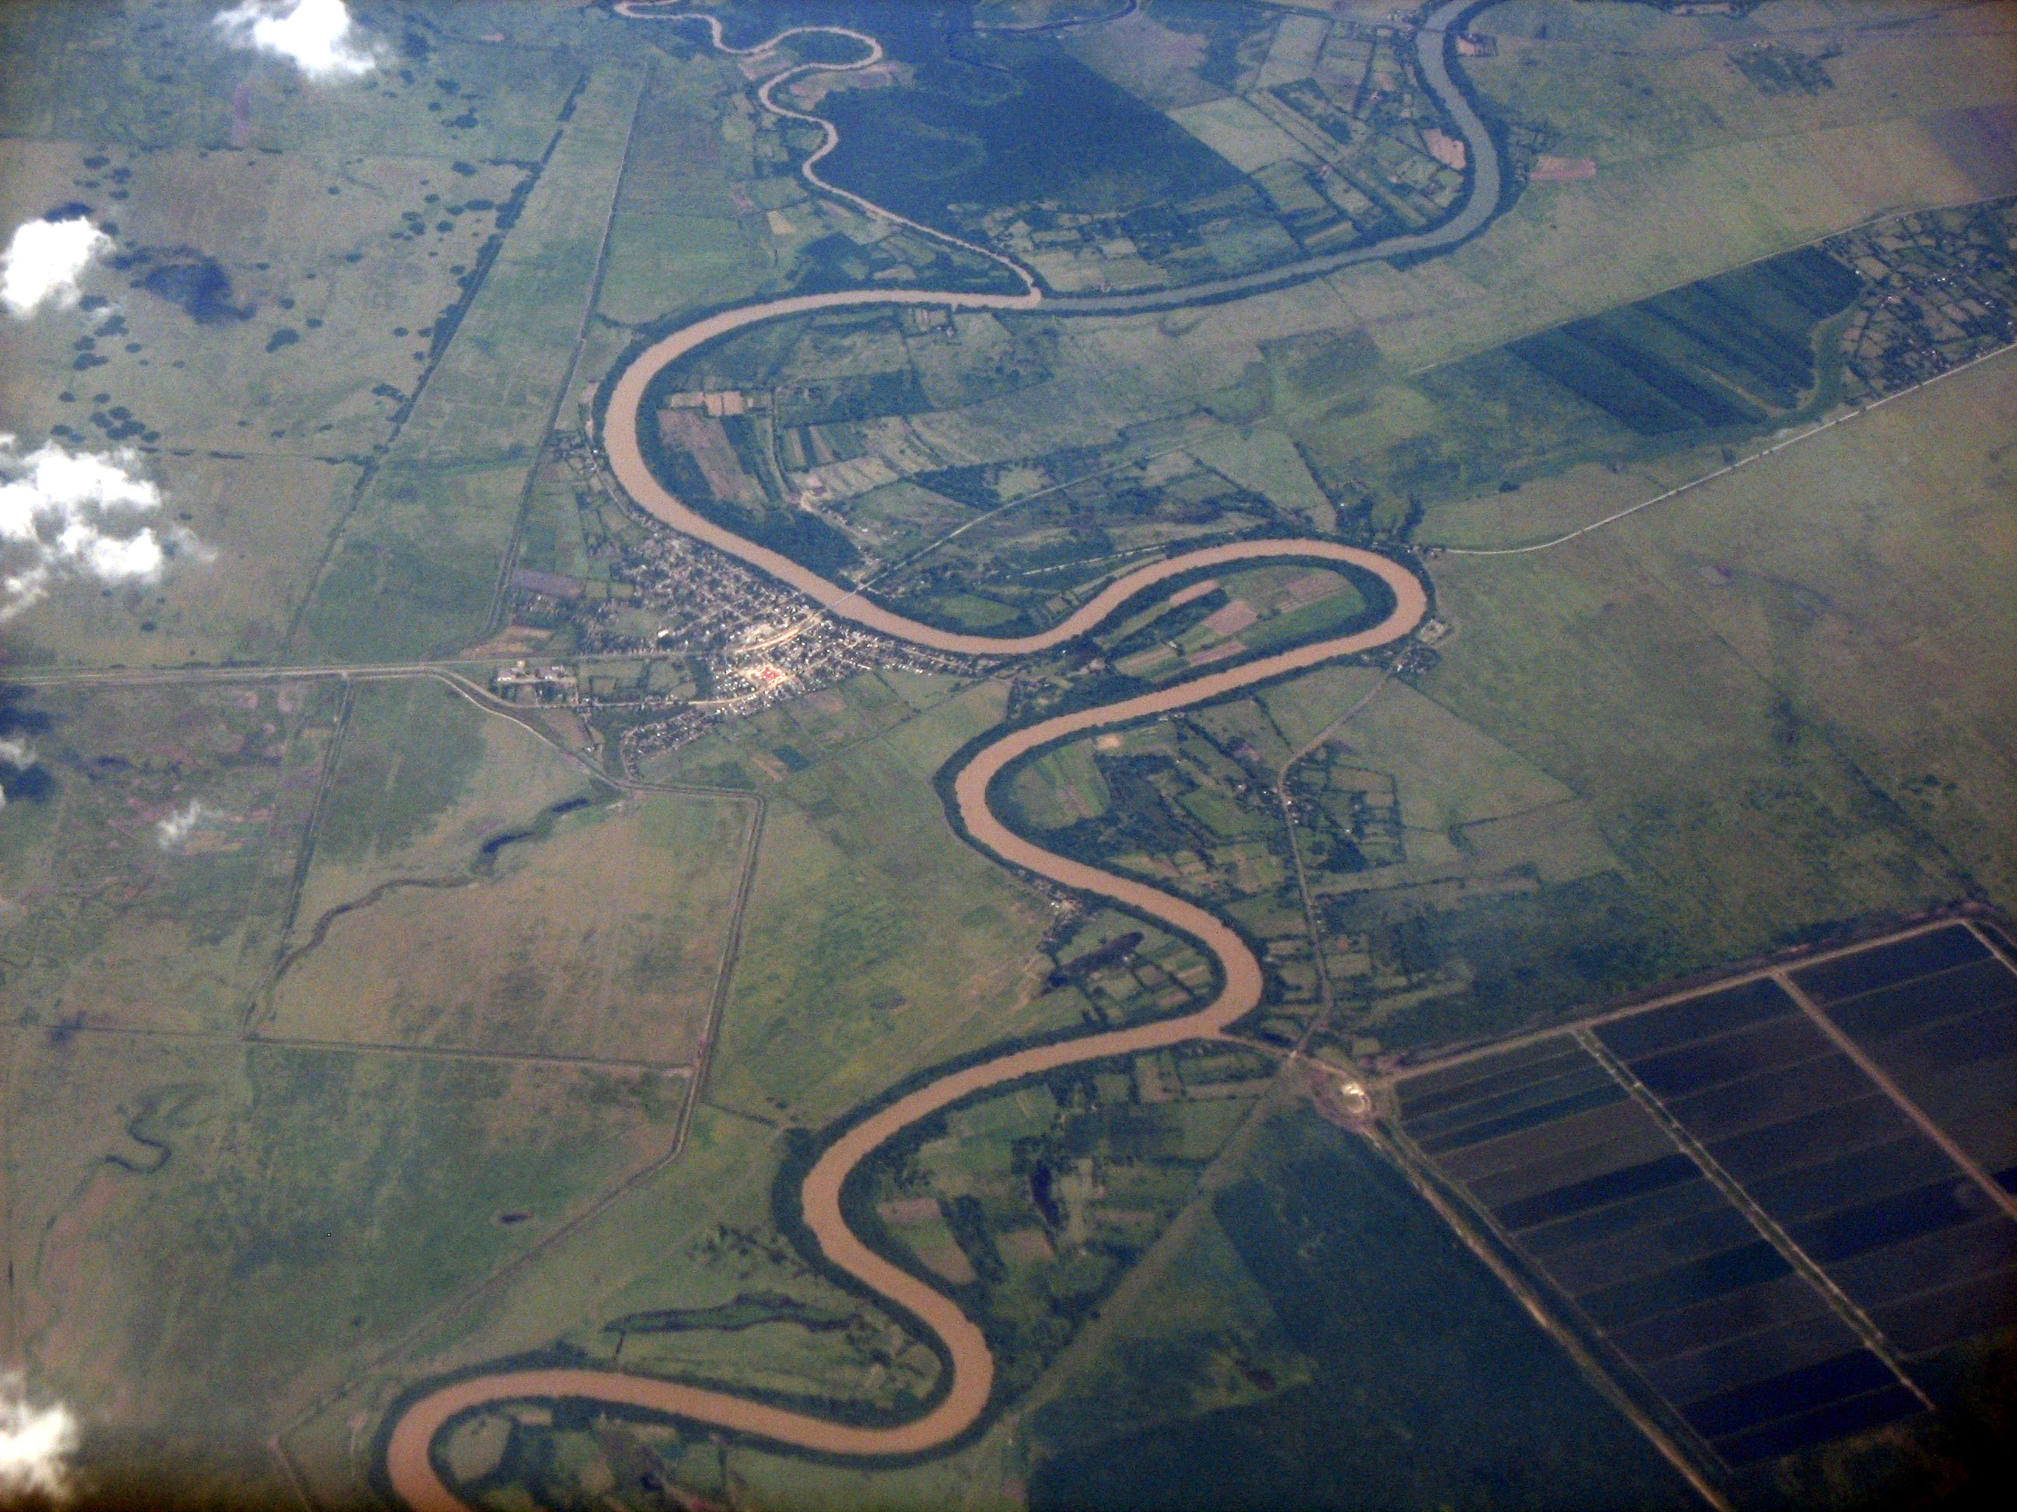
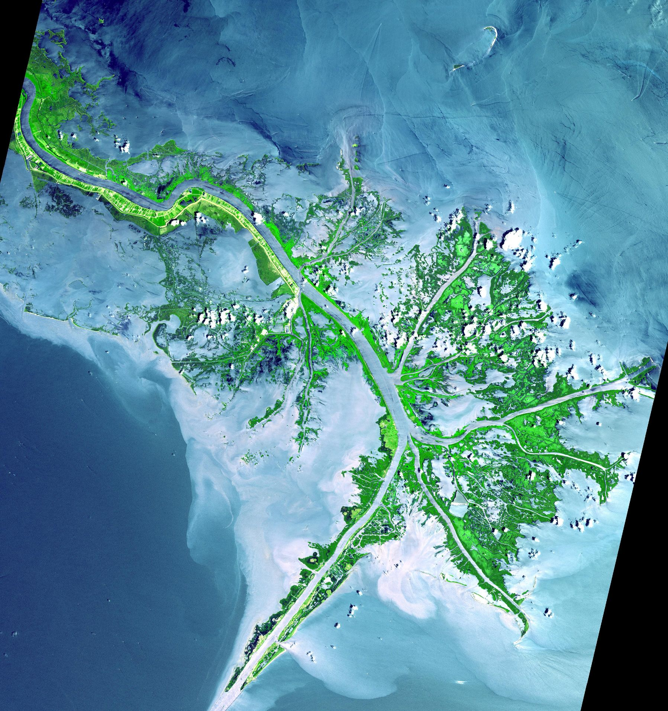

Mississippi River
Cauto River

Subsystem ______________________ Subsystem: ____________________
Zone ________________ Zone: ___________
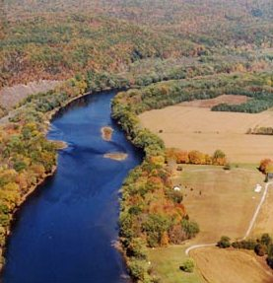
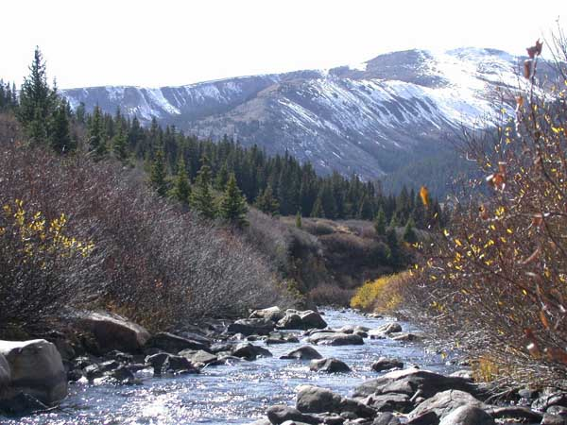

Arkansas River
Delaware River

Subsystem _______________________ Subsystem _________________________
Zone ______________ Zone _____________

Part 2:
Terms

Sediment:
- Material that has been eroded from preexisting rock.
Weathering:
- Breakdown of material caused by physical, chemical and or biological processes, often happening simultaneously. Weathering is a process that occurs in place.
Erosion:
- Erosion is the process that moves weathered material by a transport agent (air, water, ice, gravity).
Canyon:
- A narrow, deep, often V-shaped valley, usually cut by a stream.
Meander:
- A half loop bend in the major trunk of the stream channel.
Floodplain:
- The region along the edge of the stream that overflows during floods.
Tributary:
- The smaller of two streams that meet to make a larger stream.
Distributary:
- A channel that branches off and flows away from the main stream channel (trunk of a river).
Delta:
- A deposit of sediment, approximately triangular in shape, formed where a stream enters a lake or ocean.

Erosion, Transport and Deposition by Fluvial Processes
Background Information:
Fluvial processes include the erosion, transfer and deposition of sediment along a river. Common terms to describe the physical characteristics and processes along a river system are listed in the box to the left. Use these terms when describing your observations or referencing an area along a river system.
In this investigation we will use a stream table to model the effect of flow on erosion, transport and deposition in a river system. It is important to consider that not all of the characteristics commonly associated with a fluvial system will be fully developed or observable on a stream table model.
Why study a river system?
Rivers are invaluable resources for plants and animals. Think about the significance of rivers and why it is important for scientists to study how a river system behaves. Brainstorm your ideas with your group and summarize your answers below. Be prepared to share your group’s response with the class.
_________________________________________
_________________________________________
_________________________________________________________________________________________________________________________________________________________________
_____________________________________________________________________________
_____________________________________________________________________________
_____________________________________________________________________________

Scale model of a river system:
Setup:
- If you are the first lab of the day will you need to add water to the sediment that is in the tray. Add only enough water until the sediment feels damp, and mix well.
- Use the wooden scraper to push the sediment to one side of the tray so it fills about ¾ of the stream tray (refer to diagram below). This should leave approximately ¼ of the tray bottom empty.
- Shape the sediment into a hillside by gently patting the sand with your hands to form a wedge shape (A). The thickest side of the wedge should be farthest away from the location of where the river will eventually empty into a body of water.
- After you form the hillside, add a slight indentation to the sediment forming a line down the middle of the hillside (B). This is meant to direct the flow of water down a central path.
- Be sure the catch bucket (F) is empty before running water through the system. Do not empty any water containing sediment down the lab sinks. Instead use a waste bucket that can be emptied later.
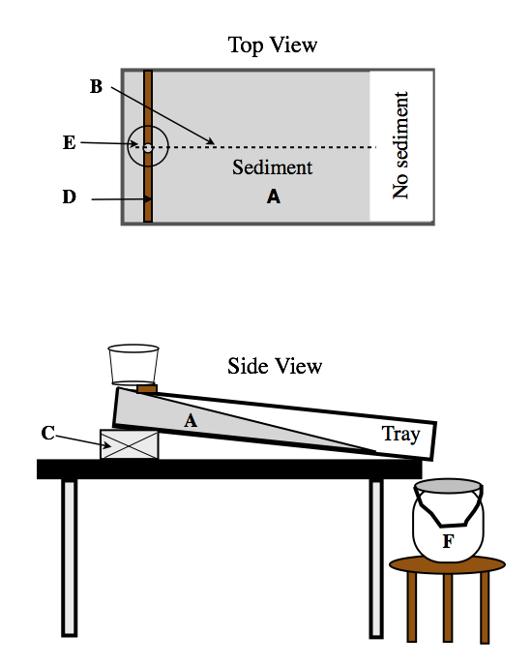
Items not shown: Plastic container for pouring water, (1) 1/2” block, scraper to smooth the surface, paper towels and sponge for cleanup.

Procedure (refer to diagrams on the previous page)
- Once the hillside is formed (A), elevate one end of the tray using a ½-inch block (C).
- Place a ruler across the width of the stream table, about 4 or 5 centimeters (2 inches) from the edge of the tray (D).
- Cover the hole in the bottom of the flow container (E) with your finger and fill it to the top with water.
- Carefully place the container on top of the ruler and center it over the indentation you previously made with your finger. Release your finger and watch closely as the water flows downstream.
- Look for any features that may develop on the surface of the hillside as gravity transports the rainwater downslope. Before the flow container is completely empty add another 500 ml to the container.
Observations:
After the water stops flowing out of the tray, answer the following questions:
2-1. What do you notice about the shape, width and depth of the stream channel as you move away from the headwaters? (Zone 1)
____________________________________________________________________________________________________________________________________________________________________________________________________________________________________________________________________________________________________________________
2-2. Which of the three zones in the river system model is the primary area for the deposition of fine to very fine grain-sized sediments? _____________________________________________________________________________
____________________________________________________________________________________________________________________________________________________________
2-3. In an actual river system, stream velocity naturally sorts the grain sizes over the course of the river system. The faster the flow of the river, the larger the grain size that will be transported downstream. Considering this information, where would you expect to find the largest rock and sediment size in a river system? Use the stream model to support your reasoning.
______________________________________________________________________________
____________________________________________________________________________________________________________________________________________________________
____________________________________________________________________________________________________________________________________________________________
______________________________________________________________________________
2-4. Sketch the model river system:
- Sketch and label the observable features of the river system model
- Circle and label the approximate boundary of each subsystem (zones 1, 2 & 3)
- Use Figure 1 as a guideline.
Body of water
Part 3:
What affect does slope have on erosion, transport and deposition of sediment?
3-1. Predict any changes in the pattern of surface features that you would expect to see by increasing the slope: _________________________________________________________________________________________________________________________________________________________________________________________________________________________________________
Procedure:
- Important! Before starting Part 3, re-mix the sediment. Try to recreate the same wedge- shaped hillside (shape and steepness) created in part 2.
- Increase the slope by removing the ½-inch block and replacing it with a 1-inch block.
- Pour 500 ml of water into the water flow container; before the water has stopped flowing, add another 500 ml. Observe the formation of surface features that form in each zone of the subsystem.
3-2. Wait until the water completely stops flowing, then make a sketch of the stream table model below.
- Use a regular pencil to draw the observable features and a colored pencil for the features that are not observable but are key features in a river system.
- Label and sketch physical features associated with each zone of a river system to show the location of the sediment source, tributaries, trunk of the river, stream meanders, delta, and distributaries.
- Circle and label the approximate location of Zones 1, 2, & 3
Questions:
3-2. What affect does slope have on the development of drainage patterns associated with fluvial processes? Use examples from the river system model to support your answer.
______________________________________________________________________________
________________________________________________________________________________________________________________________________________________________________________________________________________________________________________________________________________________________________________________________

3-3. What does the depth and width of the channel suggest about the relationship between the rate of stream flow and erosion? Use examples from the river system model to support your answer.
________________________________________________________________________________________________________________________________________________________________________________________________________________________________________________________________________________________________________________________
3-4. Observe the size of the sediment that has been transported along the stream channel. Is there a general pattern in the distribution of grain sizes? If so, what does this indicate about the amount of energy that is needed to transport the different grain sizes (coarse, fine, and very fine)? Use observable features on the river system model to support you answer.
______________________________________________________________________________
______________________________________________________________________________
____________________________________________________________________________________________________________________________________________________________

Summarizing questions:
Question 1. Explain how streams and rivers are an important factor in the formation of sedimentary rocks.
__________________________________________________________________________________________________________________________________________________________
______________________________________________________________________________________________________________________________________________________________________________________________________________________________________________________________________________________________________________________________________________________________________________________________________________________________________________________________________________

Question 2. Explain how stream velocity (assume the steeper the slope, the faster the velocity) relates to the transportation and deposition of sediment. Use specific examples from Part 2 and 3 to support your answer.
____________________________________________________________________________________________________________________________________________________________________________________________________________________________________________________________________________________________________________________________________________________________________________________________________________________________________________________________________________________
Reflect on what you have learned:
Share your answers to Questions 1 and Question with your group. As a group, select one question and craft a consensus whiteboard that explains the answer. Provide a labeled diagram to support your reasoning. Be prepared to share your findings.

