Unit 1: The Hydrologic Cycle
The activities in Unit 1 investigate water from a global perspective. The content is focused on the identification of storehouses where Earth’s water is stored, how matter (water) cycles through the geosphere (lithosphere, atmosphere, hydrosphere) and biosphere, and the energy associated with water as it changes between a solid, liquid and gas state. The unit investigations conclude with a short homework assignment on the application of the hydrologic cycle from a regional perspective as you research the quality and availability of fresh water in the state where you live. An important factor is the consideration for the percentage of fresh water that is readily available for human consumption and the impact of human activity on the quality of the water.

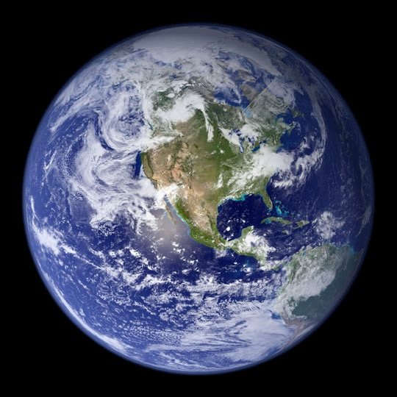
Essential questions to guide your thinking over the unit 1 investigation on water:
- How is matter transferred through the hydrologic system?
- What is the primary source of energy that drives the hydrologic system?
- How does the rock cycle interact with the hydrologic cycle?
Credit: NASA Goddard Space Flight Center
http://visibleearth.nasa.gov/view.php?id=57723
Initial Ideas – on your own
Q1. Often called the water planet, if you were to view Earth from a satellite you would observe that about 70% of the planet’s surface is covered by water. Of this percentage, what would you estimate is available for human consumption? ______________
Q2. Explain where the drinking water you consume may have been stored before it reached your house:
________________________________________________________________________________________________________________________________________________________________________________________________________________________________________________________________________________________________________________________________________________________________________________________________________________________________________________________________________________________________________________________________________________________________________________________________________________________________________________
Q3. Imagine that you are following the path of a single water molecule as it moves through the hydrologic cycle between the geosphere and the biosphere. In the space below sketch a diagram of what this path might look like (indicate the direction the molecule of water is moving with an arrow).

Part 1. Water, Water Everywhere
Original activity from: http://www.epa.gov/region1/students/pdfs/gwa5.pdf
Materials for the class
- 5-gallon aquarium or 5-gallon bucket filled with water
- 24 oz. measuring cup
- Green food coloring, ice cube tray, dropper, petri dish, clear plastic cup (at least 8 ounces) filled with sand
- Topographic map of the area where your college is located
- Laptop and overhead screen
Demonstration
Step 1:
Demonstrator fills a 5-gallon bucket or aquarium with water.
Narrator: Imagine that this aquarium, which holds 5 gallons of water, represents 100% of all the water on Earth.
Step 2:
Demonstrator removes18 ounces of the water from the aquarium with a measuring cup, and then drops green food coloring into the remaining water in the aquarium.
Narrator: This green water left in the bucket represents all the water on earth held in oceans. The water in the measuring cup represents all the water in the world that is not ocean water.

Step 3:
Demonstrator pours 15 ounces of water from the measuring cup into the ice cube tray.
Narrator: The water in the ice cube tray represents all the water held in glaciers and ice caps. This water is not readily available for our use.
Step 4:
Demonstrator places a fraction of water (approximately one drop- per of water) into a student’s hand.
Narrator: The remaining 3 ounces represent the world’s available freshwater. Of this amount, a fraction of an ounce is held in the world’s freshwater lakes and rivers.
Step 5:
Demonstrator pours the remaining water into a cup of sand.
Narrator: The remaining water (approximately 2.5 ounces) is groundwater, which is water held in pore spaces of soil and fractures of bedrock
Questions:
Major  Storehouses (natural) | Percentage of  Water Held in Each Type of Storehouse
Ocean | 97.2% of total water
Groundwater | 0.397%
Surface water (Rivers, lakes, streams, ponds) | 0.022%
Ice caps/glaciers | 2.38%
Atmosphere | 0.001%
Total % of Earth’s water held in storage. | 100%
Total % of Earth’s freshwater held in storage.
Total % of Earth’s freshwater held in storage and readily available for human consumption.
1-1. The table to the left lists the average percentage of water held in each type of storehouse. Of the 100% of water held in storage, what percentage is fresh? ______________ Note: ice caps and glaciers are not listed with surface water because the water is in a solid state and not considered readily available.

1-2. Of the percentage of freshwater held in storage, what percent is readily available for human consumption? _____________ How does this percentage compare to your initial idea you described in question Q1?
________________________________________________________________________________________________________________________________________________________________________________________________________________________
______________________________________________________________________________

Directions: Before answering questions 1-3 and 1-4, watch the video Blue Planet to learn more about how water shapes our planet and nearly every aspect of out lives.
1-3. Why is Earth called the blue planet?
______________________________________________________________________________
____________________________________________________________________________________________________________________________________________________________
1-4. There is a growing public awareness about the value and importance of water and water resources. Think about where fresh water is held in a storehouse in the region where you live. How might the impact of human activity affect the quality and quantity of the water held in storage?
______________________________________________________________________________
___________________________________________________________________________________________________________________________________________________________
Part 2: Following the Movement of Matter Through the Hydrologic Cycle
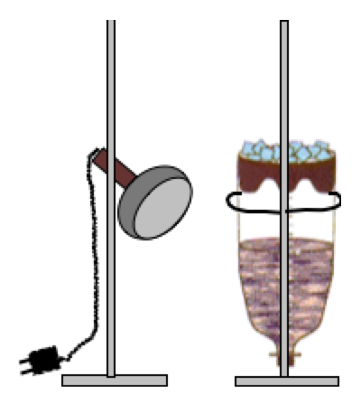
The hydrologic cycle is a conceptual model that illustrates the flow of matter (water) as it moves between Earth systems by energy that is ultimately derived from the Sun. The movement of water can be grouped into three directions: 1) moisture moving into the atmosphere, 2) moisture moving through the atmosphere, and 3) moisture returning from the atmosphere to the Earth.
Because of the interconnectedness of Earth’s systems, a change in one system often results in a change in one or more of the other systems. In this activity we will use a series of mini investigations to model the movement, processes and phase changes that occur as matter is cycled through the hydrologic system on a local and regional scale.
Collecting and Interpreting Evidence -
Part A: Evapotranspiration, condensation and precipitation

Materials needed (per group)
- 2-liter soda bottle
- Ring stand
- Crushed ice
- ~1 liter of sand
- Water
- Volumetric container with 100 ml marked increments
- Stand and clip-on light
Procedure:
Important! If you are the first lab of the day, pour slowly approximately 200 milliliters of water into the system until the water level is just below the surface of the sand. Be careful not to flood the container with water. If the water level rises above the ground surface be patient during the initial stages of the activity, the movement of water in the system will take longer.
- Fill the lid of the plastic bottle (previously the bottom section of the plastic bottle) with ice and place it securely back on top of the bottle. Push the lid down snugly to avoid any air from escaping.
- Position the heat lamp so it is pointed at the sand and not at the ice.
- Turn on the lamp. Look closely for any evidence to suggest there has been a movement of water in the system, then answer the following questions:
Questions:
2-1. What evidence did you observe to indicate an initial movement of water? ____________________________________________________________________________________________________________________________________________________________
2-2. What is the source of energy that moves the water through the bottle-model system? ______________________________________________________________________________
2-3. Explain in detail the processes and phase changes that occurred as water moved through the bottle-model hydrologic system. Start from when you turned on the lamp to where you observed evidence for the initial movement of water.
____________________________________________________________________________________________________________________________________________________________________________________________________________________________________________________________________________________________________________________________________________________________________________________________________________________________________________________________________________________
______________________________________________________________________________
2-4. As water moved through the bottle-model hydrologic system it was transferred between several storehouses. Identify the analog in the hydrologic system for each item in the bottle-model (sand, water, empty space, ice cubes) and the Earth system where the interaction occurs (lithosphere, atmosphere, hydrosphere and biosphere).
Bottle-model | Analog in the hydrologic cycle | Earth system
Sand mixture
Water in the bottle
Empty space in the bottle
Container with ice cubes

Collecting and Interpreting Evidence
Part 2B: Transpiration
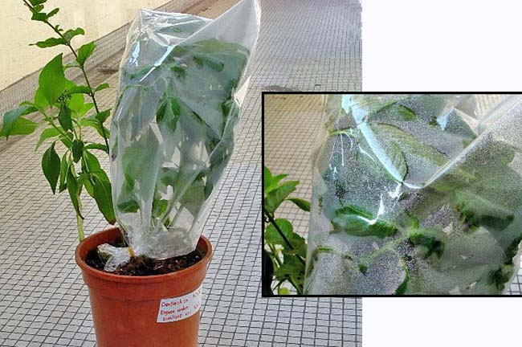
Image from: USGS Water Science Photo Gallery http://water.usgs.gov/edu/photos-air.html#8

Background
As energy from the sun heats the air surrounding plants, the plants transpire water vapor through their leaves. Environmental conditions such as soil moisture, wind, relative humidity and light are important factors in determining the movement of water out of the plant and the ability to control water loss.
Essential question to answer from this investigation:
- How does the amount of sunlight affect the rate of transpiration?
Materials and setup
Note: This activity requires set-up at least 24 hours before the investigation
- Two identical potted broadleaf plants,
- Two clear plastic bags and two twisty ties or rubber bands
2-5. A plastic bag has been placed over a group of leaves on two identical plants. Both bags have been tied tightly to avoid air from escaping. The same volume of water has been added to each plant. One has been placed in a sunny window, the other in the shade for at least 24 hrs. Predict which plant will have the greater amount of water evaporate from its leaves, and explain why.
_____________________________________________________________________________
______________________________________________________________________________
___________________________________________________________________________________________________________________________________________________________

2-6. Two plants have been placed in the classroom under the exact same conditions as described in 2-5. Describe any observational evidence that validates or nullifies your prediction in 2-5.
______________________________________________________________________________
______________________________________________________________________________
____________________________________________________________________________________________________________________________________________________________

Collecting and Interpreting Evidence
Part 2C: Infiltration and run-off
When precipitation reaches the ground as rain or snow, it will evaporate, infiltrate into the soil, or continue downslope as runoff. There are many variables that can affect the outcome of each condition like the type of soil, the amount of ground cover, the available pore space and the slope of the terrain. In the following activity we will look at the variables of soil type and slope. Each group will simulate the process of infiltration and runoff as precipitation occurs as rain on a hillside.
Essential questions to answer from this investigation:
- How do soil conditions determine whether precipitation will infiltrate into the soil or continue downslope as runoff?
F
A
Type 1 or 2
E
C
D
B
- How does the slope influence infiltration and runoff?
Materials and setup
Setup the materials according to the diagram above. Before starting, make sure that the infiltration catch pan (E) is located directly under the holes that have been drilled through the bottom of the tray.
Important! Half the class should test soil Type 1, the other half should test soil Type 2.
- Tray, with holes punched through the bottom
- Sediment (~ 3cups per tray of Soil Type 1) (~3 cups per tray of Soil Type 2)
C. 1” block of wood
D. 1/2” block of wood
- Infiltration catch-pan
- Runoff catch basin or bucket
Not shown: graduated cylinder for measuring runoff and infiltration (at least 500 ml), 500 ml plastic cup with holes to dispense the water, stop watch and mesh screen to place over the holes in the bottom of tray.

Procedure
- Shape the soil mixture into a wedge. Lightly pat down the surface. If the ground surface is compacted this will impede the infiltration of rainwater.
- Place the ½ inch block under the tray on the side with the thickest part of the wedge
- Place a finger over the hole in the bottom of the 500 ml plastic container (which in this model is a cloud) and fill it to the top with “rainwater”
- Hold the container over the end of the elevated side of the tray, start the timer as soon as you release your finger from over the hole. Move the container continuously from side to side across the crest of the hillside until the container is empty. Try to keep the rate of movement and the height above the tray consistent.
- The moment that you observe the rainwater runoff entering the fresh water storehouse (catch-basin in the sink) stop the timer and record the time on the table below. Continue to empty any remaining rainwater over the surface of the hillside.
- Wait until the rainwater stops flowing into the storehouse before measuring the volume of runoff. Record the data on the table below. Important be sure you are entering the data in the table that corresponds to the soil conditions (Type 1 or Type 2) and slope (1 or 1-1/2” height) you are testing.
- Carefully slide the catch pan beneath the hillside and measure the volume of rainwater that has infiltrated down to the water table (shallow pan). Record the data on the table below.
- Remove the ½ inch block and replace with the 1” inch block. Make sure to re-mix the sediment and gently smooth the surface of the soil before you run the second test. Repeat steps 1-7.
- After your group finishes collecting data, enter the group average on the class data collection table (use an overhead transparency or whiteboard) so it can be shared with the rest of the class.

Table 1: Runoff and Infiltration
Type 1: fine sand and clay mixture  1” block (steep slope) | Test 3 | Test 4 | Average
Time
Run-off
(Volume of water in catch bucket)
Infiltration
(Volume of water in the catch pan)

Type 1: fine sand and clay mixture,  1/2” block (gentle slope) | Test 1 | Test 2 | Average
Time
Runoff
(Volume of water in catch bucket)
Infiltration
(Volume of water in the catch pan)

Type 2: med to coarse sand  1/2” block (gentle slope) | Test 1 | Test 2 | Average
Time
Runoff
(Volume of water in the catch bucket)
Infiltration
(Volume of water in the catch pan)

Type 2: med to coarse sand  1” block (steep slope) | Test 3 | Test 4 | Average
Time
Runoff
(Volume of water in the catch bucket)
Infiltration
(Volume of water in the catch pan)

Interpretation of data
2-7. Underline the combination of surface soil and slope conditions that resulted in the most infiltration of rainwater:
(1) Steep slope and Type 1 soil, (2) Steep slope and Type 2 soil, (3) Gentle slope and Type1 soil or (4) Gentle slope and Type 2 soil. Explain where in the data you collected there is evidence to support your answers:
______________________________________________________________________________
__________________________________________________________________________________________________________________________________________________________________________________________________________________________________________
2-8. Underline the condition that resulted in the greatest amount of surface runoff:
(1) Gradual slope, (2) Infiltration rate exceeds the rate of rainfall, (3) Surface soil has reached saturation (all the pore spaces between the grains are filled with water) or (4) permeability of the surface soil. Explain where in the data you collected there is evidence to support your answers:
______________________________________________________________________________
________________________________________________________________________________________________________________________________________________________________________________________________________________________________________________________________________________________________________________________
2-9. Apply your understanding of infiltration and runoff to explain how human activity might affect the rate of water infiltration and runoff where the university you attend is located.
______________________________________________________________________________
__________________________________________________________________________________________________________________________________________________________________________________________________________________________________________

Part 3: Summarizing What You Have Learned
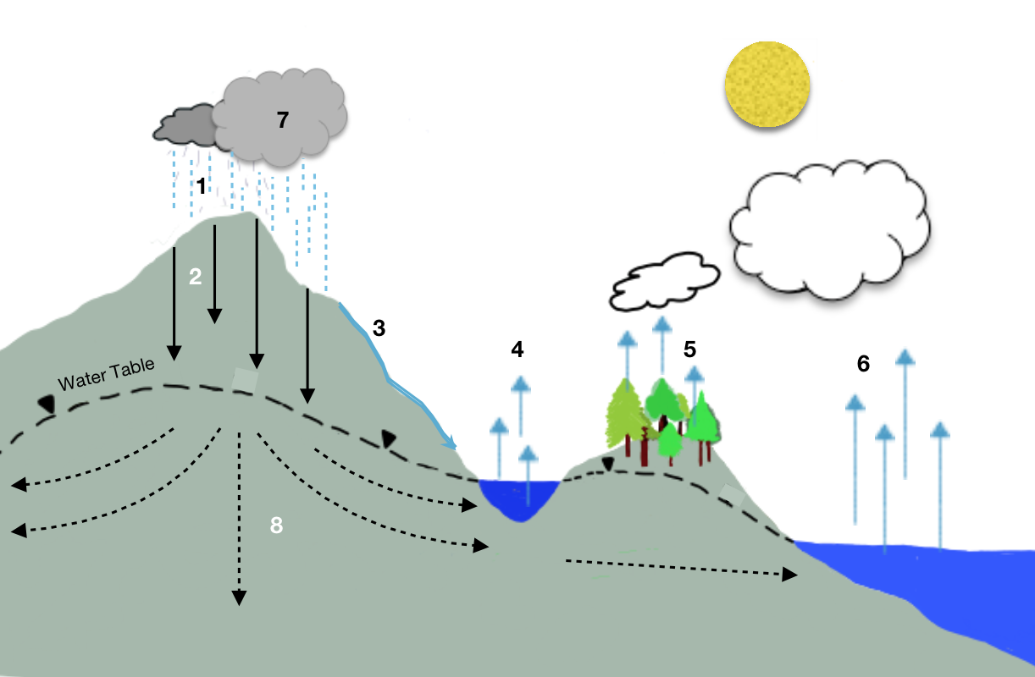
Q1. Imagine that you are a water molecule on a journey through the hydrologic cycle. Identify the process that is occurring at each numbered location on the diagram.
Source of diagram: Julie Monet 2014
- ________________________________ 2) ____________________________________
3) _________________________________ 4) ____________________________________
5) _________________________________ 6) ____________________________________
7__________________________________ 8) ____________________________________
Q2. Begin with the source of energy that ultimately drives the hydrologic cycle. At each numbered location, explain the process and or phase change that occurs as matter (water) moves through one complete cycle in the hydrologic system.
______________________________________________________________________________
____________________________________________________________________________________________________________________________________________________________
__________________________________________________________________________________________________________________________________________________________________________________________________________________________________________
______________________________________________________________________________
______________________________________________________________________________
__________________________________________________________________________________________________________________________________________________________________________________________________________________________________________

