Assessing the Impact of Land Use Change on Stormwater Runoff
Tutorial and Assessment
This tutorial is intended to guide you through the use of the National Stormwater Calculator. The National Stormwater Calculator is used to compute the amount of runoff produced by historical rainfall under different land use scenarios. In this tutorial, the instruction is based on a proposed change in land cover resulting from the expansion of residential development into a currently forested area. You will be guided through one land use scenario and will complete two additional land use scenarios on your own. A more detailed description of the model is included in the National Stormwater Calculator User’s Guide (Rossman, 2014).
Problem: City Planning and Zoning is considering a proposal, the Thomaston Trail Expansion plan, to rezone an area of land adjacent to a residential neighborhood from forest to low-density residential use, consistent with the adjoining neighborhood. Impervious surfaces (roofs, roads, sidewalks, and driveways) in the adjoining neighborhood currently comprise about 20 percent of the area; lawn covers approximately 30 percent of the area; and forest covers the remaining 50 percent. In their proposal, the developers intend to maintain the developed area as low-density residential with the same ratio of impervious to pervious area as the existing residential area (i.e., 20:30). City Planning and Zoning officials are concerned about stormwater from the new development and have asked that an analysis of stormwater runoff be completed prior to their final hearing. They have asked that two scenarios be analyzed to determine if there is a need to reduce stormwater runoff from the new development:
- pre-expansion, with 50 percent forest, 30 percent lawn, and 20 percent impervious surface, and
- post-expansion, with 60 percent lawn and 40 percent impervious surface without stormwater mitigation using low impact development (LID) controls.

Exercise

Part 1: Pre-expansion
The instructions below will guide you through the first scenario. There are two objectives of this part, to introduce you to the National Stormwater Calculator, and to calculate baseline data against which to compare changes in stormwater runoff that result from expansion.
It is assumed that the National Stormwater Calculator program has been downloaded and installed on your computer and that the file named Thomaston Trail Expansion.swc has been downloaded from the References and Resources section for this unit.
1. Open the National Stormwater Calculator from the installation folder. Familiarize yourself with the information presented in the Overview form.

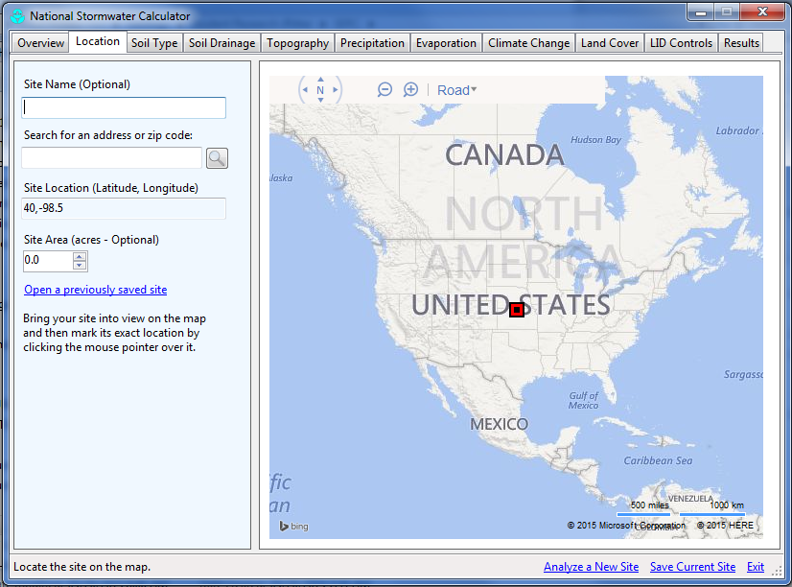
2. Click on the Location form. Click on the active link called Open a previously saved site and browse to and select the file named Thomaston Trail Expansion.swc.
The site area is 20 ac in area, approximately 50 percent developed and 50 percent forested. Because all results are expressed per unit area, there is no need to define the actual site area. Here, it helps visually to define the area so that you can consider the currently developed portion to comprise half of the site and the proposed expansion to cover the half that is currently in forest cover.

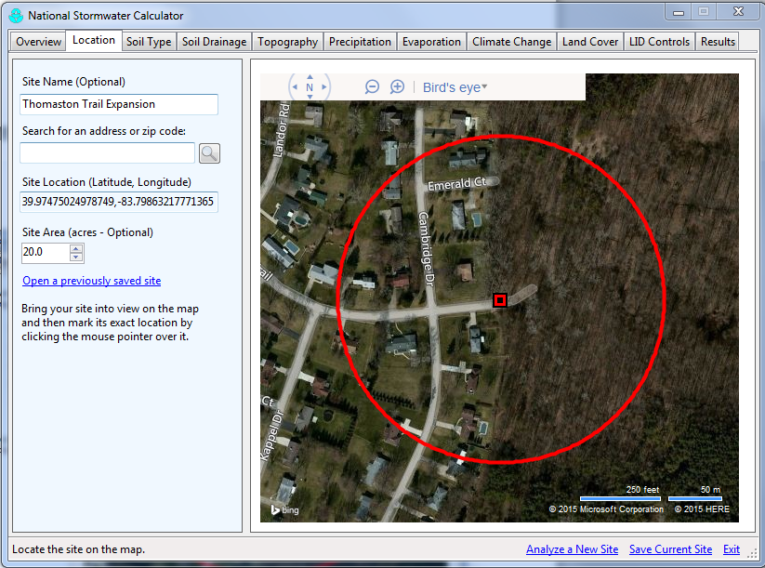
3. Hover your cursor over Road. Select “Bird’s eye” view and uncheck “show angled view.” Zoom into the area, by clicking on so that you can view the 20-ac area under consideration.
Be careful not to click within the map area while on the Location form since it will relocate the center point of the site area. This is how the site area is selected.
If you inadvertently click within the map area while on the Location form, you can attempt to relocate the exact position. Alternatively, you can repeat the step above. Click on Open a previously saved site and browse to and select the file named Thomaston Trail Expansion.swc.

4. Inputs include surface characteristics, including soil type, soil drainage, and topography, and different components of the hydrologic cycle, including precipitation and evaporation. Soil type, soil drainage, and topography can be displayed by checking the view data box.
Click on the Soil Type form, and check the View soil survey data box. Soil type is based on its Hydrologic Soil Group (HSG), which defines its runoff potential and infiltration capacity.
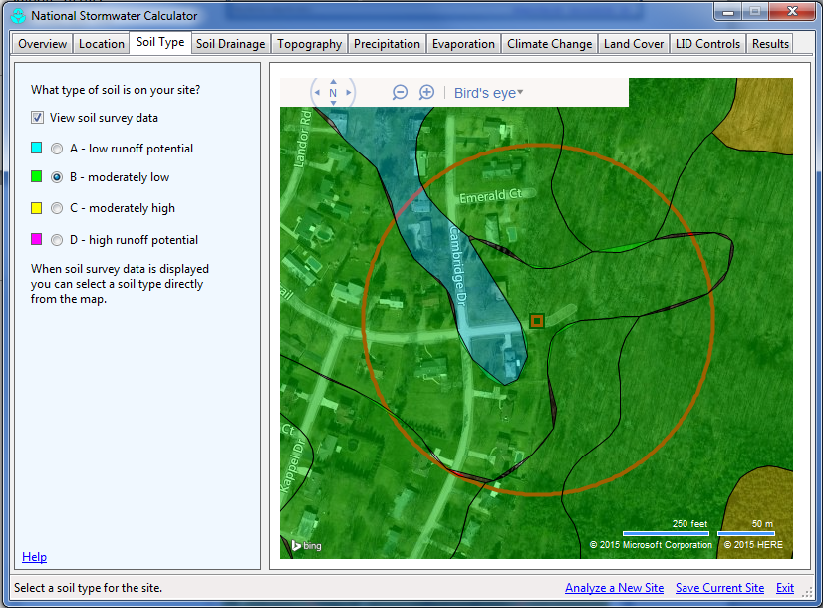
The following descriptions are based on the National Engineering Handbook (USDA, 2010):
A Soils have low runoff potential and high infiltration rates even when thoroughly wetted. They consist of deep, well- to excessively-drained sands or gravels and have a high rate of water transmission (> 0.30 in/hr)
B Soils have moderate infiltration rates when thoroughly wetted and consist chiefly of moderately well- to well-drained soils with moderately fine to moderately coarse textures. These soils have a moderate rate of water transmission (0.15-0.30 in/hr).
C Soils have low infiltration rates when thoroughly wetted and consist chiefly of soils with a layer that impedes downward movement of water and soils with moderately fine to fine texture. These soils have a low rate of water transmission (0.05-0.15 in/hr).
D Soils have high runoff potential. They have very low infiltration rates when thoroughly wetted and consist chiefly of clay soils with a high swelling potential, soils with a permanent high water table, soils with a claypan or clay layer at or near the surface, and soils over nearly impervious material. These soils have a very low rate of water transmission (0-0.5 in/hr).
Mapped soils will be collected from a national database and plotted on the site area. Examine the site area and select the dominant soil type in the area by color by clicking on the map area represented by the soil. The default is B since it underlies your study location (i.e., the red square). You can select another soil type by clicking on its color in the map area, but in this case since B represents the dominant soil type.

5. Click on the Soil Drainage form and view the soil survey data. Soil drainage represents the rate at which water can infiltrate into the soil in inches per hour, represented by map color. If the edit box is left blank, the default value of 0.4 in/hr is used. Clicking on the map with your cursor will enter a map-based value into the edit box. In this case, the area is mapped a single color, yellow, so select anywhere in the site area to input the mapped value. By zooming out, you will observe other map units (e.g., green). If the study area included more than one map unit, you would have to average your input value.

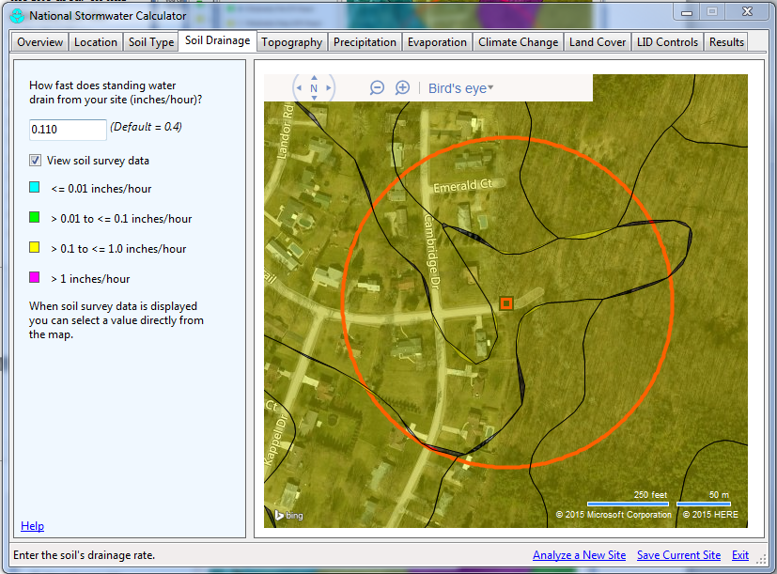

6. Click on the Topography form and view the soil survey data. Topography is mapped as the slope of the surface, steeper slopes producing greater runoff rates and less time for rainfall to infiltrate into the soil. In the case of the Thomaston Trail Expansion site area, the moderately steep and steep slopes dominate the area to be developed. Select the Moderately Steep category for our work.
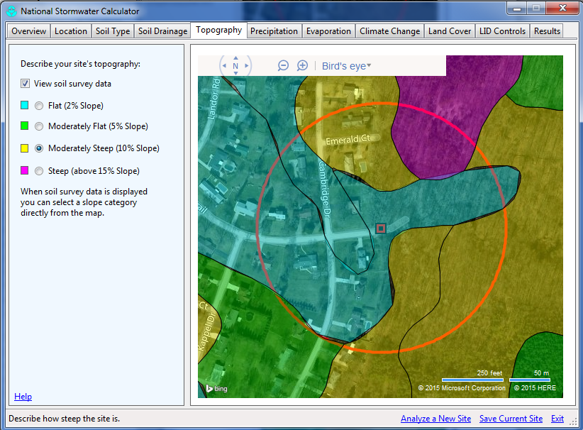

For the Precipitation and Evaporation forms, the locations where measurements or estimations are made are shown relative to the site area. The default input is the closest station. In this exercise, use the default value.
7. Click on the Land Cover form. Land cover is determined by the user. It will need to be adjusted based on the land uses identified in the “Bird’s eye” view.
Land cover choices are limited, and tradeoffs will need to be made when using the tool in agricultural areas. Agricultural land cover is highly variable throughout the year. Under conventional tillage, using cultivation to prepare for planting and to control weeds, the field is barren for a significant time of the year. During this time, it may look like desert, in fact. During other times of the year it looks more like a lawn or pasture. Interestingly enough, this does not present a critical problem with the model results. When compared to impervious pavement, runoff from exposed soil or soil under a natural cover is significantly less (an order of magnitude or ten times less). Because agricultural soils are pervious and the runoff potential and infiltration capacity is really dictated by the HSG, the data entered in the Soil Type and Soil Drainage forms are most significant. Relative to land cover, the most important estimation is the amount of impervious cover. Taking care with the approximation of impervious cover will produce the best model results.
The currently developed area in the Thomaston Trail Expansion is classified as a mix of Developed, Open Space and Developed, Low Intensity in the 2011 National Land Cover Database (NLCD). According the definitions below, from the 2011 NLCD, impervious surfaces account for less than 20 percent to as much as 49 percent of the total cover:
Developed, Open Space—areas with a mixture of some constructed materials, but mostly vegetation in the form of lawn grasses. Impervious surfaces account for less than 20% of total cover. These areas most commonly include large-lot single-family housing units, parks, golf courses, and vegetation planted in developed settings for recreation, erosion control, or aesthetic purposes.
Developed, Low Intensity—areas with a mixture of constructed materials and vegetation. Impervious surfaces account for 20% to 49% percent of total cover. These areas most commonly include single-family housing units.
The NLCD analyzes for percentage of impervious surface, and according to those data, impervious surface accounts for 20 percent of land cover in the developed part of the site area.
For the baseline analysis, adjust % Forest to 50. The developed area is 30 percent pervious surface (i.e., lawn and landscaping) and 20 percent impervious (i.e., roofs, sidewalks, driveways, and roads). In higher-density developments, more area would be impervious. In lower-density development, more area would be pervious. (By clicking in another box, % Impervious is automatically adjusted so that the total is 100% land cover). Your display should look the same as in the figure on the next page.
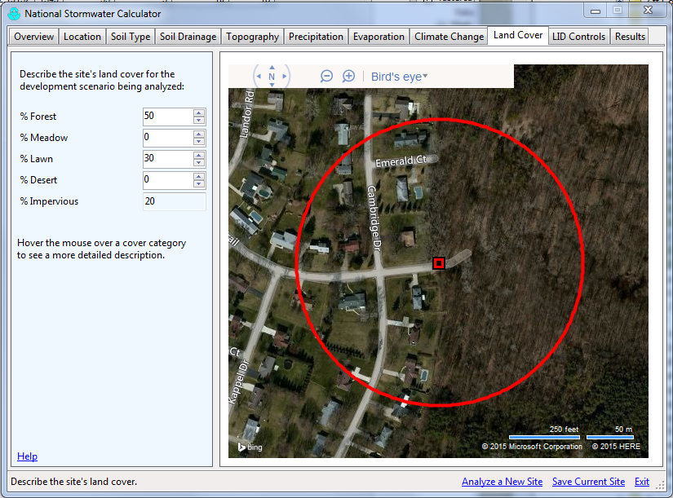

In Part 2, you will return to this screen to adjust land cover for the planned changes.
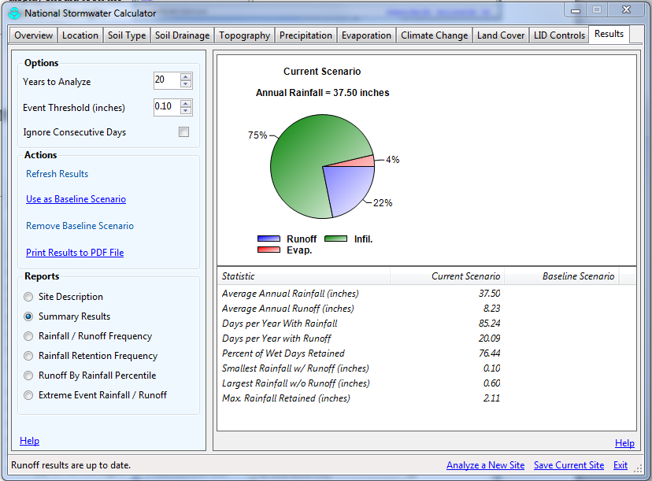
8. Select the Results form. Accept the default values for Years to Analyze and Event Threshold, and leave the Ignore Consecutive Days box unchecked.
Click on the Refresh Results link. After a minute, data on rainfall, runoff, and other important parameters will appear to the right. Depending on your input values, your results may be slightly different from those shown.
Enter this data in Table 1 at the end of this exercise in the column called Pre-expansion Condition. It represents stormwater model results for your first scenario.
9. Click on the link Use as Baseline Scenario to make this your baseline data. Your data will appear twice but this will change in Parts 2 and 3.
10. At this point, save your work by clicking on Save Current Site on the bottom right of the National Stormwater Calculator. Save your work as Thomaston Trails Expansion Baseline.swc.

Part 2: Post-expansion without LID Controls
Recall that the second scenario requested by City Planning and Zoning is for post-expansion, with 60 percent lawn and 40 percent impervious surface but without stormwater mitigation using LID controls.
1. To run the National Stormwater Calculator for the second scenario, select the Land Cover form and change land cover so that it is 60 percent lawn and 40 percent impervious surface.
2. Select the Results form and click on the Refresh Results link. After a minute, data on rainfall, runoff, and other important parameters will appear as the current scenario.
Enter this data in Table 1 in the column called Post-expansion without LID Controls. The model results represent the impact of expansion on stormwater runoff, assuming no attempt at mitigating the impact.
3. Save your work by clicking on Save Current Site on the bottom right of the National Stormwater Calculator. Save your work as Thomaston Trails Expansion Post Expansion.swc.

References
Rossman, L.A., 2014, National Stormwater Calculator User’s Guide – Version 1.1: U.S. Environmental Protection Agency EPA/600/R-13/085b, accessed 06/03/2015 at http://nepis.epa.gov/Adobe/PDF/P100HD4J.pdf.
U.S. Department of Agriculture (USDA), 2010, National Engineering Handbook, Part 630 Hydrology: Natural Resources Conservation Service, USDA, Washington, DC., accessed 06/03/2015 at http://directives.sc.egov.usda.gov/OpenNonWebContent.aspx?content=17757.wba.
Table 1. Model results for different land cover and LID controls related to the Thomaston Trail Expansion plan.
Statistic | Pre-expansion | Post-expansion without LID Controls | Post-expansion with LID Controls
% Runoff
% Infiltration
%Evaporation
Average Annual Rainfall (in)
Average Annual Runoff (in)
Days per Year with Rainfall
Days per Year with Runoff
Percent of Wet Days Retained
Smallest Rainfall w/ Runoff (in)
Largest Rainfall w/o Runoff (in)
Max Rainfall Retained (in)

