Modeling change in stormwater runoff resulting from a
subdivision expansion along the Missouri River
Problem: A 100-mile stretch of the Missouri River near Vermillion, SD, is designated as a National Park (the Missouri National Recreational River) because of its unique status as one of the few large, free-flowing river segments in the United States. Living along this stretch of the river is desirable for many people due to the aesthetic value of the river. There is currently a small subdivision of houses at the confluence of the Vermillion and Missouri Rivers (Figure 1). There is a proposal to expand this subdivision to the east to double the number of houses along the river at this location (Figure 1). You are part of a group of community members who are concerned not only with the increased stormwater runoff associated with the facility but also with the lost ecosystem services of the current land cover. You are not necessarily against the project, but your goal is for the subdivision to be stormwater neutral. A vocal minority would like stormwater generated from the site to be no more than what was produced prior to development of the area.
You plan to use the National Stormwater Calculator to determine the hydrologic impact of this subdivision on the Missouri River. The National Park Service is interested in your calculations because it is responsible for overall administration of the Missouri National Recreational River. The Vermillion Area Chamber and Development Company is also interested in this subdivision and your work because they believe that developing this subdivision as a “green” subdivision may increase its value. You have been asked to make a 5-minute presentation at an upcoming joint meeting between the National Park Service, the Vermillion Area Chamber and Development Company, and the Clay County Planning and Zoning Commission.
Specifications: The planned subdivision will occupy approximately 50 acres along the Missouri River (Figure 1). The current land use of the site is primarily crop production with some forests. The proposed subdivision is planned to be a low-intensity development (according to the National Land cover Database land covers; i.e. 20% to 49% total cover of impervious surfaces).
Concerned Students Objectives:
1. Model stormwater runoff from the area prior to any building in the area for comparison with one or more models of the current and proposed land use.
2. Propose and model alternatives using low impact development (LID) controls, green infrastructure, or environmental site design to make the subdivision water neutral at a minimum.
3. Illustrate and present results of the hydrologic impact of the proposed land use and effective means of neutralizing the impact at the least possible cost.

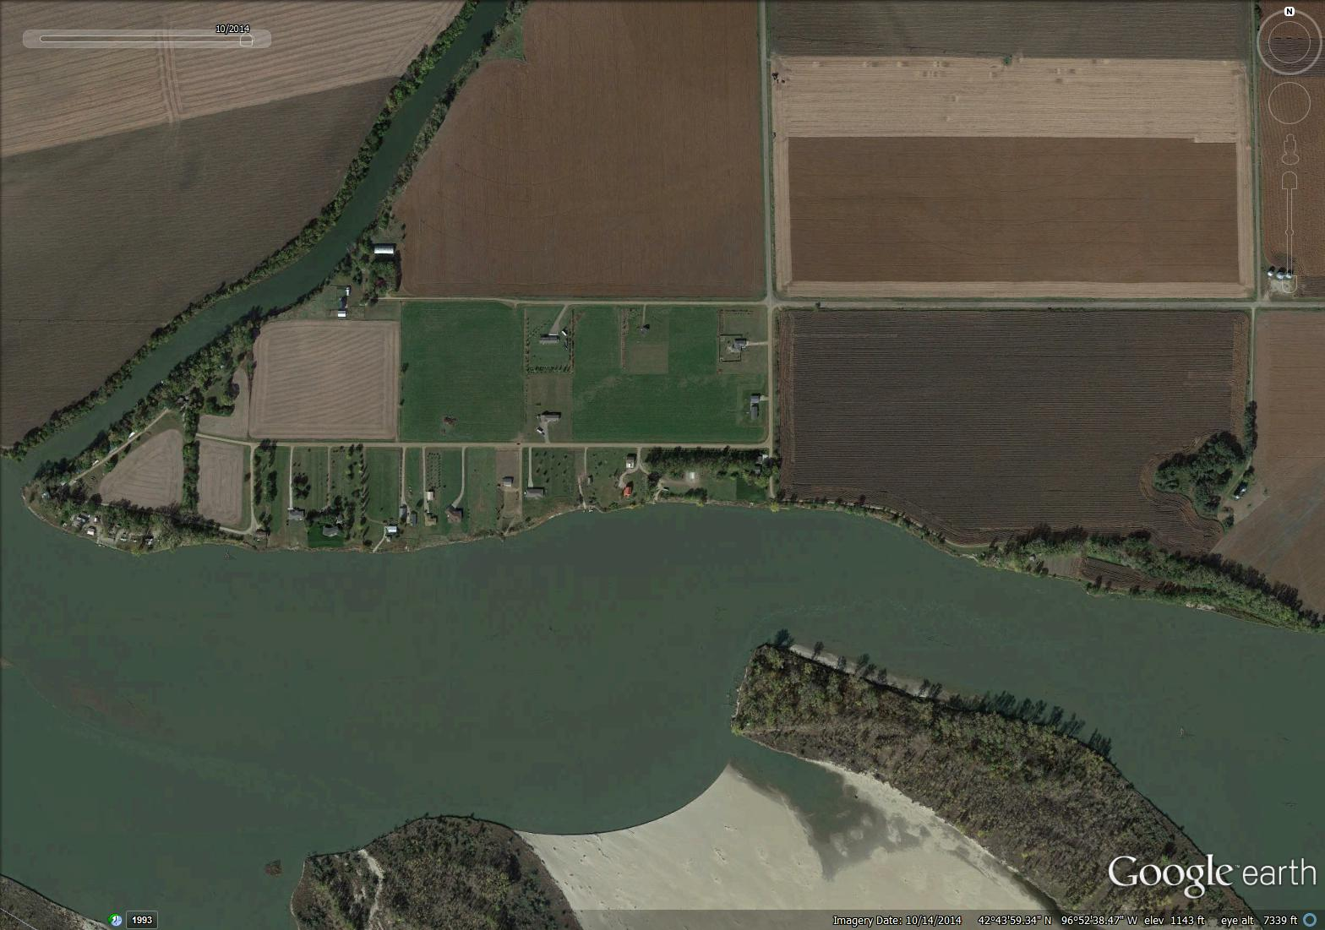
Proposed subdivision

Figure 1. Aerial photograph from Google Earth of the landscape at the confluence of the Vermillion River with the Missouri River. The proposed subdivision along the Missouri River is indicated by the red box.

This area was used as an example landscape in Unit 1.1: An Ecosystem Services Approach to Water Resources.

