Table 1. Annual rainfall and runoff data for Rock Creek and Big Creek watersheds in northern Ohio. The runoff data are calculated using total streamflow.
Rock Creek at Tiffin OH |  |  |  | Big Creek at Cleveland OH
 | USGS Gaging Station 04197170 |  |  |  |  | USGS Gaging Station 04208502
Year | Rainfall Depth (in) | Runoff Depth (in) |  | Year |  | Rainfall Depth (in) | Runoff Depth (in)
1984 | 34.29 | 13.98 |  | 1973 |  | 41.30 | 17.40
1985 | 38.37 | 12.92 |  | 1974 |  | 39.94 | 19.39
1986 | 38.42 | 15.18 |  | 1975 |  | 40.84 | 22.89
1987 | 33.59 | 5.93 |  | 1976 |  | 34.85 | 17.96
1988 | 26.59 | 4.75 |  | 1977 |  | 36.14 | 21.73
1989 | 34.92 | 8.78 |  | 1978 |  | 32.72 | 17.89
1990 | 46.01 | 19.03 |  | 1979 |  | 39.92 | 20.04
1991 | 26.55 | 5.50 |  | 1980 |  | 32.67 | 19.16
1992 | 43.18 | 18.19 |  | 1981 |  | 39.08 | 19.08
1993 | 34.64 | 13.54 |  | 1982 |  | 36.93 | 23.04
1994 | 29.58 | 7.20 |  | 1983 |  | 40.66 | 23.04
1995 | 37.26 | 9.01 |  | 1984 |  | 41.38 | 24.81
1996 | 39.77 | 15.45 |  | 1985 |  | 41.31 | 23.22
1997 | 37.50 | 16.15 |  | 2002 |  | 36.39 | 14.41
1998 | 35.85 | 16.60
1999 | 31.47 | 5.85
2000 | 39.52 | 10.70
2001 | 32.35 | 7.14
2002 | 35.10 | 12.73
2003 | 40.82 | 11.51
2004 | 38.83 | 11.54
2005 | 38.95 | 15.97
2006 | 41.62 | 14.22
2007 | 42.14 | 19.05
2008 | 42.53 | 21.40
2009 | 32.85 | 10.25
2010 | 33.62 | 7.88
2011 | 55.71 | 36.22
2012 | 36.86 | 10.43
2013 | 41.90 | 15.42
2014 | 34.51 | 11.14

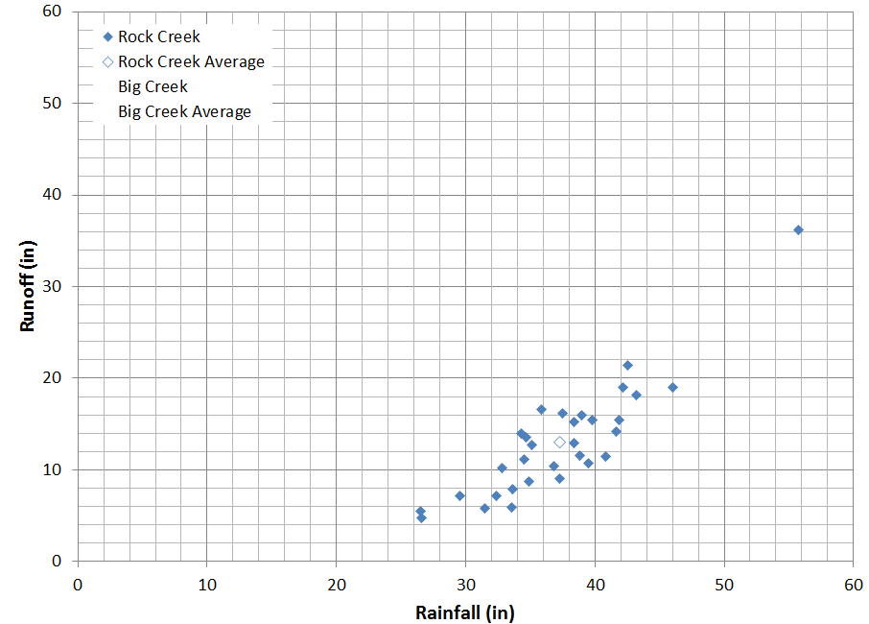
Figure 1. Annual rainfall-runoff data for Rock Creek watershed, northern Ohio. Plot the Big Creek rainfall-runoff data and averages on this plot using a different symbol.

